# Notes for Calculus Lifesaver

**CHAPTER 1 Functions, Graphs, and Lines**



1. Functions

* polynomials 多项式; exponentials 指数; logarithms 对数; trigonometric 三角法的, 三角学的; sphere;quadratics; cone; velocity; Euler's identity;
* [**R**](https://en.wikipedia.org/wiki/Real_number): the set of all real numbers: The real numbers include all the rational numbers **[Q]**, such as the integer **[Z]**[N] −5 and the fraction 4/3, and all the irrational numbers, such as √2 (1.41421356..., the square root of 2, an irrational algebraic number). Included within the irrationals are the transcendental numbers, such as π (3.14159265...). See **Figure 1**.

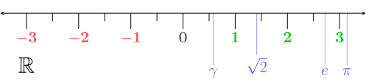

Figure 1. **[R]**: Real number; **[Q]**: rational numbers; **[Z]**: integers; **[N]**: natural numbers

1. Interval notation

* {*x*: 2≤ *x* < 5} = [2, 5)

1. Finding the domain (like *x*)

* The denominator of a fraction can't be zero. =! 0
* You can't take the square root (or fourth root, sixth root, and so on) of a negative number. ≥ 0
* You can't take the logarithm of a negative number or of 0. > 0
* (-8, 13] \ {2}: the domain is the set (-8; 13] except for the number 2

1. Finding the range using the graph

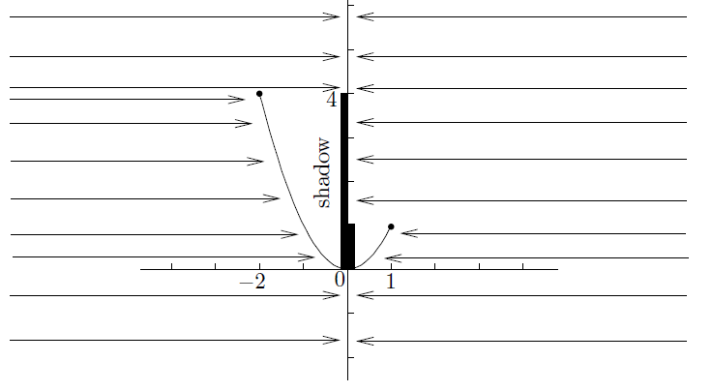

Figure 2. the range is [0, 4]

* Remember, the codomain of any function we look at will always be the set of all real numbers.
* codomain ≠ range.

1. The vertical line test

* How to judge whether it is a function? -> check the vertical lines: whether two or more points on the graph can lie on the same vertical line, see **Figure 3 and 4**.

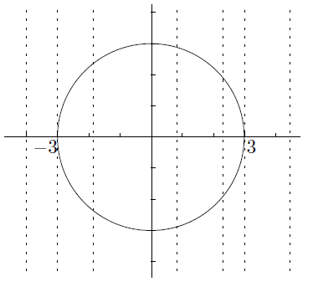

Figure 3. Not a function ()

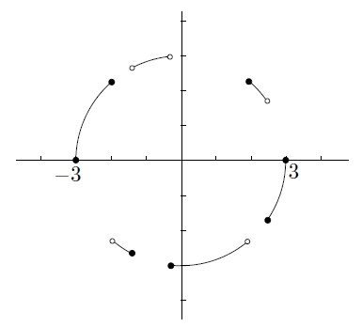

Figure 4. A function

1. Inverse Functions

* Start with a function *f* such that for any *y* in the range of *f*, there is exactly one number *x* such that *f*(*x*) = *y*. That is, different inputs give different outputs. Now we will define the inverse function *f*-1.
* The domain of *f*-1 is the same as the range of *f*.
* The range of *f*-1 is the same as the domain of *f*.
* The value of *f*-1(*y*) is the number *x* such that *f*(*x*) = *y*. So,

if *f*(*x*) = *y*; then *f*-1(*y*) = *x*.

1. The horizontal line test

* How to judge whether the function has an inverse function? -> check the horizontal lines: whether even one horizontal line intersects the graph more than once, see **Figure 5 and 6**.

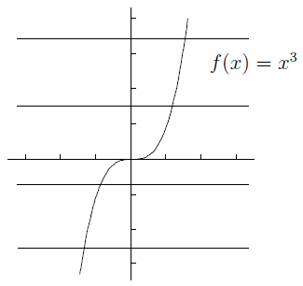

Figure 5. Inverse function existed

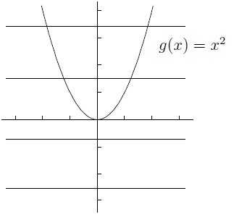

Figure 6. Inverse function doesn't exist

1. Finding the inverse

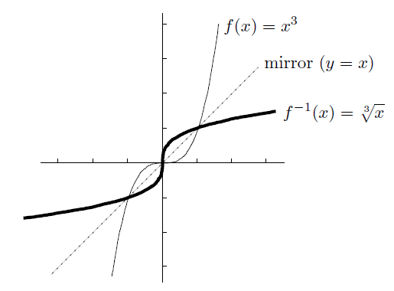

Figure 7. Draw the line y=x to find the inverse

1. Inverses of inverse functions

If the domain of a function *f* can be restricted so that *f* has an inverse *f*-1, then

* *f*(*f*-1(*y*)) = *y* for all *y* in the range of *f*; but
* *f*-1(*f*(*x*)) may not equal *x*; in fact, *f*-1(*f*(*x*)) = *x* only when *x* is in the restricted domain

1. Composition of Functions

* *f*(x) = *h*(*g*(*x*)) can be expressed as *f* = *h* O *g*, so

*f*(x) = *m*(*k*(*j*(*h*(*g*(*x*))))) can write *f* = *m* O *k* O *j* O *h* O *g*

1. Odd and Even Functions

* Even Functions: *f*(-*x*) = *f*(*x*)
* Odd Functions: *f*(-*x*) = -*f*(*x*)
* Remember, odd functions must pass through the origin if they are defined at 0
* The product of two odd functions is always an even function, the product of two even functions is always even, and also that the product of an odd and an even function must be odd

1. Graphs of Linear Functions

* , the slope is , and the -intercept is . See **Figure 8**.

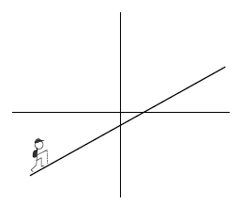

Figure 8.

* the *point-slope* form of a linear function

If a line goes through (*x*0, *y*0) and has slope *m*,

then its equation is .

1. Common Functions and Graphs

* **Polynomials:** these are functions built out of nonnegative integer powers of . You start with the building blocks , and so on, and you are allowed to multiply these basic functions by numbers and add a finite number of them together.
* The highest number such that has a nonzero coefficient is called the *degree* of the polynomial.

where is the coefficient of , is the coefficient of , and so on down to , which is the coefficient of

* **Quadratics:** , it has two, one, or zero (real) roots, depending on the sign of the *discriminant* . , There are three possibilities. If , then there are two roots; if , there is one root (called a *double root*); and if , then there are no roots. In the first two cases, the roots are given by
* An important technique for dealing with quadratics is *completing the square*, like
* **Rational functions:** these are functions of the form

where *p* and *q* are polynomials. Some simplest examples are **Figure 9**:

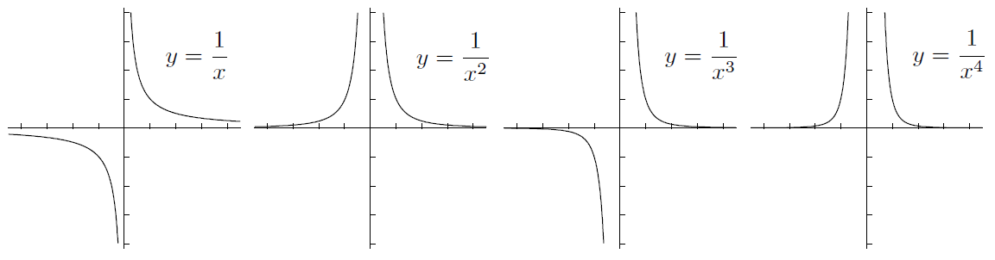

Figure 9. Some simplest rational functions

* **Exponentials and logarithms:** exponentials are , the domain is the whole real line, the *y-intercept* is 1, the range is , and there is a horizontal asymptote on the left or right at *y*=0. Since it satisfies the horizontal line test, there is an inverse function: the base *b* logarithm, which is written . The range is all of , and there’s a vertical asymptote at *x*=0. See **Figure 10**:

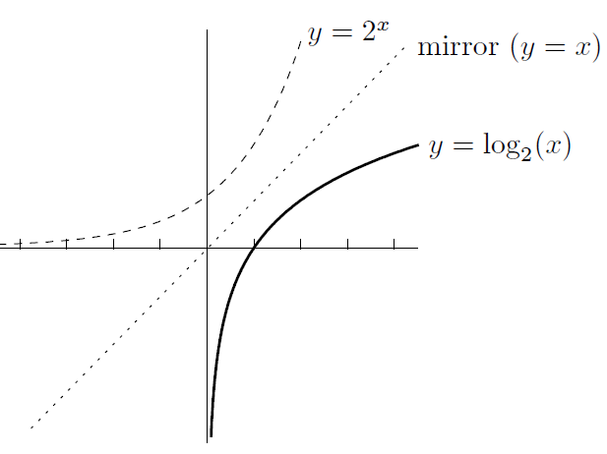

Figure 10. Base b is 2

**CHAPTER 2 Review of Trigonometry**



1. The Basics

* circumference: 圆周, 周长, 胸围; right-angled: 直角的; hypotenuse: 直角三角形的斜边; reciprocal: 互惠的, 相互的, 倒数的, 彼此相反的;
* The circumference of a circle of radius 1 unit is 2π units, see **Figure 11**:

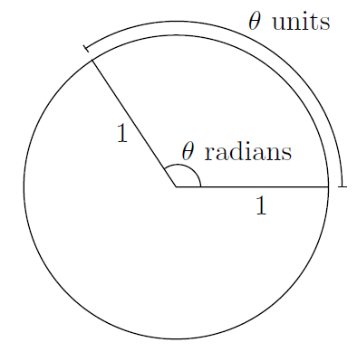

Figure 11. A circle of radius 1 unit

* The transfer formula between radians and degrees:
* A right-angled triangle **Figure 12**:

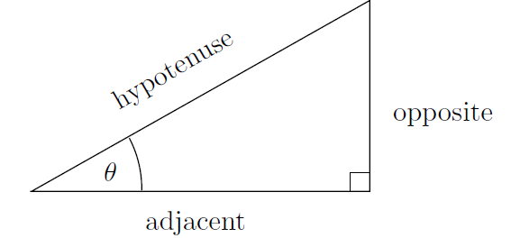

Figure 12. A right-angled triangle

We’ll also be using the reciprocal functions csc, sec, and cot:

* A nice table **Figure 13**:

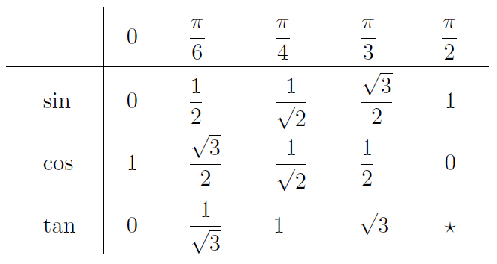

Figure 13. A nice table (the star means that tan(π/2) is undefined)

1. Extending the Domain of Trig Functions
2. The ASTC method

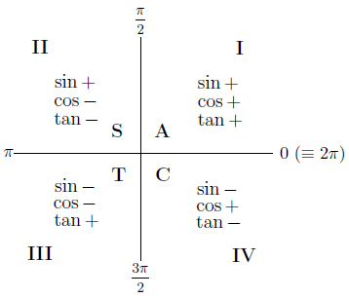

Figure 14. The ASTC method (All Sin Tan Cos)

1. The Graphs of Trig Functions

* (period 2π, odd), see **Figure 15:**

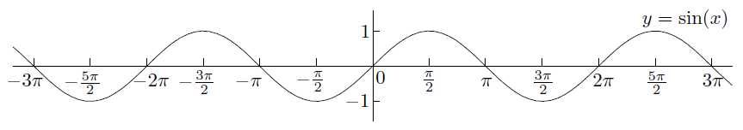

Figure 15. y=sin(x)

* (period 2π, even), see **Figure 16:**

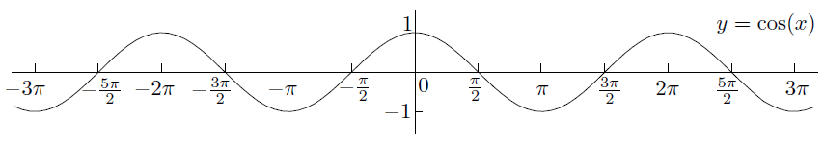

Figure 16. y=cos(x)

* (period π, odd), see **Figure 17:**

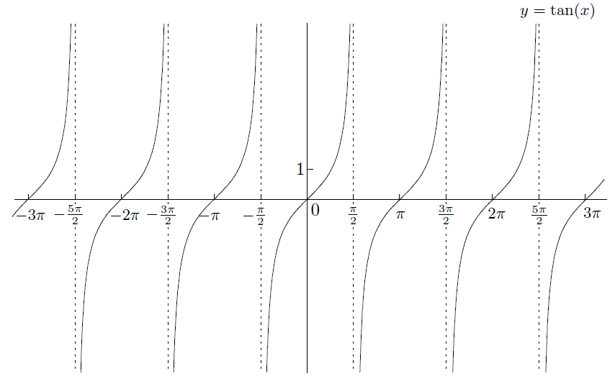

Figure 17. tan(x)

* (period 2π, even), see **Figure 18:**

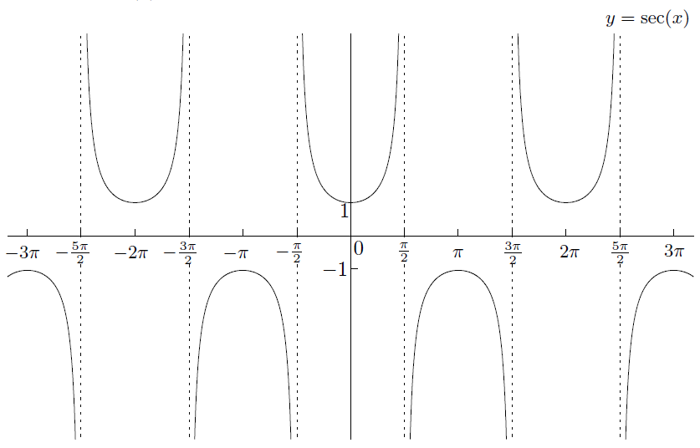

Figure 18. sec(x)

* (period 2π, odd), see **Figure 19:**

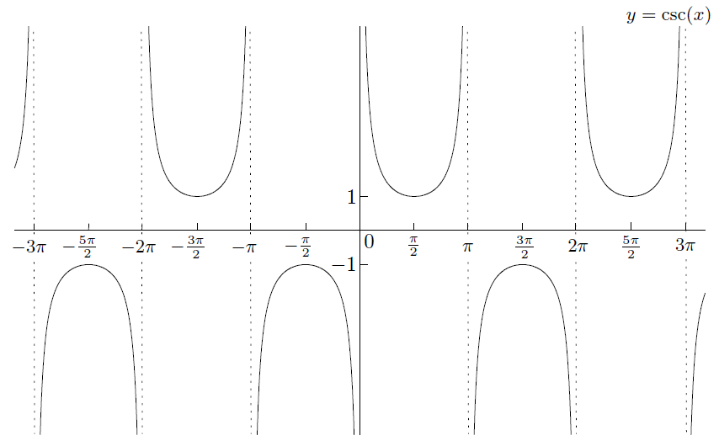

Figure 19. csc(x)

* (period π, odd), see **Figure 20:**

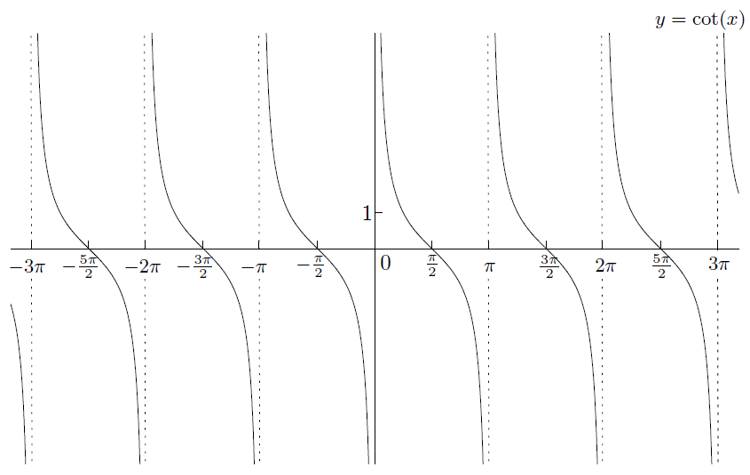

Figure 20. cot(x)

1. Trig Identities

* **:**

or

Specifically, you should remember that

The double-angle formulas are

**CHAPTER 3 Introduction to Limits**



1. Limits: The Basic Idea

* An example:

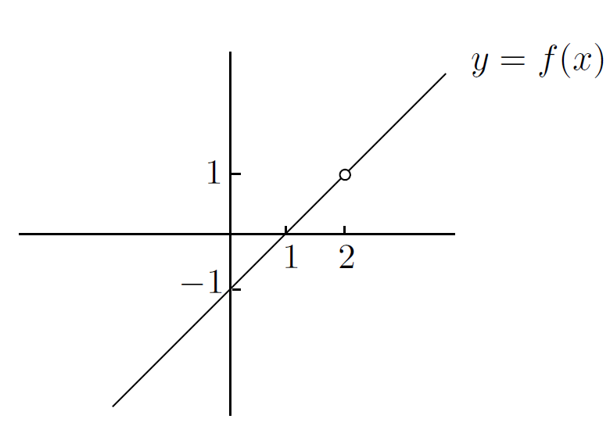

Figure 21.

* Modify it slightly:

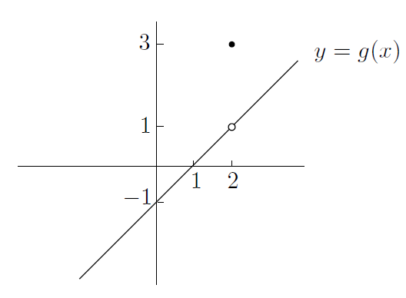

Figure 22.

1. Left-Hand and Right-Hand Limits

* How you would describe the behavior of near :

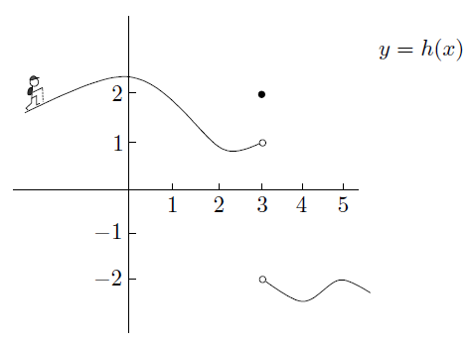

We can summarize

and

* The regular two-sided limit at exists **exactly** **when** both left-hand and right-hand limits at exist **and are equal to each other**!

I’m saying that

and

is the same thing as

If the left-hand and right-hand limits are not equal, then the two-sided limit does not exist. We'd just write

does not exist

1. When the Limit Does Not Exist

* A formal definition of the term “vertical asymptote”:

“ has a vertical asymptote at ” means that at least one of and is equal to or .

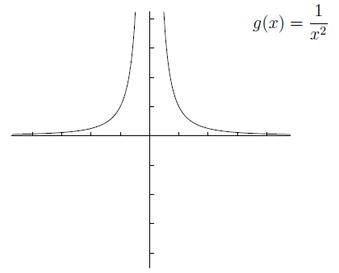

1. Limits at and

* How a function behaves when gets really huge:

“ has a right-hand horizontal asymptote at ” means that .

“ has a left-hand horizontal asymptote at ” means that .

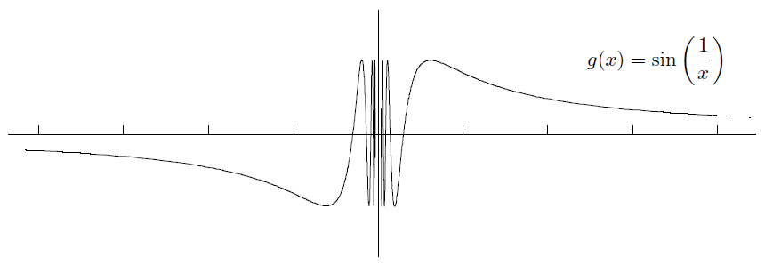

* Large numbers and small numbers

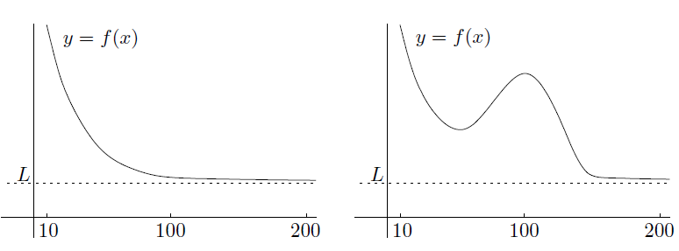

1. Two Common Misconceptions about Asymptotes

* First, a function doesn't have to have the same horizontal asymptote on the left as on the right

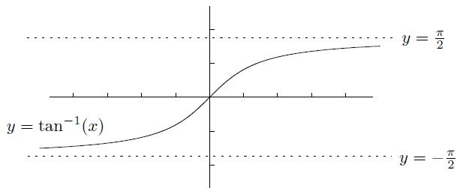

and

* A function can't cross its asymptote

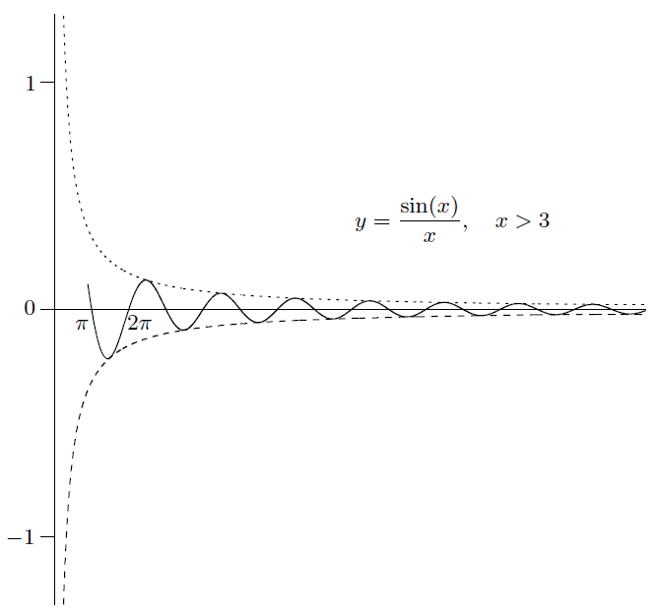

1. The Sandwich Principle

* The *sandwich principle*, also known as the *squeeze principle*, says that if a function is sandwiched between two functions and that converge to the same limit as , then also converges to as .

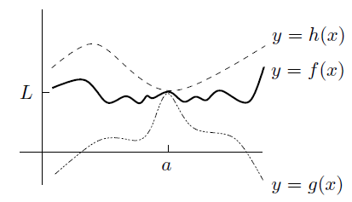

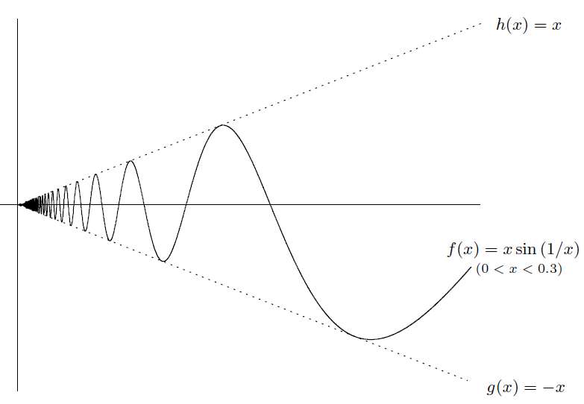

* In summary, here's what the sandwich principle says:

If for all near , and , then

1. Summary of Basic Types of Limits

* The right-hand limit at . Behavior of to the left of , and at itself, is irrelevant

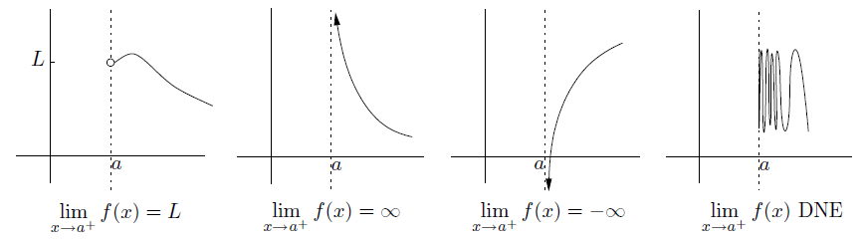

* The left-hand limit at . Behavior of to the right of , and at itself, is irrelevant

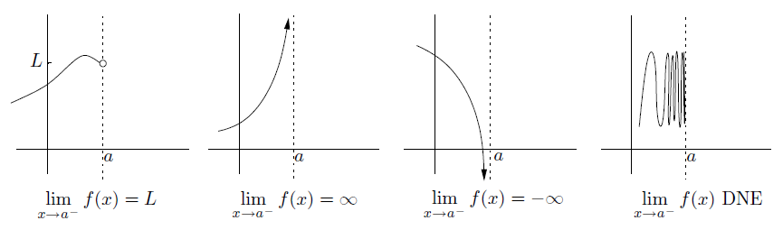

* The two-sided limit at

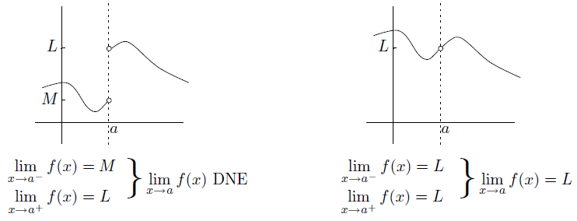

* The limit as

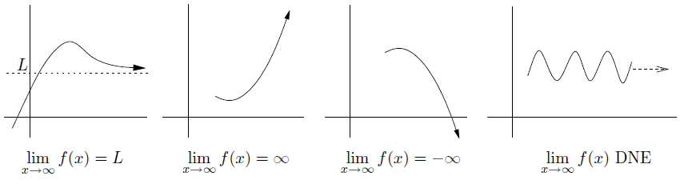

* The limit as

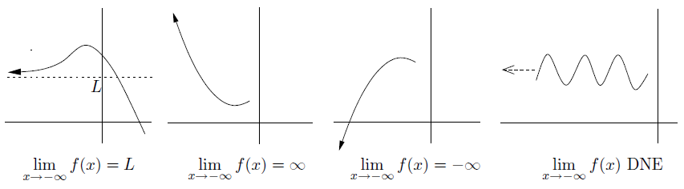

**CHAPTER 4 How to Solve Limit Problems Involving Polynomials**



1. Limits Involving Rational Functions as

* Let's start off with limits that look like this:

,

where and are polynomials and is a finite number. (Remember that the quotient of two polynomials is called a rational function.)

* The first thing you should always try is to substitute the value of for
* The formula for the difference of two cubes:
* Since we are taking limits, we use the plugging-in technique after factoring and canceling

1. Limits Involving Square Roots as

* Consider the following limit:
* conjugate expression:

1. Limits Involving Rational Functions as

* We are now trying to find limits of the form
* Here's a very important property of a polynomial: when is large, the leading term dominates
* More generally, you can use the following theorem:

for any , as long as is constant.

* So we have proved that
* Method and examples

1. Limits Involving Poly-type Functions as

* These aren't polynomials because they involve fractional powers or th roots, for example, let's consider
* Now let's see what happens when we modify the situation very slightly. Consider
* But wait, you say-what if they are the same? For example, what is

Use conjugate expression

1. Limits Involving Rational Functions as

* Now let's spend a little time on limits of the form

where and are polynomials or even poly-type functions. All the principles

we've been using apply equally well here

* There's only one other thing you have to beware

when is negative

for all (positive, negative, or zero)

If and you want to write , the only thing you need a minus sign in front of is when is even and m is odd

1. Limits Involving Absolute Values

* Sometimes you have to deal with functions involving absolute values. Consider this limit:

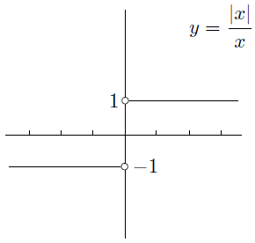

* A very slight variation of the above example is

we see that it matters whether or . These conditions can be rewritten as or

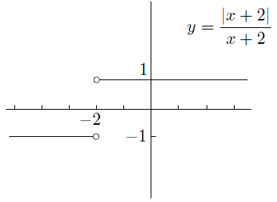

**CHAPTER 5 Continuity and Differentiability**



1. Continuity

* The intuition is that you can draw the graph of the function in one piece, without lifting your pen off the page
* Continuity at a point

A function is *continuous* as if

we can be a little more precise about the definition and explicitly require three things to be true:

1. The two-sided limit exists (and is finite)
2. The function is defined at ; that is, exists (and is finite)
3. The two above quantities are equal: that is,

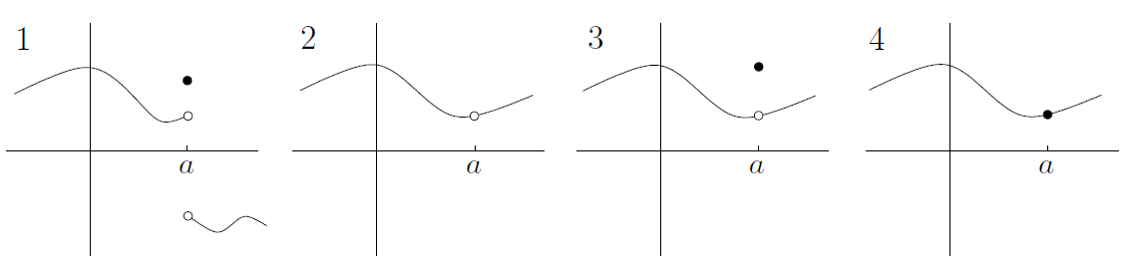

* Continuity on an interval

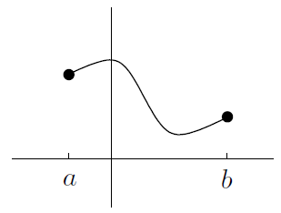

We say that a function is continuous on if

1. the function is continuous at every point in
2. the function is *right-continuous* at . That is, exists (and is finite), exists, and these two quantities are equal; and
3. the function is *left-continuous* at . That is, exists (and is finite), exists, and these two quantities are equal

* Examples of continuous functions. For example, every polynomial is continuous. Also, if you add, subtract, multiply or take the composition of two continuous functions, you get another continuous function. The same is almost true if you divide one continuous function by another: the quotient function is continuous everywhere except where the denominator is 0.

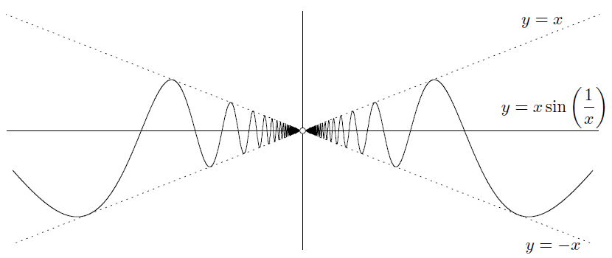

* Knowing that a function is continuous brings some benefits. The first is called the *Intermediate Value Theorem* (IVT)

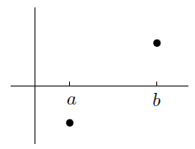

**Intermediate Value Theorem**: if is continuous on , and and , then there is at least one number in the interval such that . The same is true if instead and .

Here's a slightly harder example. How would you show that the equation has a solution? The first step is to use a little trick: **put everything onto the left-hand side**. So, instead of solving , we try to solve .

* A harder IVT example

Any polynomial of odd degree has at least one root

* The second benefit of knowing that a function is continuous: Maxima and minima of continuous functions

**Max-Min Theorem**: if is continuous on , then has at least one maximum and one minimum on .

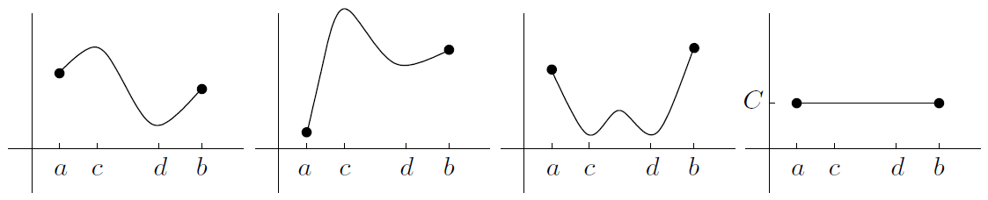

If the function isn’t continuous, the following diagrams show some potential problems:

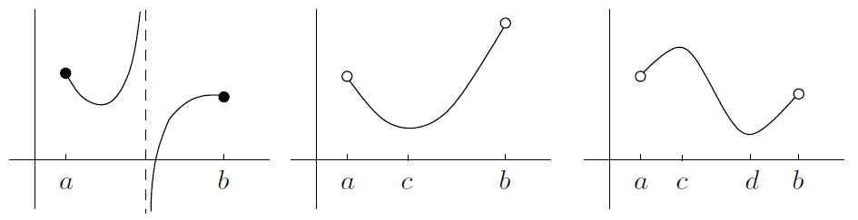

So, you can only use the theorem to guarantee the existence of a maximum and minimum in an interval if you know the function is continuous on the entire closed interval

1. Differentiability

* Differentiability. This essentially means that the function has a derivative. One of the original inspirations for developing calculus came from trying to understand the relationship between speed, distance, and time for moving objects
* Average speed
* Instantaneous velocity

In particular, suppose that at time , the car is at position . That is, let

* The graphical interpretation of velocity

We have a graphical interpretation for average velocity over the time period to

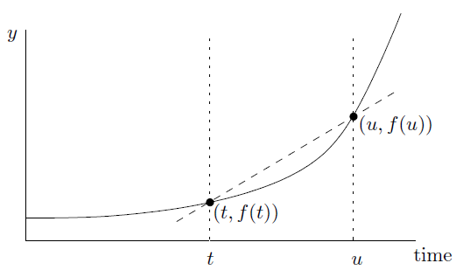

Try to find a similar interpretation for the instantaneous velocity

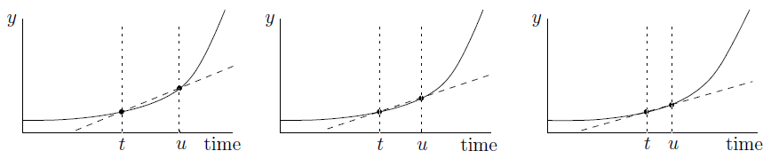

We'd like to say that the instantaneous velocity is exactly equal to the slope of the tangent line through

* Tangent lines

The tangent line doesn't have to intersect the curve only once!

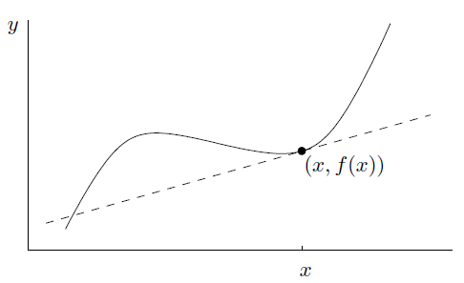

It's possible that there's no tangent line through a given point on a graph

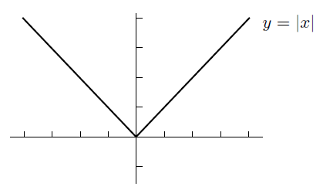

Start by picking a number which is close to

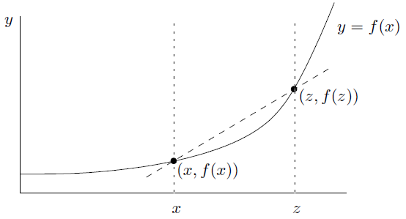

* The derivative function

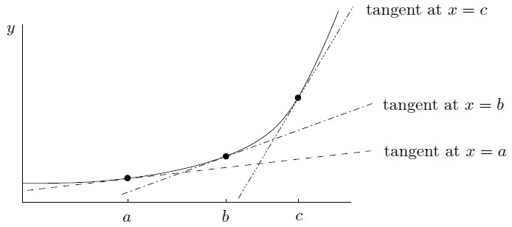

As for the parabola , its derivative is

* The derivative as a limiting ratio

Here the symbol means “change in,” so that is just the change in

Notice that isn’t actually equal to the ratio of to : it's equal to the limit of that ratio as tends to

We'd now like to write , which should mean “really really tiny change in ,” and similarly for

If , then you can write instead of

and are the same thing. Finally, remember that the quantity is not actually a fraction at all-it's the limit of the fraction as

* The derivative of linear functions

In our case, the graph of is just a line of slope and -intercept equal to . Then the tangent at any point on the line is just the line itself! This means that the value of should be no matter what is

As you might expect, only linear functions have constant slope

By the way, if is actually constant, so that , then the slope is always . So we've proved that the derivative of a constant function is identically

* Second and higher-order derivatives

There's a similar sort of notation for the second derivative:

If , then you can write instead of

The third derivative of as being the derivative of the second derivative of

The notation is particularly convenient for higher derivatives. That way, any derivative can be written in the form for some integer .

* When the derivative does not exist

We know the graph of has a sharp corner at the origin

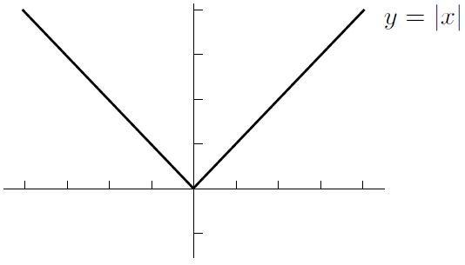

The point is that if , at the right-hand derivative is and the left-hand derivative is . Since the left-hand slope doesn't equal the right-hand slope, there can be no derivative at .

In conclusion, there are continuous functions which are not differentiable, but all differentiable functions are continuous.

* Differentiability and continuity

If a function is differentiable at , then it's continuous at .

Differentiable functions are automatically continuous. Remember, though, that continuous functions aren't always differentiable!

So, how do we prove our big claim? Let's start by seeing what we want to prove. To show that is continuous at , we're going to need to show that

Before we proceed farther, I want to substitute as we've done before. In that case, , and as , we see that . So the above equation can be replaced by

Now that we are aware of our destination, let's start with what we actually know. Well, we know that is differentiable at ; this means that exists, so by the definition of , the limit

exists. We know that exists. We still need to do something clever. The trick is to start with another limit:

we can work out this limit exactly by splitting it into two factors:

On the other hand, we could have taken the original limit and instead canceled out the factor of to get

Of course, the value of doesn't depend on the limit at all:

**CHAPTER 6 How to Solve Differentiation Problems**



1. Finding Derivatives Using the Definition

If is constant, then

1. Finding Derivatives (the Nice Way)

* Constant multiples of functions
* Sums and differences of functions

It's even easier to differentiate sums and differences of functions: just differentiate each piece and then add or subtract.

* Products of functions via the product rule

Product rule (version 1): if , then

Product rule (version 2): if , then

Product rule (three variables): if , then

* Quotients of functions via the quotient rule

Quotients rule (version 1): if , then

Quotients rule (version 2): if , then

* Composition of functions via the chain rule

Chain rule (version 1): if , then

Chain rule (version 2): if is a function of , and is a function of , then

* A nasty example
* Justification of the product rule and the chain rule

1. Finding the Equation of a Tangent Line

* One benefit of finding derivatives is that you can use derivatives to find the equation of a tangent line to a given curve

1. **find the slope**
2. **find a point on the line**
3. **use the point-slope form**
4. Velocity and Acceleration

* Another application of finding derivatives is to compute velocities and accelerations of moving objects

velocity

acceleration

* Constant negative acceleration

An object thrown at time from initial height with initial velocity satisfies the equations

, , and

1. Limits Which Are Derivatives in Disguise

* If you get stuck on a limit, it might be a derivative in disguise. Telltale signs are that the dummy variable is by itself in the denominator, and the numerator is the difference of two quantities. Even if this doesn't happen, you could still be dealing with a derivative in disguise

1. Derivatives of Piecewise-Defined Functions
2. Sketching Derivative Graphs Directly

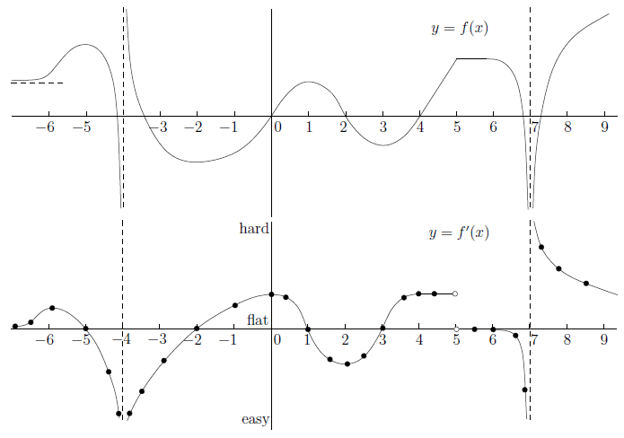

**CHAPTER 7 Trig Limits and Derivatives**



1. Limits Involving Trig Functions

* The small case

It is true in the limit as :

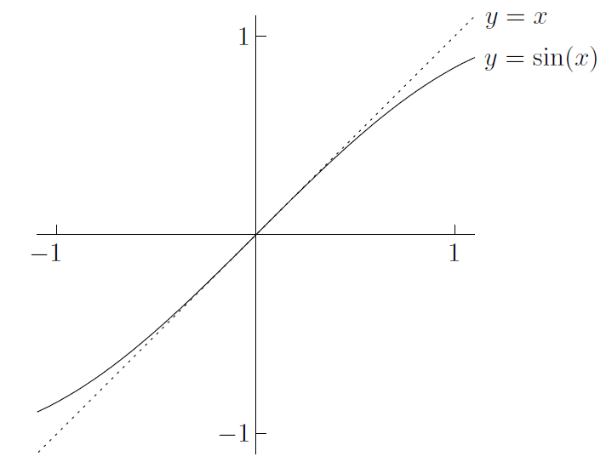

Look at

So we have shown that

What happens to as

* Solving problems-the small case

and

* The large case

and for any

Using the sandwich principle, you can treat or as being

of lower degree than any positive power of , so long as you are only adding or subtracting

More precisely, if you are solving a problem of the form

where and are polynomials or poly-type functions but with some sines and cosines added on, then the degrees of the top and bottom are the same as they would be without the sines and cosines added on. The only exception is when or has degree 0; then the trig part could be significant

In practice, most mathematicians would have established the general principle that

for any positive exponent , and similarly when sine is replaced by cosine

* The “other” case

Consider the limit

A good general principle when dealing with a limit involving for some is to **shift the problem to by substituting**

* Proof of an important limit

Now it's time to prove it

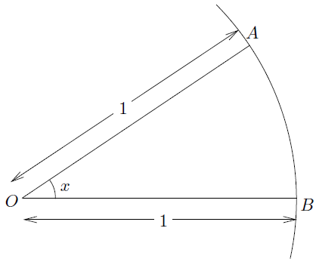

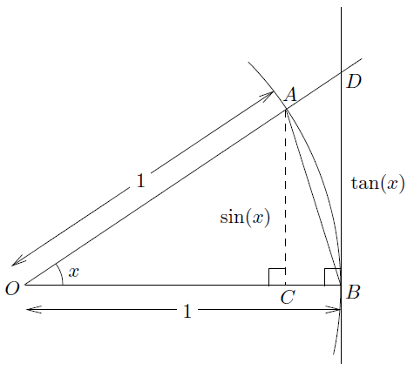

for

Let's first take reciprocals of the nice inequality, and multiply by the positive quantity

By the sandwich principle

To prove that the left-hand limit is set

1. Derivatives Involving Trig Functions

* Examples of differentiating trig functions
* Simple harmonic motion

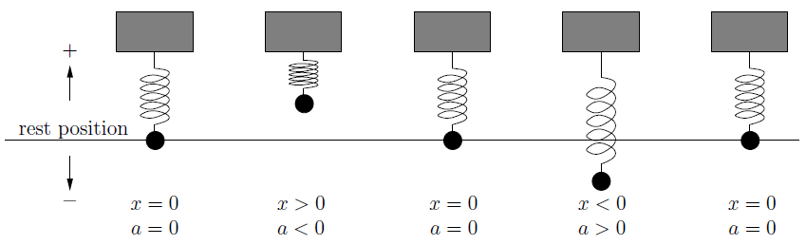

* A curious function

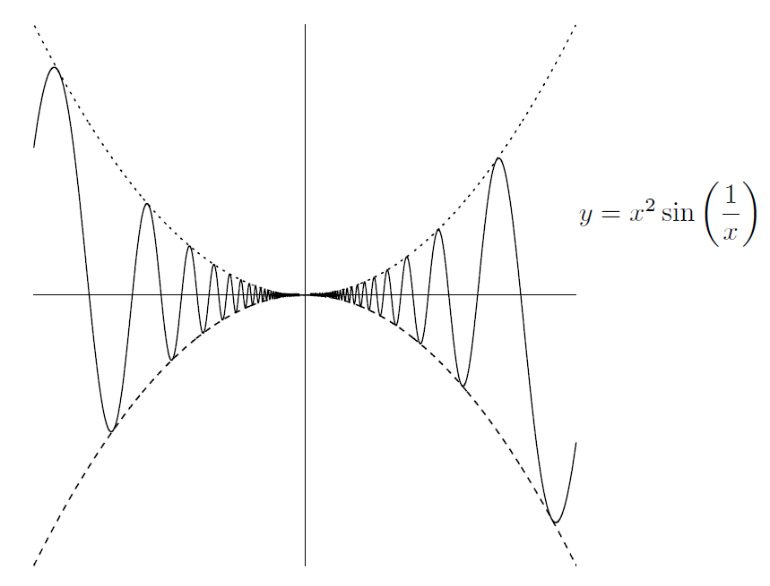

But DNE, neither does

So, there are functions out there which are differentiable, yet their derivatives aren't continuous

**CHAPTER 8 Implicit Differentiation and Related Rates**



1. Implicit Differentiation

Consider the following two derivatives:

and

The best way is to say to yourself that the first of the derivatives above is asking how much the quantity changes when we change a little bit. On the other hand, think of second this way, if you change , then will change a little bit; this change in will cause to change. (All this is true only if depends on , of course-if not, then when you change , nothing at all will happen to

* Techniques and examples

Now it's time to get practical. Consider the following equation:

whack a in front of both sides:

Here's another example: if

Now let's differentiate the above equation:

Finally, plug in and to see that:

But do you see how we might have saved a little effort? Go back to the second equation, we could have saved a little time by plugging and into the above equation, which can easily reduce . So a good rule of thumb is **that if you only need the derivative at a certain point, substitute before rearranging**-it often saves time.

Here's a brief summary of the above methods:

1. in your original equation, differentiate everything and simplify using the chain, product, and quotient rules;
2. if you want to find , rearrange and divide to solve for ; but
3. if instead you want to find the slope or equation of the tangent at a particular point on the curve, first substitute the known values of and , then rearrange to find . Then use the point-slope formula to find the equation of the tangent, if needed

* Finding the second derivative implicitly

It's also possible to differentiate twice to get the second derivative. For example, if

Now, if you want to differentiate twice, you have to start by differentiating once! You should get

Differentiate the above equation with respect to :

Beware: the quantities

and

are completely different!

Finally, we can write this as

Phew. That was exhausting. We're not done yet, though: we still need to find when and . So plug that in to the above equation: you get

We still need ! So put and to second equation above and get

Put that into our second derivative equation and we will get

when and , so we're finally done!

1. Related Rates

Consider two quantities-they can measure anything you like-that are related

to each other. If you know one, you can find the other

Of course, as one of the two quantities changes, so does the other. Suppose that we know how fast one of the quantities is changing. Then how fast is the other one changing? That is exactly what we mean by the term *related rates*. You see, a *rate of change* is the speed at which a quantity is changing over time

Here's the real definition: **the rate of change of a quantity is the derivative of with respect to time**. That is,

if is some quantity, then the rate of change of is

When you see the word \rate," you should automatically think “”

So, let's look at a general overview of how to solve problems involving related rates:

1. Read the question. Identify all the quantities and note which one you need to find the rate of. Draw a picture if you need to!
2. Write down an equation (sometimes you need more than one) that relates all the quantities. To do this, you may need to do some geometry, possibly involving similar triangles. If you have more than one equation, try to solve them simultaneously to eliminate unnecessary variables.
3. Differentiate your remaining equation(s) implicitly with respect to time . That is, whack both sides of each equation with a . You end up with one or more equations relating the rates of change.
4. Finally, substitute values for everything you know into all the equations you have. Solve the equations simultaneously to find the rate you need.

Just one more thing before we look at examples: it's vital that you **substitute values at the** **end, after differentiating**! That is, don't switch steps 3 and 4. If you substitute values first, denying the quantities the ability to change, then your rates will all be 0. That's what you get for freezing everything in place. . . .

* A simple example

Suppose that a perfectly spherical balloon is being inflated by a pump. Air is entering the balloon at the constant rate of cubic inches per second. At what rate does the radius of the balloon change at the instant when the radius itself is inches? Also, at what rate does the radius change when the volume is cubic inches?

OK, let's write down our quantities (step 1):

These are the volume and the radius of the balloon. Let's call the volume (in cubic inches) and the radius (in inches)

Now, we need an equation relating V and r (step 2):

Here's where the geometry comes in. Since the balloon is a sphere, we know that

Now we need to relate the rates (step 3):

Differentiate both sides implicitly with respect to :

Finally, we're ready to substitute (step 4):

In symbols, we have , Plugging this into the above equation, we get

Rearranging leads to

Armed with the formula, we can quickly do both parts of the question. In the first part, we know that the radius is inches, so set in our formula from above:

So the answer is . But what? It's important to write a sentence summarizing the situation, as well as including the **units** of measurement. In this case, we'd say that when the radius is inches, the rate of change of the radius is inches per second

Now, for the second part of the question, we know that the volume is cubic inches. Put and solve for , you should be able to see that inches. Finally, substituting into the equation for gives

So when the volume is cubic inches, the rate of change of the radius is inches per second

* A slightly harder example

Let's look at another relatively straightforward example, this time involving three quantities. Suppose there are two cars, and . Car is driving on a road heading directly north away from your house, and car is driving on a different road heading directly west toward your house. Car travels at miles per hour and car travels at miles per hour. At what rate is the distance between the cars changing when is miles north of your house and car is miles east of your house?

To answer this question, we'd better draw a picture (step 1): Draw your house and the cars and . Let the distance between and be given by ; let the distance between and be called ; and let the distance between the cars be called . The diagram looks like this:

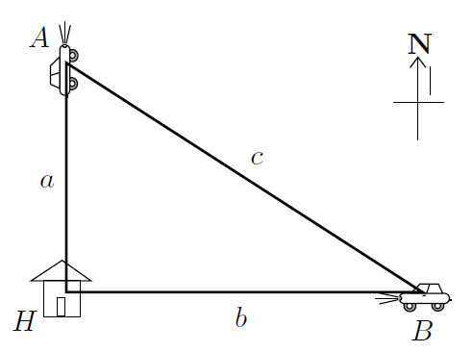

Time for step 2. The equation relating , , and c is nothing other than Pythagoras' Theorem:

Moving on to step 3, we differentiate implicitly with respect to time . Make sure you agree that we get

Now, we know that car is moving at miles an hour away from your house. This means that the distance is increasing by miles per hour, so . As for , it is moving at miles an hour toward your house. This means that is decreasing by miles an hour, so

The end result is that

* A much harder example

Here's a tougher example involving similar triangles: suppose there's a freakin' huge water tank in the shape of a cone (with the point at the bottom). The height of the cone is twice the radius of the cone. Water is being pumped into the tank at the rate of cubic feet per second. At what rate is the water level changing when the volume of water in the tank is cubic feet?

There's a second part as well: assume that the tank develops a little hole at the bottom that causes water to flow out at a rate of one cubic foot per second for every cubic foot of water in the tank. I want to know the same thing as before: at what rate is the water level changing when the volume of water in the tank is cubic feet, but now with the leak in the tank?

Let's start with the first part. Here's a diagram of the situation:

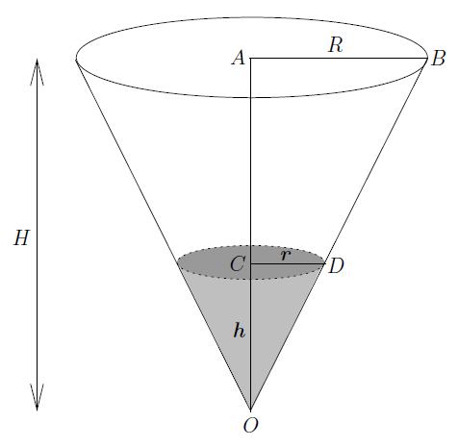

The height of the tank is and its radius is . The height of the water level is and the radius of the top of the water surface is . All these quantities are measured in feet. Let's also let be the volume of water in the tank, measured in cubic feet (step 1)

For step 2, we have to start relating some of these quantities. We are given that the tank's height is twice the radius, so we have . There are some similar triangles in the diagram: in fact, is similar to , so . Since , we have , which means that . The volume of a cone of height units and radius units is given by cubic units. Using the equation , we have

Now, for step 3, let's differentiate this with respect to time . By the chain rule,

Great-now for step 4, substitute in everything we know into the two equations

Above. We know that and we're interested in what happens when . Substituting, we get

and

Final, we get

The second part is almost the same. In fact, the only difference occurs at step 4. We know one cubic foot is leaving per second for every cubic foot of water in the tank. Since there are cubic feet of water in the tank (by definition!), the rate of outflow from the leak is cubic feet per second. So

* A really hard example

Suppose that a plane is flying eastward directly away from you at a height of feet above your head. The plane moves at a constant speed of feet per second. Meanwhile, some time ago a parachutist jumped out of a helicopter (which has since own away). The parachutist is floating directly downward, feet due east of you, at a constant speed of feet per second. The situation is summarized in the following picture:

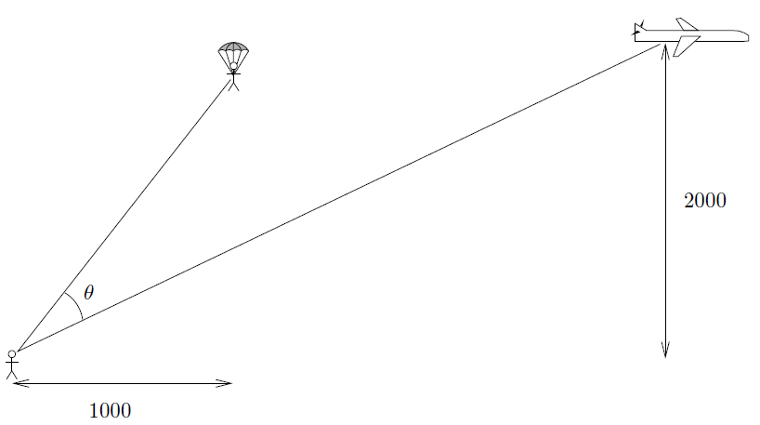

In the picture, what you might call the inter-azimuthal angle between the parachutist and the plane (with respect to you) is marked as . The question is, at what rate is changing when the plane and the parachutist have the same height but the plane is feet due east of you?

Let the plane be feet to the east of you. Let the height be feet. By drawing a few extra lines, we can recast the above diagram as follows:

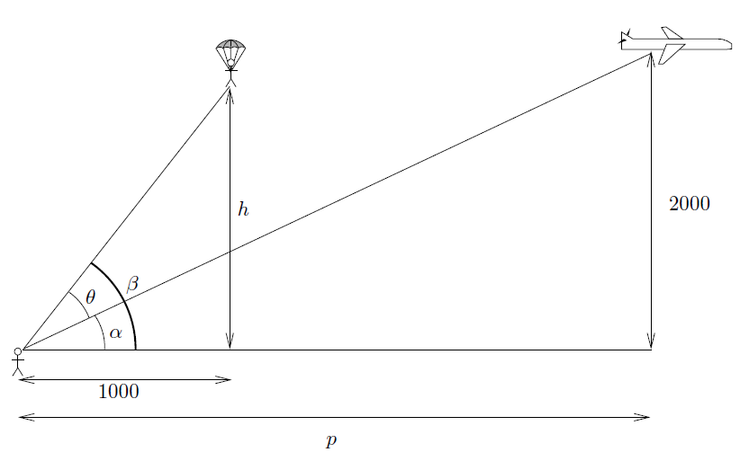

So we know that . Actually, we should probably write , just in case the parachutist is much lower than the plane. At around the time we're interested in, the heights are the same but the plane is much farther to the east than the parachutist, so must be bigger than and we don't need the absolute values

Now, let's do some trig. We have two right-angled triangles

and

Step 2 is finally done, and we can move on to step 3, differentiating these two relations implicitly with respect to time

Now we'd better make some substitutions and get to the bottom of this mess. Well, the speed of the plane is 500 feet per second, which means that . The speed of the parachutist is 10 feet per second, but the height is decreasing, so . We're interested in what happens when the plane is feet away, so , and when the parachutist is at height feet (the same as the plane), so set

Use our trig identities, we get

So

The same with

So for the final equation

So the angle is increasing at a rate of radians per second (at the moment we're considering), and we're finally done

**CHAPTER 9 Exponentials and Logarithms**



1. The Basics

* Review of exponentials

The rough idea is that we'll take a positive number, called the *base*, and raise it to a power called the *exponent*:

For example, the number is an exponential with base and exponent . It's essential that you know the so-called exponential rules, For any base and real numbers and :

1. The zeroth power of any nonzero number is
2. The first power of a number is just the number itself
3. When you multiply two exponentials with the same base, you **add** the exponents.
4. When you divide two exponentials with the same base, you **subtract** the bottom exponent from the top one.
5. When you take the exponential of the exponential, you **multiply** the exponents.

* Review of logarithms

Suppose that you want to solve the following equation for :

The way you can bring down from the exponent is to hit both sides with a logarithm. Since the base on the left-hand side is , the base of the logarithm is . Indeed, by definition, the solution of the above equation is

Let's go back to the equation . We know that this means that . If we now plug that value of into the original equation, we get the bizarre looking formula

In more generality, **is the power you have to raise the base to in order to get** . This means that is the solution of the equation for given and . Plugging this value of in, we get the formula

which is true for any and (except ). Remember is always positive! **You can only take the logarithm of a positive number**

You might also have noticed that I mentioned that is bad. For any base between and : for all , and is greater than .

* Logarithms, exponentials, and inverses

Fix a base and set . The function has domain and range . Since it satisfies the horizontal line test, it has an inverse, which we'll call . The domain of is the range of , which is , while the range of is the domain of , which is . Remembering that the graph of the inverse function is the reflection of the original function

in the mirror line :

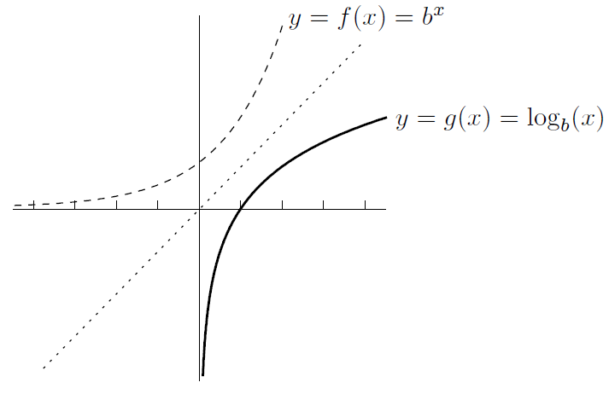

**The exponential of the logarithm is the original number**- provided that the bases match!

**The logarithm of the exponential is the original number** (provided that the bases match!)

* Log rules

Here are the rules, which are valid for any base and positive real numbers and :

1. **The log of the product is the sum of the logs**.
2. **The log of the quotient is the difference of the logs**.
3. **The log moves the exponent down in front of the log**. In this equation, can be any real number (positive, negative or zero).
4. **Change of base rule**:

for any bases and and any number . This means that all the log functions with different bases are really constant multiples of each other. Indeed, the above equation says that

where is constant (it happens to be equal to ), which means it doesn't depend on . We can conclude that the graphs of and are very similar-you just stretch the second one vertically by a factor of to get the first one

Actually, there is a change of base rule for exponentials too: for , , and .

1. Definition of

So far, we haven't done any calculus involving exponentials or logs. Let's start doing some. We'll begin with limits and then move on to derivatives. Along the way, we need to introduce a new constant , which is a special number in the same sort of way that is a special number. One way of seeing where comes from involves a bit of a finance lesson

* A question about compound interest
* The answer to our question

First, let's suppose that we are compounding times a year at an annual rate of . This means that each time we compound, the amount of compounding is . After this happens times in one year, our original fortune has grown by a factor of

We want to know what happens if we compound more and more often; in fact, let's allow to get larger and larger. It would also be nice to know what happens at interest rates other than . So let's replace by and worry about the more general limit

fortune after years, compounded times a year at a rate of per year

With , we have

This means that if you compound more and more frequently at an annual rate of , your fortune will increase by an amount very close to , but never more than that. The quantity is the “fortune-increase limit” we've been looking for. The only way you get this rate of increase is if you compound continuously-that is, all the time!

fortune after years, compounded **continuously** at a rate of per year

The quantities and look quite different, but for large they're almost the same

* More about and logs

Let's take a closer look at our number . Remembering that

we can replace by to get

Of course, corresponds to an interest rate of per year. Let's draw up a little table of values of **to three decimal places** for some different values of :

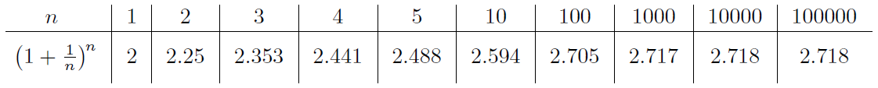

Our number , which is the limit as of the numbers in the second row of the above table, turns out to be an irrational number whose decimal expansion begins like this:

In practice, just knowing that is a little over will be more than enough

We can even write a different way: instead of . The expression “” is **not** pronounced “lin ” or anything like that-just say “” or perhaps “ell en ”, or if you're feeling particularly geeky, “the natural logarithm of ”. In fact, most mathematicians write without a base to mean the same thing as or . The base logarithm is called the *natural logarithm*

Let's take another look at the log rules and formulas we've seen so far, for and :

(Actually, in the second formula, can even be negative or , and in the last formula, can be negative or .)

One more point before we move on to differentiating logs and exponentials. Suppose you take the important limit

and this time substitute . What we’ve found:

and

When , we get two formulas for :

and

These are important!

1. Differentiation of Logs and Exponentials

One of the reasons why the logarithm base is called the natural logarithm is that the derivative of is just

Writing as , we get the important formula

Since , we have proved the nice formula

* Examples of differentiating exponentials and logs

As long as you know the basic formulas for differentiating exponentials and logs (they are the boxed equations in the previous section), then you'll be all set

1. How to Solve Limit Problems Involving Exponentials or Logs

* Limits involving the definition of

To find or construct our classic limit

* Behavior of exponentials near

In fact, since , we know that

This sort of approach works well if your exponential term appears in a product or a quotient, but it fails miserably with something like this:

when the dummy variable is by itself on the bottom, your limit might be a derivative in disguise:

we get the useful fact by replacing by that

* Behavior of logarithms near 1

Now let's look at how logs behave near 1. It turns out that the situation is pretty similar to the case of exponentials near 0. We know that but what is

This is another example of a limit which is a derivative in disguise:

Since , this simplifies to

* Behavior of exponentials near or

Now we want to understand what happens to when or . Let's take another look at the graph of :

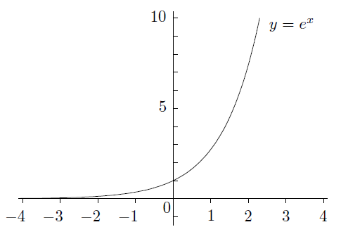

These are special cases of the following important limit:

This is not the whole story. The limit

gets larger and larger, and is larger than

In fact

It is also true if you replace by any power of . Even can’t compete with

So in general we have the following principle:

**Exponentials grow quickly**: no matter how large is

In fact, by tweaking this a little, you can get a more general statement:

For example,

In fact, the base can be replaced by any other base greater than . For example,

* Behavior of logs near

Let's look at what happens to when is a large positive number. (Remember, you can't take the log of any negative number, so there's no point in studying the behavior of logs near ) Here's the graph of once again:

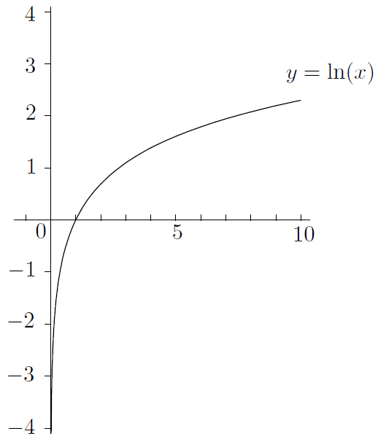

Again, it's important to note that the curve never touches the *y*-axis, even though it looks as if it does. In any event, it seems as if

Actually, goes to infinity much more slowly than any positive power of , even something like . In symbols, we have

**Logs grow slowly**: no matter how small is

Just as in the case of exponentials, it's not too hard to extend this to a more general form:

Actually, we shouldn't be surprised that logs grow slowly, once we know that exponentials grow quickly. After all, logs and exponentials are inverses of each other

* Behavior of logs near 0

The graph of above suggests that

You need to use the right-hand limit here, since isn't even defined for

Consider the limit

Here's one way to solve the above problem. Replace by

**Logs “grow" slowly at 0**: no matter how small is

1. Logarithmic Differentiation

Logarithmic differentiation is a useful technique for dealing with derivatives of things like , where both the base and the exponent are functions of . After all, how on earth would you find

with what we have seen already? It doesn't fit any of the rules. Still, we have these nice log rules which cut exponents down to size. If we let , then

by log rule. Now let's differentiate both sides (implicitly) with respect to :

Set , by the chain rule and product rule,

Now we can get this:

That's the answer we're looking for. (By the way, there is another way we could have done this problem. Instead of using the variable , we could just have used our formula to write

This is also work. When you've finished, you should replace by and check that you get the same answer as the original one above

Let's review the main technique. Suppose you want to find the derivative with respect to of

where both the base and the exponent involve the variable . Here's what you do:

1. Let be the function of you want to differentiate. Take (natural) logs of both sides. The exponent comes down on the right-hand side, so you should get
2. Differentiate both sides implicitly with respect to . The right-hand side often requires the product rule and the chain rule (at least). The left-hand side always works out to be . So you get
3. Multiply both sides by to isolate , then replace by the original expression , and you're done

Even if the base and exponent are not both functions of , logarithmic differentiation can still come in handy. If your function is really nasty and involves lots of products and quotients of powers (like ) and exponentials (like ), you might want to try logarithmic differentiation. For example,

By logarithmic differentiation, that's how. Just take natural logs of both sides, and you'll find that the right-hand side becomes much more manageable

* The derivative of

Now we can finally show something that we've been taking for granted:

for **any** number , not just integers as we've seen before, when

When , we have a bit of a problem. In fact, without using complex numbers, you can only make sense of for when is a rational number with an odd denominator. For

example, makes sense for negative since you can always take a cube root-we're **OK** because is odd. It's not really any different from what we've done before-just that we can handle non-integer exponents now

1. Exponential Growth and Decay

We've seen that bank accounts with continuous compounding grow exponentially. It occurs in nature too. For example, under certain circumstances, populations of animals, like rabbits (and humans!), grow exponentially. There's also exponential decay, where a quantity gets smaller and smaller in an exponential fashion. This occurs in radioactive decay, allowing scientists to find out how old some ancient artifacts, fossils, or rocks are.

Here's the basic idea. Suppose . Then, . The right-hand side of this equation can be written as , since . That is,

This is an example of a *differential equation*. There are other functions satisfying the above equation. For example, if , then , which is once again equal to . More generally, if , then , which is once again equal to . It turns out that this is the **only** way you can have :

If we change the variable to , so that we are looking at This means that the rate of change of is equal to . Interesting! The rate that the quantity is changing depends on how much of the quantity you have. If you have more of the quantity, then it grows faster (assuming ). This makes sense in the case of population growth: the more rabbits you have, the more they can breed. If you have twice as many rabbits, they also **produce** twice as many rabbits in any given time period. The number , which is called the *growth constant*, controls how fast the rabbits are breeding in the first place. The hornier they are, the higher is!

* Exponential growth

So, suppose we have a population which grows exponentially. In symbols, let (or , if you prefer) be the population at time , and let be the growth constant. The differential equation for is

We’ll write to indicate that it represents the population at time . Altogether, we have found the

Remember, is the initial population and is the growth constant

Approximation symbol:

* Exponential decay

Let's turn things upside-down and look at exponential decay. To set the scene, let me tell you that there are certain atoms which are radioactive. They are like little time bombs: after awhile they break apart into different atoms, emitting energy at the same time. The only problem is that you never know when they are going to break apart (we'll say “decay" instead of “break apart"). All you know is that over a given time, there's a certain chance that the decay will happen

For example, you might have a certain type of atom which has a 50% chance of decaying within any 7-year period. So if you have one of these atoms in a box, close the box, and then open it up in 7 years, there's a 50-50 chance that it will have decayed. Of course, it's pretty difficult to see an individual atom! So let's suppose, a little more realistically, that you have a trillion atoms. (That's still a tiny speck of material, by the way.) You put them in the box and come back 7 years later. What do you expect to find? Well, about half the atoms should have decayed, while the other half remain intact. So you should have about half a trillion of the original atoms. What if you come back in another 7 years? Then half the remaining original atoms will be left, leaving you with a quarter of a trillion of the original atoms. Every 7 years, you lose half of your remaining sample

So let's try to write down an equation to model the situation. If is the number (population?) of atoms at time , then I claim that

for some constant . This says that the rate of change of is a negative multiple of

where is the original number of atoms (at time ). is called the *decay constant*

In the above example, we know that it takes years for any sample of atoms to halve in size. This length of time is called the *half-life* of the atom (or material)

Now let's generalize a little. Suppose you have some other radioactive material with a half-life of years:

1. Hyperbolic Functions

Let's change course and look at the so-called *hyperbolic functions*. These are actually exponential functions in disguise, but they are similar to trig functions in many ways. We won't be using them much but they do come up occasionally, so it's good to be familiar with them

We'll start by defining the hyperbolic cosine and hyperbolic sine functions:

These functions behave somewhat like their ordinary cousins, but not exactly. For example,

and

So we have

For any . Not quite the same as the regular old trig identity-the minus makes all the difference. (Indeed, is the equation of a hyperbola.)

How about calculus properties? In any case, we have

and

Now let's look at the graphs of these functions. First, you should try to convince yourself that is an even function of and that is an odd function of . (Just plug in and see what happens.) Furthermore, and (check this too)

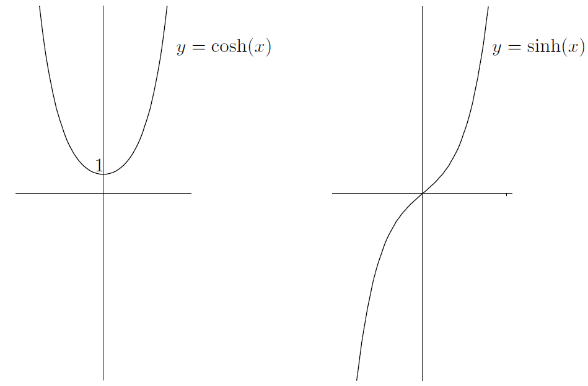

Of course you can define as , as well as the reciprocals

There are also identities connecting the functions, the most important of which is

Now I'm just going to list the derivatives of the other hyperbolic functions and display their graphs

Now the graphs:

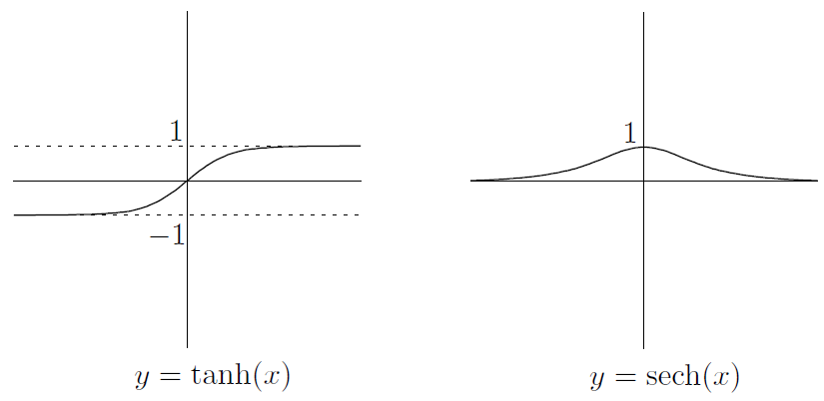

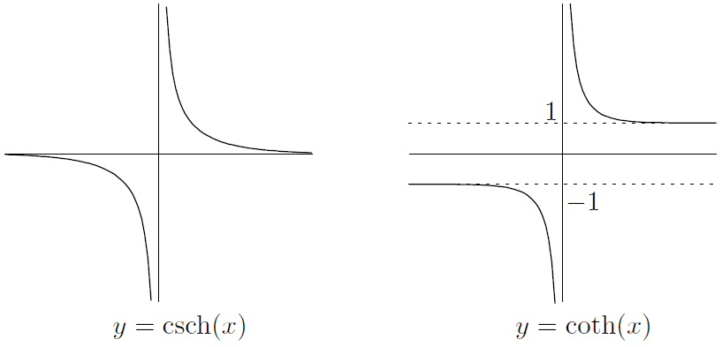

From the definitions of the functions, you can see that all the hyperbolic trig functions are odd functions except for cosh and sech, which are even. This is the same as in the case of regular old trig functions! Also, and both have horizontal asymptotes at and , whereas and have a horizontal asymptote at

**CHAPTER 10 Inverse Functions and Inverse Trig Functions**



1. The Derivative and Inverse Functions

we're going to explore two connections between derivatives and inverse functions

* Using the derivative to show that an inverse exists

Suppose that you have a differentiable function whose derivative is always positive. What do you think the graph of this function looks like? Well, the slope of the tangent has to be positive everywhere, so the function can't dip up and down: it has to go upward as we look from left to right. In other words, the function must be **increasing**

In any case, if our function is always increasing, then it must satisfy the horizontal line test. No horizontal line could possibly hit the graph of twice. Since the horizontal line test is satisfied by , we know that has an inverse. This has given us a nice strategy for showing that a function has an inverse: show that its derivative is always positive on its domain

We've seen that if for all in the domain, then has an inverse. There are some variations. For example, if for all , then the graph is decreasing. The horizontal line test still works, though-the graph is just going down and down, so it can't come back up and hit the same horizontal line twice. Another variation is that the derivative might be for an instant but positive everywhere else. This is **OK** as long as the derivative doesn't stay at for a long time. Here's a summary of the situation:

**Derivatives and inverse functions**: if is differentiable on its domain and any of the following are true:

or

then has an inverse. If instead the domain is of the form , and is continuous on the whole domain, then still has an inverse if any of the above four conditions are true

* Derivatives and inverse functions: what can go wrong

We noticed that the derivative of our function is allowed to be occasionally and the function can still have an inverse. Why can't a little more often? For example, suppose that is defined by

Unfortunately the horizontal line test fails, and there is no inverse! Check out the graph

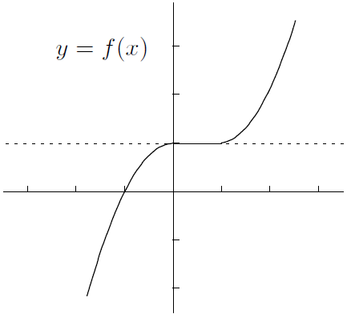

Here's another potential problem. The four conditions on the previous page all require that the domain be an interval like . What if the domain isn't in one piece? Unfortunately, then the conclusion can totally fail to hold. For example, if , then , which can't be negative; however, you can see from the graph that fails the horizontal line

test pretty miserably. So the methods of the previous section won't work, in general, when your function has discontinuities or vertical asymptotes

* Finding the derivative of an inverse function

If you know that a function has an inverse, which we'll call as usual, then what's the derivative of that inverse? Here's how you find it. Start off with the equation . You can rewrite this as . Now differentiate implicitly with respect to to get

The right-hand side is easy: it's just . To find the left-hand side, we use implicit differentiation. If we set , then by the chain rule, we have

Now divide both sides by to get the following principle:

If you want to express everything in terms of , then you have to replace by to get

In words, this means that the derivative of the inverse is basically the reciprocal of the derivative of the original function

Even though the original function is differentiable everywhere, the inverse isn't differentiable everywhere: If you have any function which has an inverse, and it has slope at the point , the inverse function will have infinite slope at the point , as the following picture illustrates:

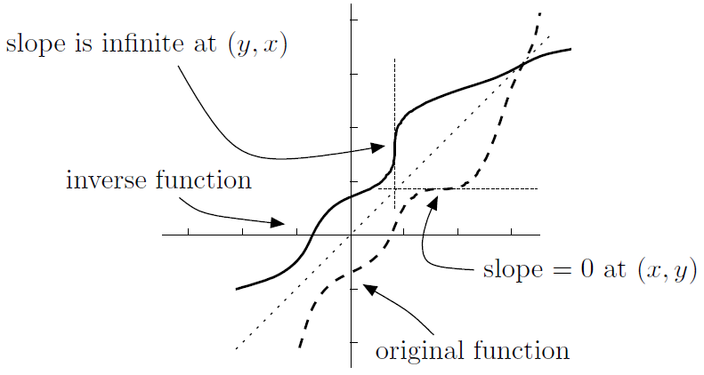

* A big example

1. Inverse Trig Functions

* Inverse sine

Let's start by looking at the graph of once again:

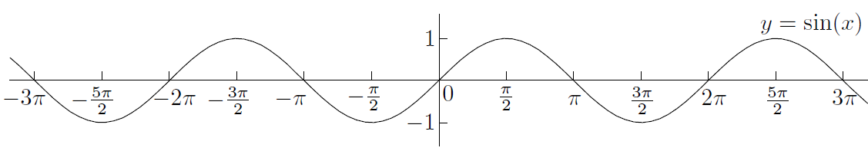

In fact, every horizontal line of height between and intersects the graph **infinitely** many times, which is a lot more than the zero or one time we can tolerate. So, we throw away as little of the domain as possible in order to pass the horizontal line test. There are many options, but the sensible one is to restrict the domain to the interval . Here's the effect of this:

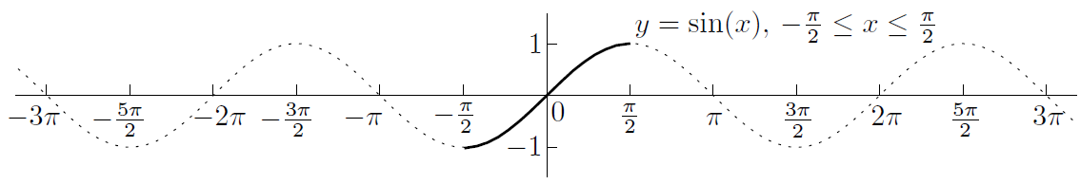

OK, if with domain , then it satisfies the horizontal line test, so it has an inverse . We’ll write as or . (Beware: the first of these notations is a little confusing at first, since does **not** mean the same thing as , even though and . )

So, what is the domain of the inverse sine function? Well, since the range of is , the domain of the inverse function is . And since the domain of our function is , the range of the inverse is

How about the graph of ?

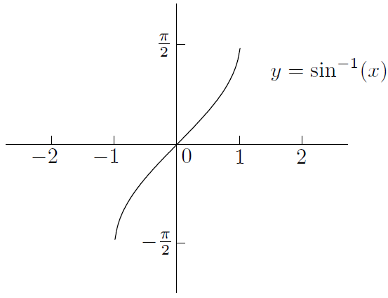

Note that since is an odd function of , so is

Now let's differentiate the inverse sine function

Now, we really want the derivative in terms of , not . No problem-we know that , it shouldn't be too hard to find . In fact, , which means that . This leads to the equation , so we have

But which is it? Plus or minus? If you look at the graph of above, you can see that the slope is always positive:

Note that is not differentiable, even in the one-sided sense, at the endpoints and , since the denominator is in both these cases

Here's a summary of the important facts about the inverse sine function:

* Inverse cosine

Start with the graph of :

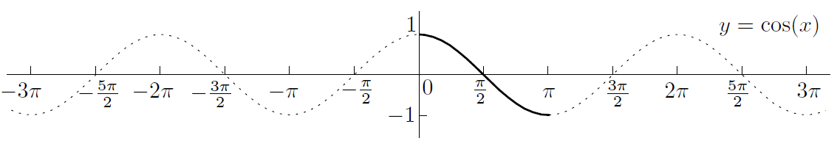

This time, restricting the domain to won't work, since the horizontal line test would fail and also we'd be throwing away part of the range that would be useful. You can see that the section between is highlighted and obeys the horizontal line test. We get an inverse function which we write as or arccos. Like inverse sine, the domain of inverse cosine is , since that's the range of cosine. On the other hand, the range of inverse cosine is , since that's the restricted domain of cosine that we're using. The graph of :

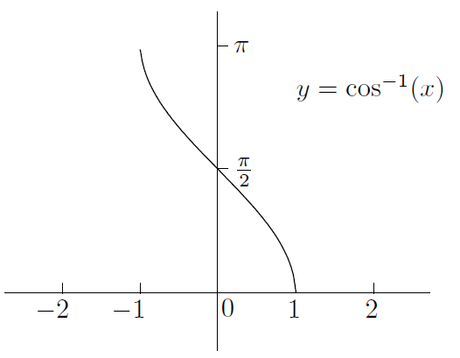

Notice that the graph shows that is neither even nor odd

Unlike the case of inverse sine, the graph of inverse cosine is all downhill, which means that the slope is always negative, so we get

Here are the other facts about inverse cosine that we collected above:

Let's just look at the derivatives of inverse sine and inverse cosine side by side:

The derivatives are negatives of each other! Let's try to see why this makes sense

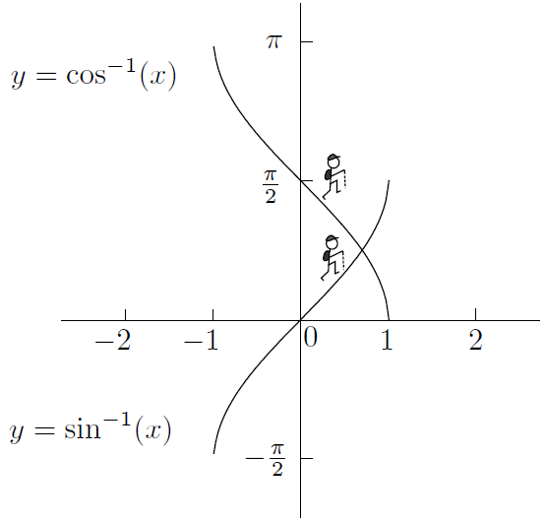

Indeed, we now know that

So has constant slope , which means that it's at as a pancake. We've just used calculus to prove the following identity:

for any in the interval . Look at the following diagram:

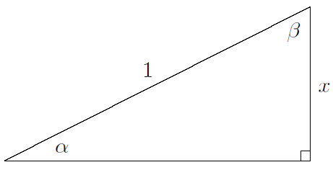

Since , we have . Similarly, which means that . But , which means that

once again. Kind of nice how the calculus agrees with the geometry, huh?

* Inverse tangent

Let's remember the graph of :

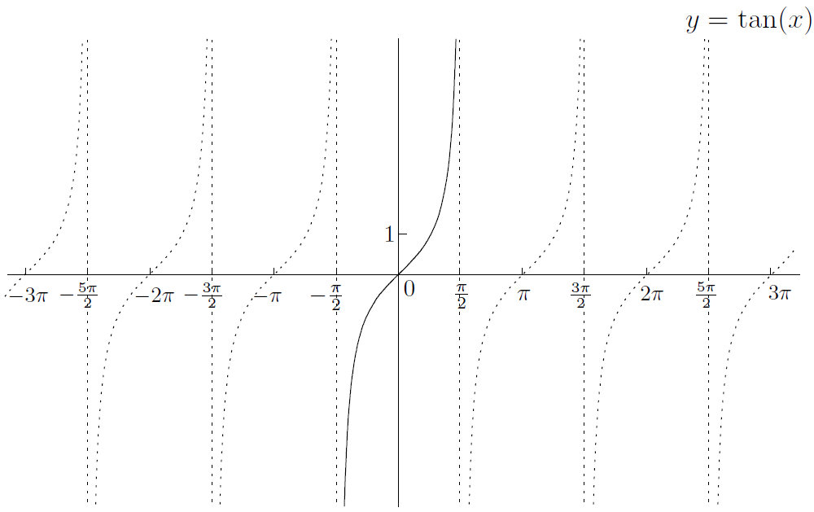

We'll restrict the domain to so that we can get an inverse function , also written as arctan. The domain of this function is the range of the tangent function, which is all of . The range of the inverse function is . The graph of looks like this:

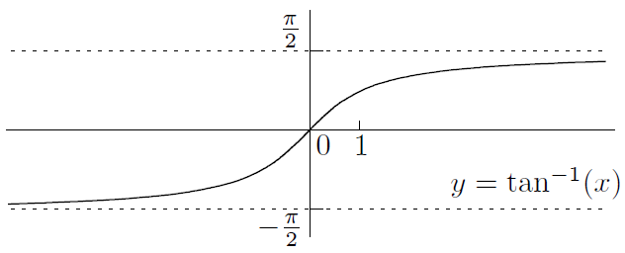

Now is an odd function of , as you can see from the graph-it inherits its oddness from that of

Now let's differentiate with respect to . Write and differentiate implicitly with respect to . Since , and , we see that . This means that

We also have the following facts from above:

is odd; it has domainand range

Unlike inverse sine and inverse cosine, the inverse tangent function has horizontal asymptotes. This means that we have the following useful limits:

and

* Inverse secant

Here's the graph of :

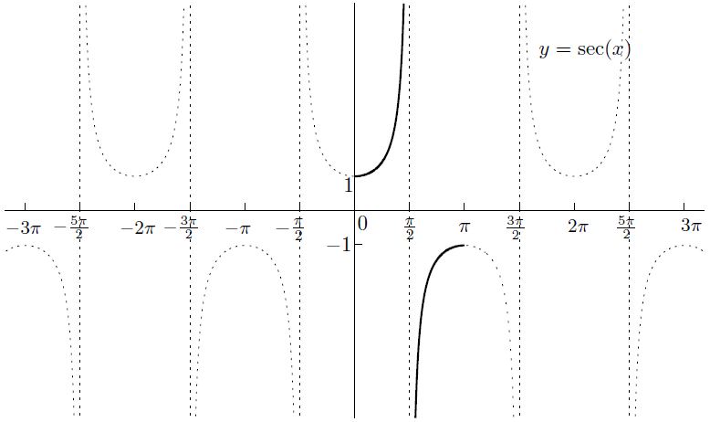

The situation is (unsurprisingly) very similar to the one we faced when we inverted the cosine function. The domain has to be restricted to , except for the point , which isn't even in the original domain of . The range of secant is the union of the two intervals and , so this becomes the domain of the inverse function (alternatively arcsec). As for the range of , it's the same as the restricted domain: minus the point . The graph looks like this:

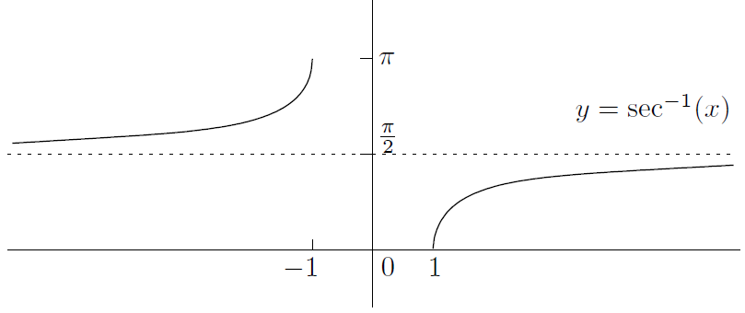

Note that there's a two-sided horizontal asymptote at , so

and

Let's find the derivative. If then . So since , we can rearrange and take square roots to show that . This means that

Is it plus or minus? Looking at the graph above, in fact we need to be a little more clever-instead of the plus or minus, we can simply put instead of and we always get something positive. That is,

We can summarize the other facts about inverse secant like this:

is neither odd nor even; it has domain and range

* Inverse cosecant and inverse cotangent

You can repeat the above analyses to find the domain, range, and graphs of and :

is odd; it has domainand range

is neither odd nor even; it has domain and range

This is what the graphs look like:

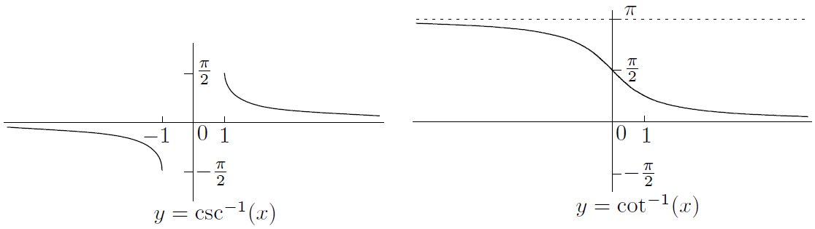

Both functions have horizontal asymptotes:

and

and

Notice that the graphs of and from above are very similar; in fact, you can get one from the other by flipping about the line . This is exactly the same relation as the one that and have with each other:

* Computing inverse trig functions

We've completed a pretty thorough survey of the inverse trig functions. Since you have a few more derivative rules, it's a great idea to practice differentiating functions involving inverse trig functions. For one thing, you should try to make sure that you can compute quantities like without stretching your brain:

Now, here's some more interesting questions:

Just remember that tan is positive in the third quadrant!

Luckily, it's not: the answer is just . In general, , provided that is in the domain of inverse sine. The trouble comes when you try to write . This just isn't true

The trick in both cases is to use the trig identity

In fact, we've noticed that must always be nonnegative, even if is negative. This is because is in the interval , and sine is nonnegative on that interval

1. Inverse Hyperbolic Functions

The situation is a little different for hyperbolic functions. If you want an inverse for , you have to throw away the left half of the graph, just as you do when you take the positive square root (and throw away the negative one). On the other hand, already satisfies the horizontal line test. So we get two inverse functions with the following properties:

is neither odd nor even; it has domain and range

is odd; its domain and range are all of

The graphs are obtained by reflecting the original graphs in the line as usual:

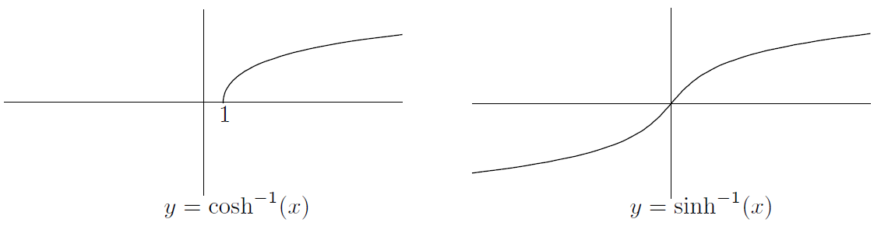

The derivatives are obtained in the same way that we got the derivatives of the inverse trig functions

Now, let's forget about the calculus for a few seconds and recall the definitions of and :

Since we can write and in terms of exponentials, we should be able to write the inverse functions in terms of logarithms. After all, exponentials and logarithms are inverses of each other

when

for all

* The rest of the inverse hyperbolic functions

So far, we've only looked at hyperbolic sine and cosine. If you repeat the analysis for the other four hyperbolic functions, you should be able to conclude that:

is odd; its domain is ; its range is all of

is neither even nor odd; its domain is ; its range is

is odd; its domain and range are both

is odd; its domain is ; its range is

Note that we've restricted the domain of sech to in order to get an inverse, just as we did for cosh

Now, here are the graphs:

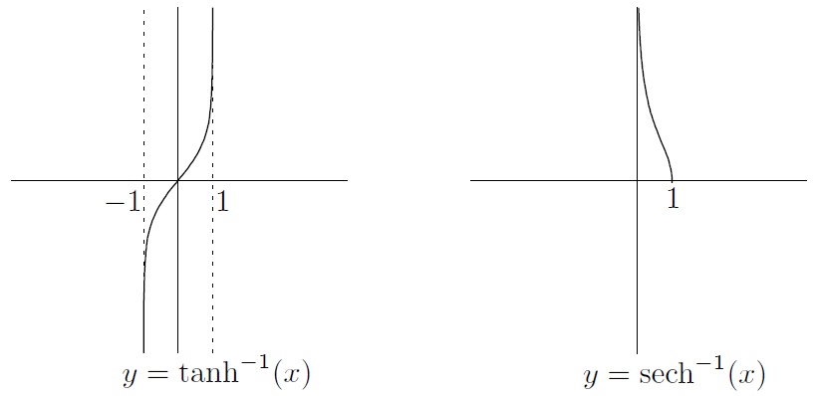

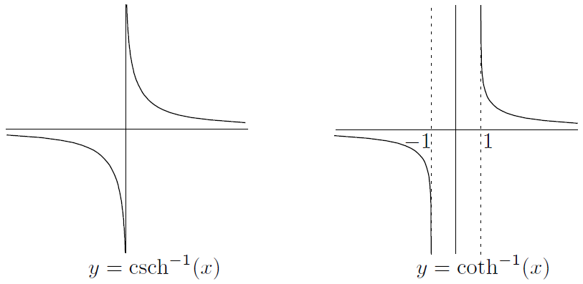

Finally, you can find the derivatives using the standard trick of solving for and differentiating implicitly with respect to . Here's what the derivatives turn out to be:

**CHAPTER 11 The Derivative and Graphs**



1. Extrema of Functions

If we say that is an *extremum* of a function , this means that has a maximum or minimum at . (The plural of “extremum” is “extrema,” of course.) In any event, we need to go a little deeper and distinguish between two types of extrema: global and local

* Global and local extrema

The basic idea of a maximum is that it occurs when the function value is highest. Think about where the maximum of the following function on its domain should be:

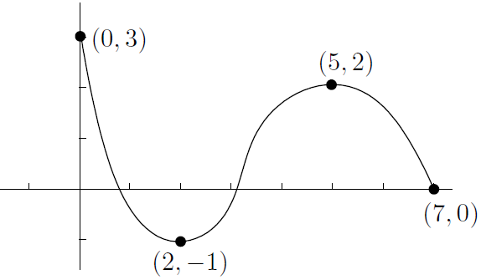

Let's say that a *global maximum* (or *absolute maximum*) occurs at if is the highest value of on the **entire** domain of . In symbols, we want for any value in the domain of . We're simply being more precise and saying “global maxima” instead of just “maxima.”

As we noted before, there could be multiple global maxima; for example, has a maximum value of , but this occurs for infinitely many values of . (These values are all the integer multiples of , as you can see from the graph of .)

How about that other type of maximum? Let's say that a *local maximum* (or *relative maximum*) occurs at if is the highest value of **on some small interval containing**

In fact, it's pretty obvious that **every global maximum is also a local maximum**

In the same way, we can define global and local minima

* The Extreme Value Theorem

In Chapter 5, we looked at the Max-Min Theorem. This says that a **continuous** function on a **closed** interval must have a global maximum somewhere in the interval and also a global minimum somewhere in the interval

The problem with the Max-Min Theorem is that it doesn't tell you anything about where these global maxima and minima are. That's where the derivative comes in. Let's say that is a *critical point* for the function if either or if does not exist. Then we have this nice result:

**Extreme Value Theorem**: suppose that is defined on and is in . If is a local maximum or minimum of , then must be a critical point for . That is, either or does not exist

So local maxima and minima in an open interval occur only at critical points. But it's not true that a critical point must be a local maximum or minimum! For example,

The above theorem applies to open intervals. How about when the domain of your function is a closed interval ? Then the endpoints and might be local maxima and minima; they aren't covered by the theorem. So in the case of a closed interval, local maxima and minima can occur only at critical points or at the endpoints of the interval

* How to find global maxima and minima

The Extreme Value Theorem really makes finding global extrema pretty easy, since it narrows down where they can be. Here's the idea: every global extremum is also a local extremum. Local extrema can only occur at critical points. So just find all the critical points and look at the corresponding function values. The biggest one gives the global maximum, while the smallest gives the global minimum! In gory detail, here's how to find the global maximum and minimum of the function with domain :

1. Find . Make a list of all the points in where does not exist or . That is, make a list of all the critical points in the interval
2. Add the endpoints and to the list
3. For each of the points in the list, find the -coordinates by substituting into the equation
4. Pick the highest -coordinate and note all the values of from the list corresponding to that -coordinate. These are the global maxima
5. Do the same for the lowest -coordinate to find the global minima

Notice: since isn’t even a number, can’t be an extremum

1. Rolle's Theorem

Imagine you're driving down a long straight highway. I watch you stop at a gas station. Then you proceed, always facing the same direction, although you can put the car in reverse if you want. Later on, I see you at the gas station again, without watching what you did in the meantime. I make the following conclusion: at some point when I wasn't looking, your car had velocity equal to zero

This is the content of Rolle's Theorem, which says:

**Rolle’s Theorem**: suppose that is continuous on and differentiable on . If , then there must be at least one number in such that

Now, let's look at some pictures of a few possibilities of functions where Rolle's Theorem applies:

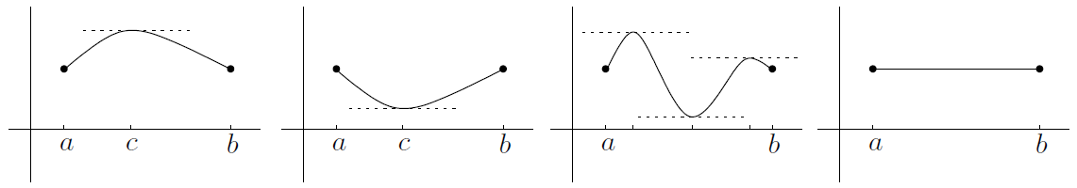

Now, let's look at some pictures where Rolle's Theorem does **not** apply:

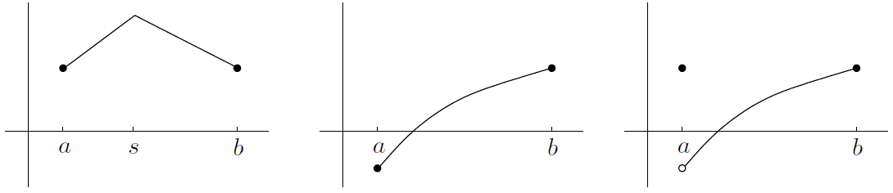

1. The Mean Value Theorem

Suppose you go on another journey, and I find out that you have traveled miles in hours. Your average velocity was miles per hour. This doesn't mean that you were going at exactly miles per hour the whole time. Now, here's my question: were you ever going at miles per hour, even for an instant? The answer is yes. Even if you go at mph for the first hour and mph for the second hour, you still have to accelerate from the slow velocity to the fast velocity. This leads to the Mean Value Theorem, which says:

**The Mean Value Theorem**: suppose that is continuous on and differentiable on . Then there’s at least one number in such that

Let's look at a picture of the situation. Suppose your function looks like this:

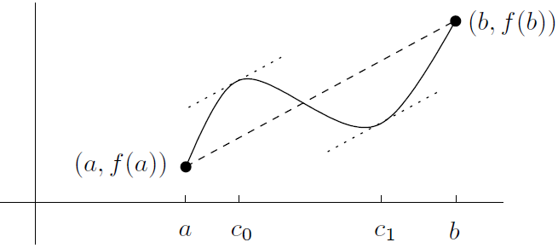

The Mean Value Theorem looks a lot like Rolle's Theorem. In fact, the conditions for applying the two theorems are almost the same. In fact, if you apply the Mean Value Theorem to a function satisfying , you'll see that , so you get a number in satisfying . So the Mean Value Theorem reduces to Rolle's Theorem!

* Consequences of the Mean Value Theorem

We've been taking a few things about the derivative for granted. For example, if a function has derivative equal to everywhere, it must be constant. Facts like this seem obvious but they actually deserve to be proved. Let's use the Mean Value Theorem to show three useful facts about derivatives:

1. Suppose that a function has derivative for **every** x in some interval :

if for all in , then is constant on

1. Suppose that two differentiable functions have exactly the same derivative. Are they the same function? Not necessarily. They could differ by a constant

if for all , then for some constant

This fact will be very useful when we look at integration in a few chapters' time

1. If a function has a derivative that's always positive, then it must be *increasing*. This means that if , then . On the other hand, if for all , the function is always *decreasing*; this means that if then
2. The Second Derivative and Graphs

So far, we haven't paid much attention to the second derivative. We've only used it to define acceleration, and that's about all. Actually, the second derivative can tell you a lot about what

the graph of your function looks like

We'll say a function is *concave up* on an interval if its slope is always increasing on that interval, or equivalently if its second derivative is always positive on the interval (assuming that the second derivative exists):

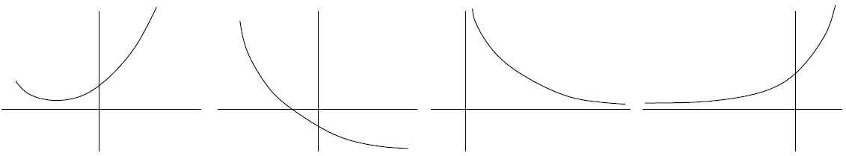

They all look like part of a bowl. Notice that you can't tell anything about the sign of the first derivative just by knowing that

If instead the second derivative is negative, then everything is reversed. Saying that is *concave down* on any interval where its second derivative is always negative:

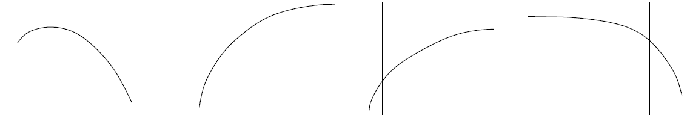

Of course, the concavity doesn't have to be the same everywhere: it can change:

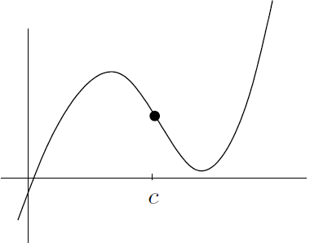

We'll say that the point is a point of inflection for because the concavity changes as you go from left to right through

* More about points of inflection

In the above picture, we see that to the left of and to the right of . What about itself? It must be 0, since everything is nice and smooth

Assuming of course that actually exists when is near , it must be true that

if , is a point of inflection for , then

On the other hand, if , then may or may not be an inflection point! That is,

if , then it's not always true that is a point of inflection for

1. Classifying Points Where the Derivative Vanishes

It's time to apply some of the above theory to a practical problem. Suppose that you have a function and a number such that . You can say for sure that is a critical point for , but what else can you say? It turns out that there are only three common possibilities: could be a local maximum; it could be a local minimum; or it could be a horizontal point of inflection, which means that it is a point of inflection with a horizontal tangent line (Another possibility is that the concavity isn't even well-defined near the critical point. For example, ):

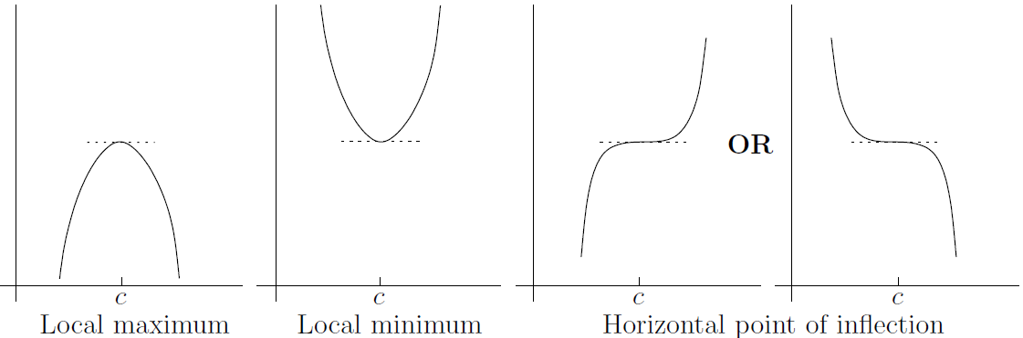

* Using the first derivative

Here's a summary of what we have just observed. Suppose that . Then:

* if changes sign from positive to negative as you pass from left to right through , then is a local maximum;
* if changes sign from negative to positive as you pass from left to right through , then is a local minimum;
* if doesn't change sign as you pass through from left to right, then is a horizontal point of inflection

If we now set , then :

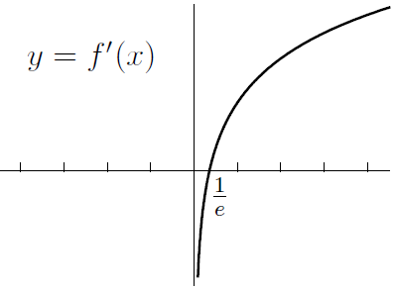

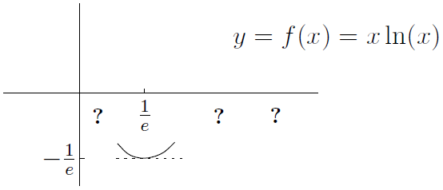

* Using the second derivative

Take another look at the common possibilities which arise when :



Here's the summary of the situation. Suppose that . Then:

* if , then is a local maximum;
* if , then is a local minimum;
* if , then you can't tell what happens! Use the first derivative test from the previous section

Yes, the first derivative test is better, although it's a little more cumbersome to use. It always works, while the second derivative test sometimes lets you down

**CHAPTER 12 Sketching Graphs**



Now it's time to look at a general method for sketching the graph of for some given function . When we sketch a graph, we're not looking for perfection; we just want to illustrate the main features of the graph. Indeed, we're going to use the calculus tools we've developed: limits to understand the asymptotes, the first derivative to understand maxima and minima, and

the second derivative to investigate the concavity

1. How to Construct a Table of Signs

Suppose you want to sketch the graph of . For any number , the quantity could be positive, negative, zero, or undefined. Luckily, if is continuous except for maybe a few points, and you can find all of the zeroes and discontinuities of , then it's easy to see where is positive and where it's negative by using a table of signs

Here's how it works: start off by making a list of all the zeroes and discontinuities of in ascending order. For example, if

The table would look like this (with three rows and plenty of columns):

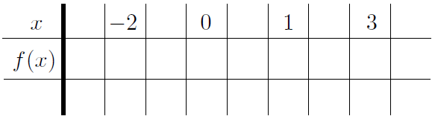

Now you can fill in some of the second row-just put a where is and a star where is discontinuous

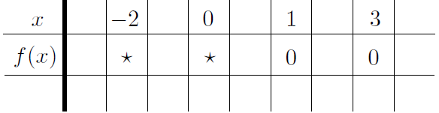

Next, pick your favorite number between each of the special numbers on the top, as well as one at the beginning and one at the end

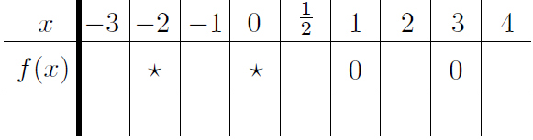

Now, the next thing is to find whether is positive or negative for each of the values we just chose. Since we could care less about the value of : we only care whether it's positive or negative

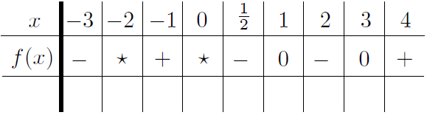

The main point is not that is negative, but that is negative for **all** . The number is just a representative sample point for the region

For now, let's see how to make a table of signs for the derivative and the second derivative

* Making a table of signs for the derivative

A table of signs for the derivative can summarize all this information in a compact, simple way:

whenever the derivative is positive, the function is increasing; when the derivative is negative, the function is decreasing; and when the derivative is , the function has a local maximum, a local minimum, or a horizontal point of inflection

The method is the same as for the table of signs for that we looked at above, except that now you apply it to instead. The only other difference is that when is zero, we'll put a little at line in the third row; when is positive, the line will slope upward; and when is negative, the line will slope downward. Let's see how it works for our previous example where . We calculated that

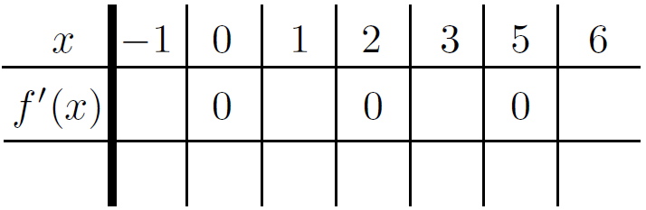

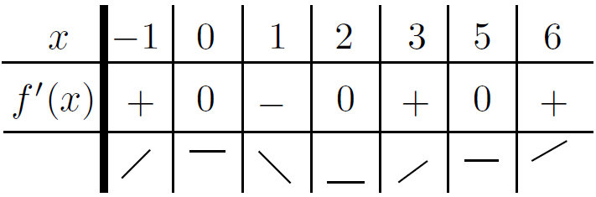

A word of warning: the lines in the third row of the table are meant only to guide you as you sketch the graph of . The graph probably doesn't look like a collection of lines tacked together! Instead, just use the information in that third row to understand where the graph is increasing, decreasing or temporarily flat

* Making a table of signs for the second derivative

The table of signs for the second derivative tells all: when the sign is positive, the curve is concave up; when the sign is negative, the curve is concave down; and when it's , you may or may not get a point of inflection

The method is the same as for the function or the derivative, except that the third row is now used to show whether the function is concave up or concave down. Put a little upward parabola-like curve whenever the sign is , a downward version when the sign is , and a dot when the sign is . If we return to our example from above, we find that we have

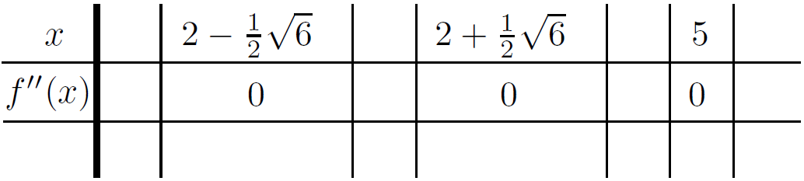

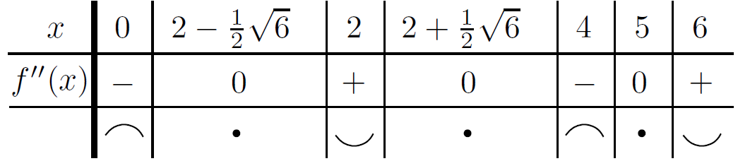

As we noted in the case of the first derivative in the previous section, the pictures in the third row are meant only as a guide to sketching the graph. They show where the original function is concave up and concave down, but they won't necessarily give anything more than a rough idea of what the curve actually looks like. That's why we're going to look at a big method for sketching curves

1. The Big Method

Here is an eleven-step method for sketching the graph of

1. **Symmetry**: check whether the function is even, odd, or neither by replacing by and seeing whether you get back the original function or its negative (you may only need to sketch it for )
2. **-intercept**: find the -intercept (if it exists) by setting
3. **-intercepts**: find the -intercepts by setting and solving for . This is sometimes difficult or impossible!
4. **Domain**: find the domain of . If it's specified in the definition of , there's nothing to do; otherwise, the domain is assumed to be as much of the real line as possible. Remember, you have to avoid numbers which lead to in the denominator, or the square root of a negative number, or the log of a negative number or . If inverse trig functions are involved, the situation is more complicated
5. **Vertical asymptotes**: these generally occur where the denominator is zero (if there is a denominator!). Beware: if the numerator is zero too, then you might have a removable discontinuity instead of a vertical asymptote. Also, you may have a vertical asymptote due to a log factor
6. **Sign of the function**: at this point, draw up a table of signs for . We already know where is zero from above, and we know where it's discontinuous from and . The table tells you exactly where the curve is above or below the -axis
7. **Horizontal asymptotes**: find the horizontal asymptotes by calculating

In any case, draw dashed horizontal lines on your graph to remind you about the horizontal asymptotes, if there are any

1. **Sign of the derivative**: Find the derivative, then find all the critical points-remember, these are points where the derivative is or does not exist. Use the third row of the table to tell where the function is increasing, decreasing, or flat
2. **Maxima and minima**: from the table of signs, you can find all the local maxima or minima-remember, these only occur at critical points. For each maximum or minimum , you also need to find the value of
3. **Sign of the second derivative**: find the second derivative, then find all the points where the second derivative is zero or does not exist. The pictures in the third row of the table indicate where the curve is concave up and where it's concave down
4. **Points of inflection**: use the table of signs for the second derivative to identify the inflection points. Remember, the second derivative at an inflection point has to be zero, and the sign of the second derivative has to be different on either side of the inflection point. For each inflection point , you need to find the -coordinate
5. Examples (Page 252)

Since the original function is odd, its derivative is even and its second derivative is odd

**CHAPTER 13 Optimization and Linearization**



We're now going to look at two practical applications of calculus: optimization and linearization. Basically, optimization involves finding the best situation possible, whether that be the cheapest way to build a bridge without it falling down or something as mundane as finding the fastest driving route to a specific destination. On the other hand, linearization is a useful technique for finding approximate values of hard-to-calculate quantities. It can also be used to find approximate values of zeroes of functions; this is called Newton's method

1. Optimization

To “optimize” something means to make it as good as possible. This being math, we're going for quantity over quality here. The term “optimize” just means “maximize or minimize, as appropriate.”

* An easy optimization example (Page 267)
* Optimization problems: the general method

Here's a way to tackle optimization problems in general:

1. Identify all the variables you might possibly need. One of them should be the quantity you want to maximize or minimize-make sure you know which one! Let's call it for now, although of course it might be another letter like , , or
2. Get a feel for the extremes of the situation, seeing how far you can push your variables
3. Write down equations relating the variables. One of them should be an equation for
4. Try to make a function of only one variable, using all your equations to eliminate the other variables
5. Differentiate with respect to that variable, then find the critical points; remember, these occur where the derivative is or the derivative doesn't exist
6. Find the values of at all the critical points and at the endpoints. Pick out the maximum and minimum values. As a verification, use a table of signs or the sign of the second derivative to classify the critical points
7. Write out a summary of what you've found, identifying the variables in words rather than symbols (wherever possible)

Actually, sometimes step 4 can be quite difficult, but you might be able to avoid it altogether by using implicit differentiation

* An optimization example

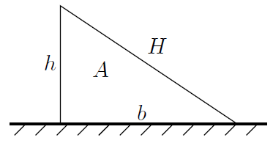

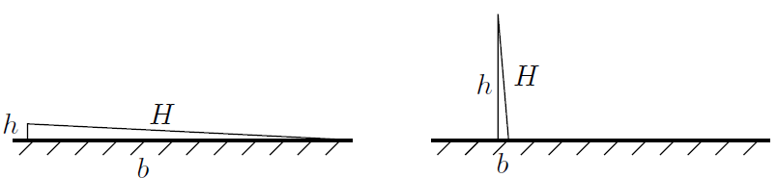

* Another optimization example

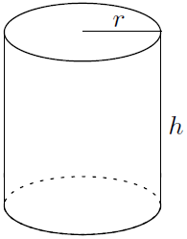

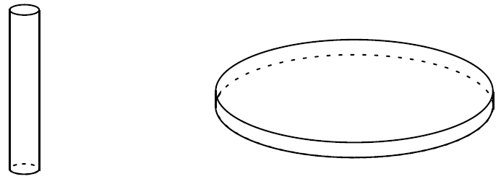

* Using implicit differentiation in optimization (Page 274)
* A difficult optimization example

1. Linearization

Now we're going to use the derivative to estimate certain quantities. For example, suppose you want to get a decent estimate of without using a calculator. We know that is a little bigger than , so you could certainly say that is approximately 3-and-a-bit. That's OK, but you can actually do a better job without too much work. Here's how it's done

Start off by setting for any . Inspired by our knowledge of when , let's sketch the graph of , and draw in the tangent line through the point , like this:

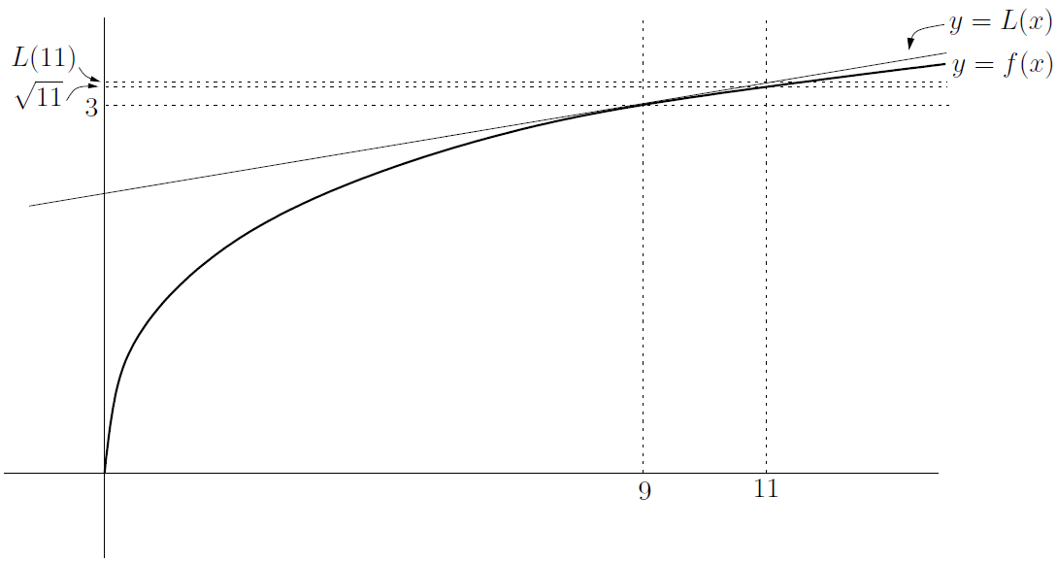

The linear function is . This means that the value of is a good approximation to . We get

We conclude that

That's a lot better than 3-and-a-bit! In fact, you can use a calculator to see that is (to three decimal places), so the approximation is pretty good

* Linearization in general

Let's generalize the above example. If you want to estimate some quantity, try to write it as for some nice function . Next, we pick some number , close to (what we’re interested in), such that is really nice. So, given our function and our special number , we find the tangent to the curve at the point . If the tangent line is , we get

The linear function is called the *linearization* of at . Remember, we're going to use as an approximation to . So we have

The benefit is that we now have an approximation for for **near**

* The differential

Let's take a look at the general situation once more. We saw that

Let's define to be , so that . The above formula becomes

Here's a graph of the situation:

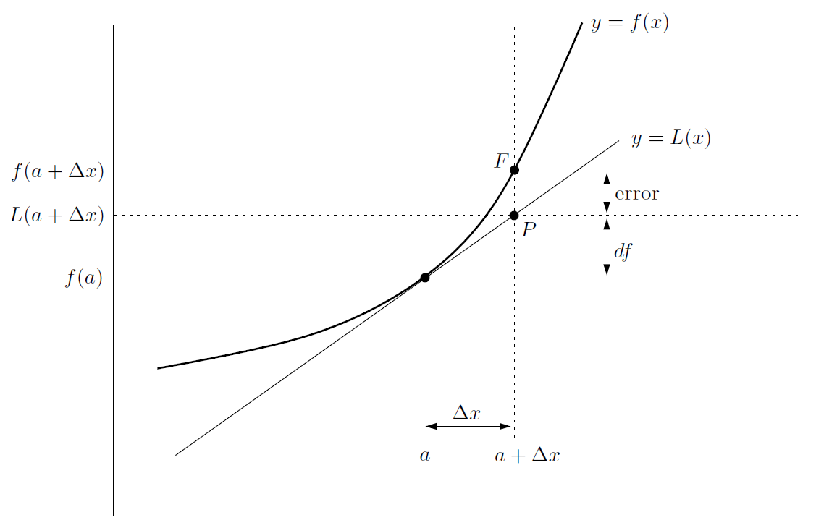

We want to estimate the value of . That's the height of the point in the above picture. As an approximate value, we're actually using , which is the height of in the picture. The difference between the two quantities is labeled “error”

In the above graph, there's one more quantity marked: this is , which is the difference between the height of and . It is the amount we needed to add to in order to get our estimate. Since , we see that

The quantity is called the *differential* of at . It is an approximation to the amount that changes when moves from to

We've actually touched on these ideas before: if , then

Here's an important example at page 282: a truth that when you compound the error in a one-dimensional measurement in the calculation of a three-dimensional quantity

* Linearization summary and examples

Here's the basic strategy for estimating, or approximating, a nasty number:

1. Write down the main formula
2. Choose a function , and a number such that the nasty number is equal to . Also, choose close to such that can easily be computed
3. Differentiate to find
4. In the above formula, replace and by the actual functions, and a by the actual number you've chosen
5. Finally, plug in the value of from step 2 above. Also note that the differential is the quantity

More generally an example, how would you find an approximation for , where is **any** small number? That is,

when is small. Actually, this shouldn't be a surprise! Since

* The error in our approximation

We've been using as an approximation for . They are not the same thing, though. How wrong could we be to use instead of ? The way to find out is to consider the difference between the two quantities:

where r(x) is the error in using the linearization at in order to estimate . It turns out that if the second derivative of exists, at least between and , then there's a nice formula (Page 285) for :

The problem is, we don't know what is, only that it's between and . The above formula is related to the Mean Value Theorem

In summary,

* if is **positive** between and , then using the linearization leads to an **underestimate**
* if is **negative** between and , then using the linearization leads to an **overestimate**

Now look back at the equation for the error above. If we take absolute values of both sides of the equation, then we get

Suppose we know that the biggest could be, as ranges between and , is some number . Then even though we don't know what is, we do know that , so we get the following formula:

1. Newton's Method

Here's another useful application of linearization. Suppose that you have an equation of the form that you'd like to solve, but you just can't solve the darned thing. So you do the next best thing: you take a guess at a solution, which you call . The situation might look something like this:

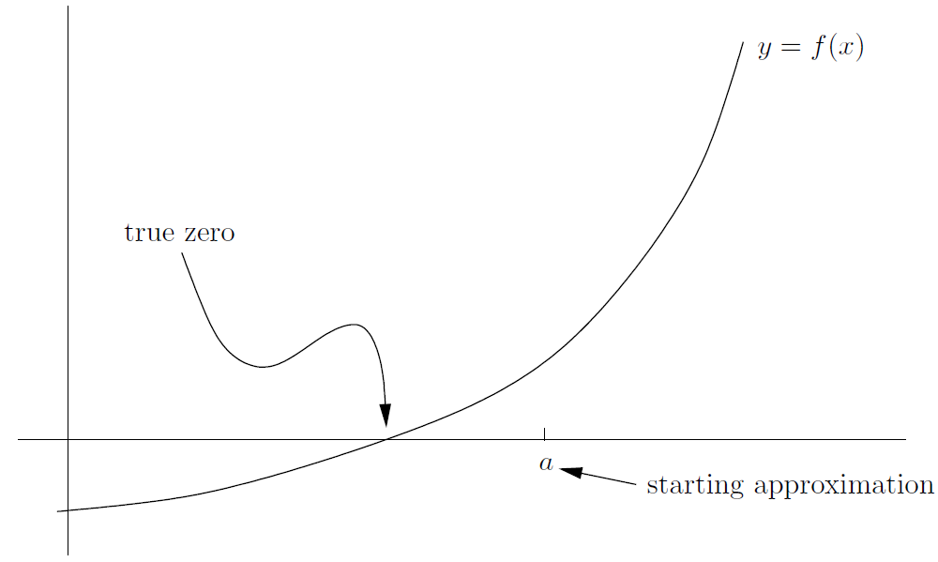

Think of as a first stab at an approximation, which is why it's labeled “starting approximation” in the picture above. Now, the idea of Newton's method is that you can (hopefully) improve upon your estimate by using the linearization of about . (This means that needs to be differentiable at , of course!)

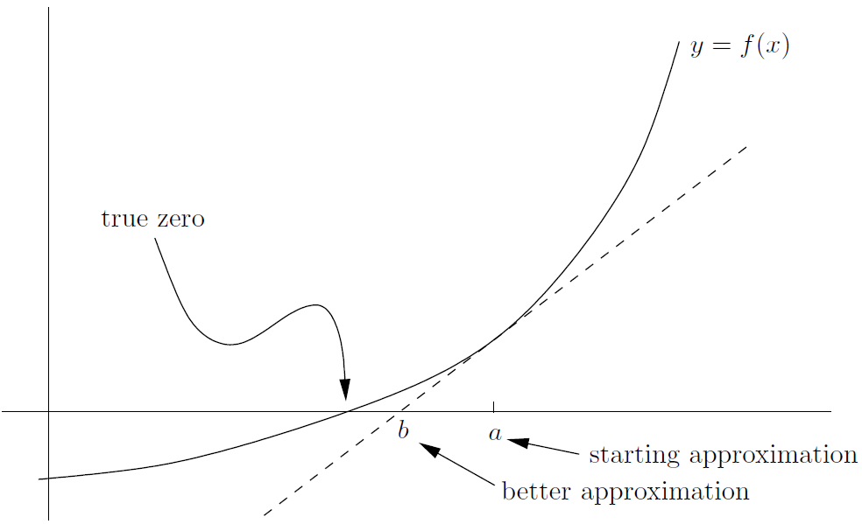

The -intercept of the linearization is labeled , and it's clearly a better approximation to the true zero than is. So what is the value of ? Well, it's just the -intercept of the linearization , which is given by

To find the -intercept, set ; then we get

So we have found the following formula:

**Newton’s method**: suppose that is an approximation

to a solution of . If you set

then a lot of the time is a better approximation than

It doesn't work all the time, so I put in the phrase “a lot of the time” to cover my ass

It might seem confusing to reuse and like this. A way around it is to use as the initial guess and as the first improvement; then is the second improvement, starting with ; and so on. The formula can now be written like this:

Sometimes Newton's method doesn't work. Here are four different things that could go wrong:

1. **The** value **of could be near** . Clearly, if

then can't be or else isn't even defined. Even if is close, but not equal to , Newton's method can still give a whacked-out result; for example, check out this picture:

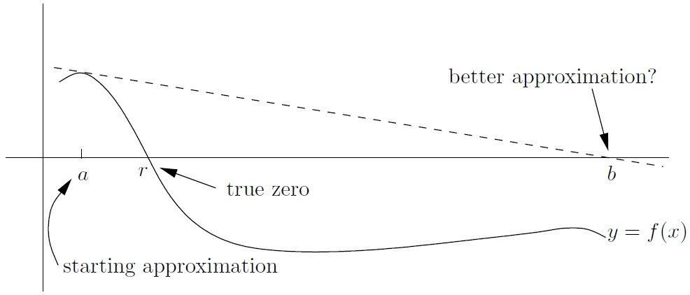

To get around this, make sure that your initial approximation is not near a critical point of your function

1. **If has more than one solution, you might not get the right one**. For example, in the following picture, if you are trying to estimate the left-hand root , and you guess to start at , you'll end up estimating instead:

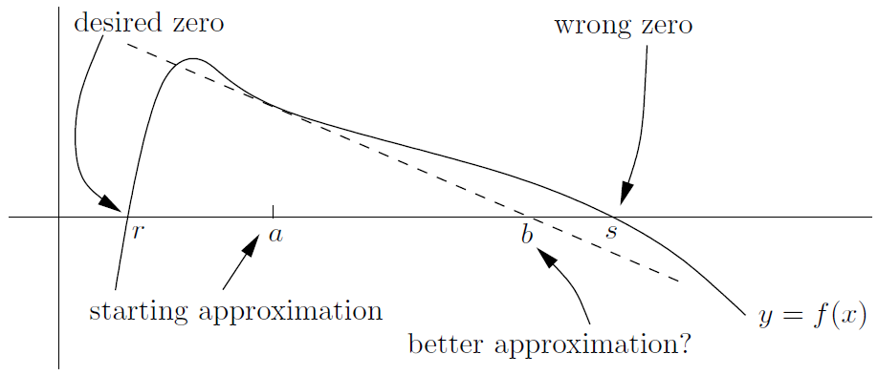

So you should make some effort to start with an estimate which is close to the zero you want, unless you're sure there's only one zero!

1. **The** **approximations might get worse and worse**. For example, if , the only solution to the equation is . If you try to use Newton's method (for reasons best known to yourself, I guess!), then something weird happens. You see, unless you start with , this is what you find:

So the next approximation is always times the one you started with. These would be just getting farther and farther away from the correct value . There's not much you can do with Newton's method if this sort of thing happens

1. **You might get stuck in a loop**. It's possible that your estimate leads to another estimate , which then leads back to again. Here's how the situation might look:

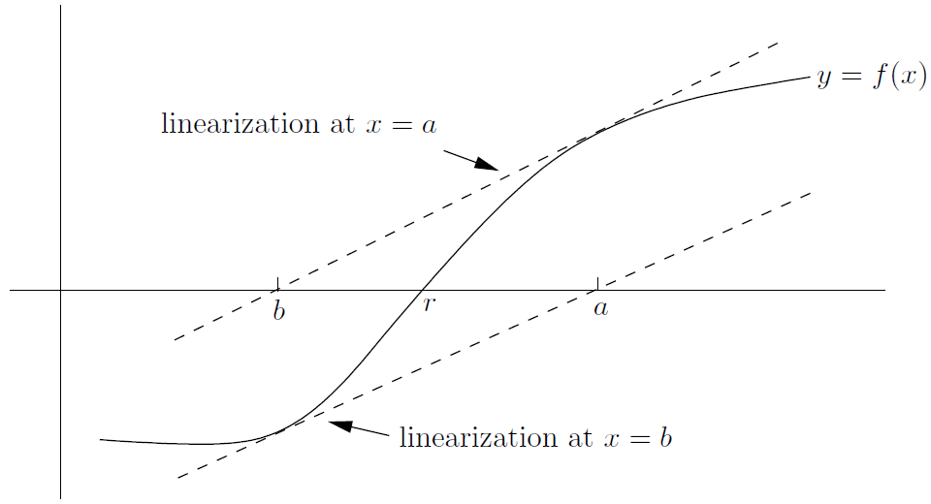

The linearization at has -intercept , and the linearization at has -intercept , so Newton's method just doesn't work. A concrete (but messy) example is

(By the way, the study of these sorts of loops leads to a nice type of fractal that you might have seen as a screensaver on someone's computer. . . .)

**CHAPTER 14 L'Hôbpital's Rule and Overview of Limits**



We've used limits to find derivatives. Now we'll turn things upside-down and use derivatives to find limits, by way of a nice technique called l'Hôpital's Rule

1. L'Hôbpital's Rule

Most of the limits we've looked at are naturally in one of the following forms:

Sometimes you can just substitute and evaluate the limit directly, effectively using the continuity of and . This method doesn't always work, though-for example, consider the limits

Luckily, all four types can often be solved using l'Hôpital's Rule

It turns out that the first type, involving the ratio , is the most suitable for applying the rule, so we'll call it “Type **A**.” The next two types, involving and , both reduce directly to Type A, so we'll call them Type **B1** and Type **B2**, respectively. Finally, we'll say that limits involving exponentials like are Type **C**, since you can solve them by reducing them to Type **B2** and then back to Type **A**

* Type **A**: case

Consider limits of the form

where and are nice differentiable functions. If , everything's great. If but , then you're dealing with a vertical asymptote at .

The only other possibility is that and . That is, the fraction is the indeterminate form

One version of l'Hôpital's Rule:

**provided that the limit on the right-hand side exists.** (Actually, there's another condition as well: can't be when is close to, but not equal to, . You have to be really unlucky for this to be a problem, though!)

For example,

Notice how there's a little “l’H” above the equal sign to show that we're using l'Hôpital's Rule



* Type **A**: case

L'Hôpital's Rule also works in the case where and . That is, when you try to put , the top and bottom both look infinite, so you are dealing with the indeterminate form . For example

Now, a gentle reminder: please, please, please check that you have an indeterminate form! The only acceptable forms for a quotient are or

* Type **B1**

Here's a limit from the beginning of this chapter:

As , both and go to . As , both quantities go to .Either way, you're looking at the difference of two huge (positive or negative) quantities, so we can express the indeterminate form as

Luckily, it's pretty easy to reduce this to Type A. Just take a common denominator:

Now we are in the case

Taking a common denominator doesn't always work. Sometimes you might not even have a denominator at all, so you have to create one out of thin air. For example, to find

There's no denominator, so let's make one by multiplying and dividing by the conjugate expression:

Now we are in the case of Type **A**

Unfortunately, it's not always possible to use l'Hôpital's Rule on type **B1** limits. In fact, the only time it can actually work is when you're able to manipulate the original expression to be a ratio of two quantities, as in the above examples

* Type **B2**

Here's a limit we've looked at before:

Let's turn the limit into Type **A** by manufacturing a denominator. The idea is to move into a new denominator by putting it there as

Now the form is , so we can use l'Hôpital's Rule

* Type **C**

Finally, the trickiest type involves limits like

where both the base and exponent involve the dummy variable ( in this case). If you just put , you get , which is another indeterminate form. To find the limit, we'll use a technique very similar to logarithmic differentiation. The idea is to take the logarithm of the quantity first, and work out its limit as :

As , we have and , so now we're dealing with a Type **B2** problem. We can put the into a new denominator as , which is just , then use l'Hôpital's Rule on the resulting Type **A** problem:

Are we done? Not quite. We now know that

so now we just have to exponentiate both sides to see that

In fact, sometimes you don't even have to go through the Type **B2** step on your way to Type **A**. For example, to do

from the beginning of the chapter, first note that we are dealing with the form . So take logarithms:

This is now of the form , so it's already a Type **A** limit

There is one more indeterminate form of this type, . An example is

The same trick still works: take logarithms and use the Type **A** methodology

It's not really necessary to learn that the only indeterminate forms involving exponentials are . You see, if you have any limit involving exponentials, you can always use the above logarithmic method to convert everything to a product or quotient, then work out the new limit . The actual limit will just be . The only exceptions are that if , then you have to interpret as ; and if , then you need to recognize as

* Summary of l'Hôpital's Rule types

Here are all the techniques we've looked at:

* Type **A**: if the limit involves a fraction, like

**check that the form is indeterminate**. It must be or . Use the rule

Do not use the quotient rule here! Now, solve the new limit, perhaps even using l'Hôpital's Rule again

* Type **B1**: if the limit involves a difference, like

where the form is , try taking a common denominator or multiplying by a conjugate expression to reduce to a Type **A** form

* Type **B2**: if the limit involves a product, like

where the form is , pick the simplest of the two factors and put it on the bottom as its reciprocal. (Avoid picking a log term-keep that on the top.) You get something like

This is now a Type **A** form

* Type **C**: if the limit involves an exponential where both base and exponent involve the dummy variable, like

then first work out the limit of the logarithm:

This should be either Type **B2** or Type **A** (or else it's not indeterminate and you can just substitute). Once you've solved it, you can rewrite the equation as something like

then exponentiate both sides to get

1. Overview of Limits

It's time to consolidate. Here's a brief summary of all the techniques we've seen so far involving evaluating limits. The following techniques apply to limits of the form

where is a function which is at least continuous for near , but maybe not at itself. Also, a could be or . So, here's the summary:

* **Try substituting first**. You might be able to evaluate the limit
* If your substitution leads to or , where is some finite number, then the limit is
* If the substitution gives , where , then you're dealing with a **vertical** **asymptote**. The left-hand and right-hand limits must be or , and the two-sided limit either doesn't exist or is one of and
* If none of the above points are relevant, and your limit is of the form , try seeing if it is a **derivative in disguise**. If you can rewrite it in the form

for some particular function and possibly a specific number , then the limit is just

* If **square roots** are involved, multiplication by a conjugate expression might help
* If **absolute values** are involved, convert them into piecewise-defined functions using the formula
* Otherwise, **you** can use the properties of various functions which can pop up as ingredients in your main function. Remember that “small” means “near 0,” and “large” can mean large positive or negative numbers. Here's the deal for polynomials, trig functions, exponentials, and logs:

1. **Polynomials and poly-type functions:**

- **General tip:** try factoring, then cancel common factors

- **Large arguments:** the **largest-degree term dominates**, so divide and multiply by that term

1. **Trig and** **inverse** **trig functions:**

- **General tip:** know the graphs of all the trig and inverse trig functions, and their values at some common arguments

- **Small arguments:** behaves like when is small, so divide and multiply by . The same goes for , but **not** : that just behaves like 1. This technique is useful when only products and quotients are involved. It probably won't work when the trig function is added to or subtracted from some other quantity

- **Large arguments:** for sine or cosine, use the facts that

in conjunction with the sandwich principle. Some other useful facts are

1. **Exponentials:**

- **General tip:** know the graph of , and learn the limits

- **Small arguments:** since , you can normally just isolate any factors which involve the exponential of a small number and replace them by when you take the limit. The exception is when sums or differences occur; then you might want to use l'Hôpital's Rule, or perhaps the limit is actually a derivative in disguise

- **Large arguments:** learn the important limits

Also remember that **exponentials** **grow** **quickly** as . This means that

The base could instead be any number bigger than , and the exponent could instead be some other polynomial with positive leading coefficient

1. **Logarithms:**

- **General tip:** know the graph of and the log rules

- **Small arguments:** a really important limit is

Also, logs “grow” slowly down to as :

for any , no matter how small

- **Large arguments:** we have

which has the informal abbreviation . Nevertheless **logs** **grow** **slowly**, that is, more slowly than any polynomial:

for any polynomial of positive degree

- **Behavior near 1:** we have . L'Hôpital's Rule can be very useful in this regard, or the limit might be a derivative in disguise

* If none of the above techniques work, consider using l'Hôpital's Rule. If you do, you'll always get a new limit to solve, which you can attack using any of the above principles or l'Hôpital's Rule once again

All these facts and methods above are just tools to help you solve limits. They may not work on every limit you see. There's an art to knowing which tool to use, and of course, practice makes perfect

**CHAPTER 15 Introduction to Integration**



So far as calculus is concerned, differentiation is only half the story. The other half concerns integration. This powerful tool enables us to find areas of curved regions, volumes of solids, and distances traveled by objects moving at variable speeds

1. Sigma Notation

Consider the sum

This is not just a sum of random numbers: there's a definite pattern. The terms in the sum are reciprocals of the squares from through . Here's a more convenient way to write the sum:

To read it out loud, say “the sum, from .” We can tell that we're supposed to start at and end up at by the symbols below and above the big Greek letter (which is a capital sigma, hence the term “sigma notation”). So we have

Notice that we haven't actually worked out the value of the sum! All we've done is abbreviate it

Sigma notation is also really useful when you want to vary where the sum stops (or starts). For example, consider the series

This starts at and finishes at , so we have

it looks as if there are two variables, and , but in reality there is only one: it's . You can easily see this by looking at the expanded form

Let's look at some more examples. What is

Don't fall into the trap of saying that it's equal to . In fact, it is

where there are terms in the sum. Similarly, consider the series

How many terms of are there in this sum? You might be tempted to say that there are , or , but actually there's one more. The answer is . In general, the number of integers between and , **including** and , is

* A nice sum

Consider the sum

So

Now, how about the sum

This is the same sum as before! What we've done is shift the index of summation down by . Now, consider this sum:

That is

This is the same sum as before, just written backward. There are many ways of expressing any sum in sigma notation

In fact, this last way of writing the sum isn't just a curiosity-we can actually use it to find the value of the sum. Suppose that we let be the sum ; then we have seen that

If you add up these two expressions, you get

There are copies of the number , so we have . This means that . We have shown that the sum of the numbers from to is . Believe it or not, the great mathematician Gauss worked this out (using the same method) at the age of !

* Telescoping series

Check out the following sum:

This expands fully to

You can cancel a lot of the terms here. In fact, if you take a close look, you'll see that everything cancels out except , so the sum is just

This sort of series is called a *telescoping series*. You can compact it down to a much simpler expression, just like collapsing one of those old spyglasses. In general, we have

For example, we have

Here's another example

On the other hand, the quantity works out to be or just . So we have actually shown that

So, we have proved that the sum of the first odd numbers is

We can say even more, though. We can split up the sum like this:

We can pull out the constant from the first sum and get

Stick the second sum on the right and divide by to get

So the right-hand side is , which can be written as . We have proved the useful formula

When , this formula specializes to

agreeing with what we saw in the previous section

Instead of starting with squares as we did in the previous example, let's try starting with cubes:

So

Now we know how to add up the first square numbers. For example,

1. Displacement and Area

Let's move on from sigma notation, and spend some time investigating the following question:

If you know the velocity of a car at every moment during some time interval, what is its total displacement over that time interval?

In symbols, this means that we know the velocity at every time in some interval , and we want to find the displacement . We already know how to do this the other way around: if we know , then is just . That is, velocity is the derivative (with respect to time) of displacement. In order to answer the reverse question, let's look at some simple cases first

* Three simple cases

Consider three cars going in the forward direction along a long straight highway. Since the cars are always going forward, we can work with speed and distance instead of velocity and displacement (respectively)|there's no difference in this case. Each of the cars leaves from the same gas station at p.m. and finishes the journey at p.m

The first car goes at a speed of miles per hour the whole time. So for all in the interval . To work out the distance traveled in this case, just use the fact that . Luckily, the average speed and the instantaneous speed are both equal to , since the speed never changes. So we get

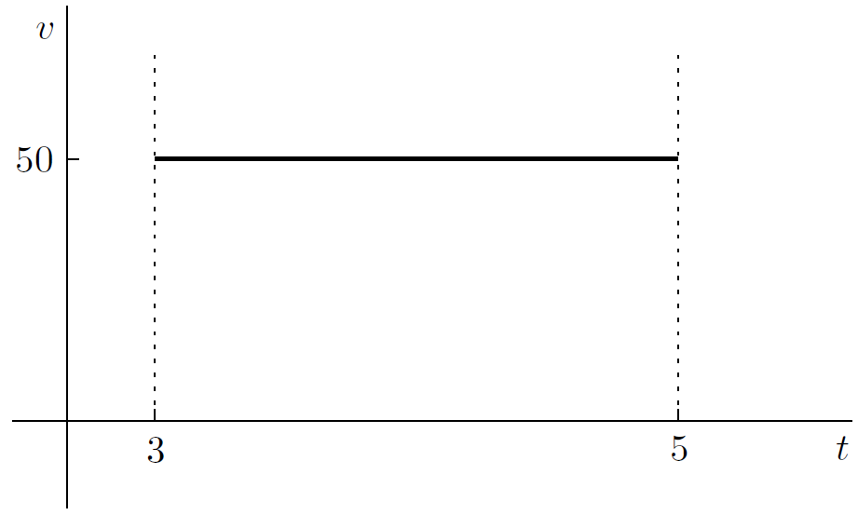

As for the second car, it goes at a speed of mph for the first hour; then at p.m. it starts going mph. Ignoring the few seconds that it takes to accelerate, the graph of the situation looks like this:

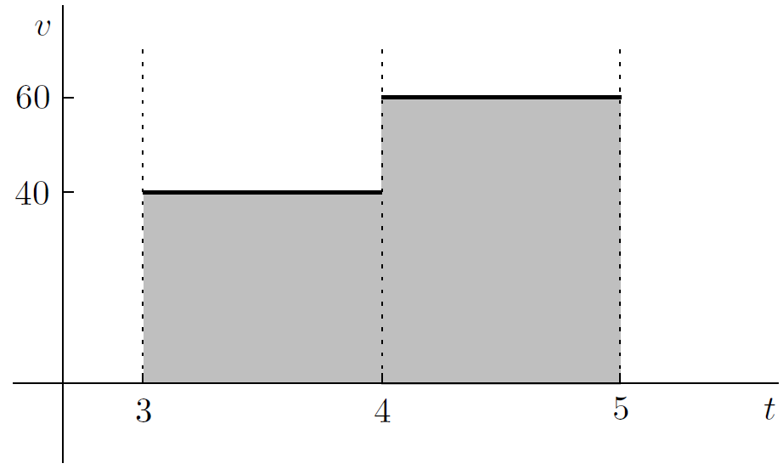

The third car travels at mph for the first minutes, then goes mph until p.m. At that time, it switches to mph for half an hour, before shifting to the slower speed of mph for the rest of the journey. Once again ignoring the short accelerations and decelerations when the speed changes, the graph of against looks like this:

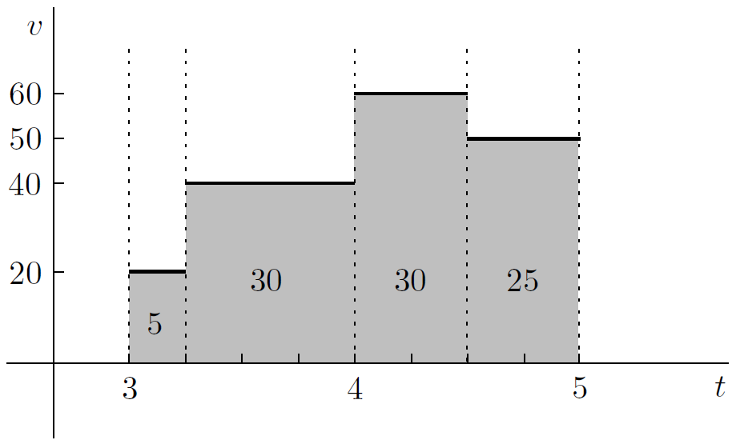

* A more general journey

Let's look at a general framework to describe the sort of journey that the three cars made. Suppose that the time interval involved is ; also, suppose that we can chop up this interval into smaller intervals so that the car is going at a constant speed on each interval. We don't want to fix the number of intervals, so let's call it . We also need to have some way of describing the beginning and end of each small interval:

* The first interval begins at time and finishes at some later time . Since is earlier than , we can say that . In fact, it will be useful to also let , so that we have
* The second interval begins at time and finishes at some later time , so that
* The third interval goes from to , where
* Keep going in the same way, so that the th time interval starts at time and ends at time
* The second-to-last interval goes from to , where
* Finally, the last interval goes from to , which is the same as the very end time . So we have

All together, we can summarize the situation by saying that

On the number line, it looks something like this:



Overall, the picture looks like this (for example):

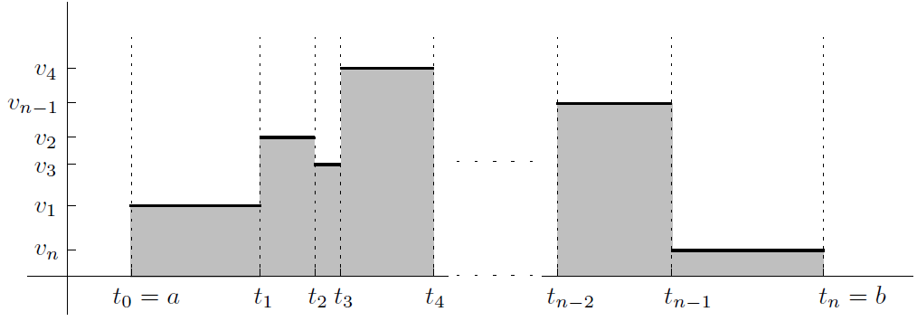

* Signed area

What if our car goes backward? For example, suppose that the car goes forward at mph between and p.m., then backward at mph until p.m. The graph looks like this:

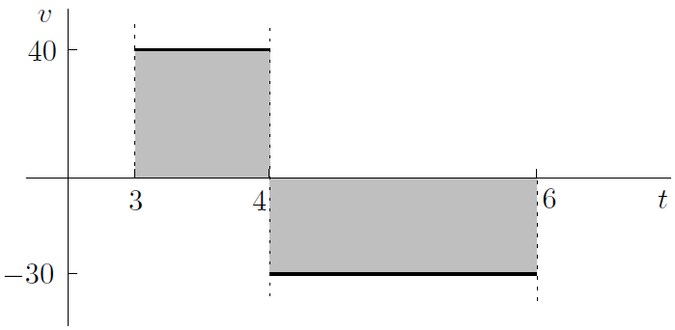

Now it's really important to distinguish between distance and displacement. The total distance traveled from p.m. to p.m. is . On the other hand, the displacement is , since the second part of the journey is backward

Of course, a rectangle can't actually have a negative height, but nevertheless it would be good to distinguish between rectangles above and below the axis. So if the “height” is mph, then the “area” is . Let's drop the quotation marks and correctly refer to this as the *signed area*. Our convention, then, is that areas below the axis count as negative toward the total

So instead of adding up the actual (unsigned) area in the graph above to get the distance, we could graph against :

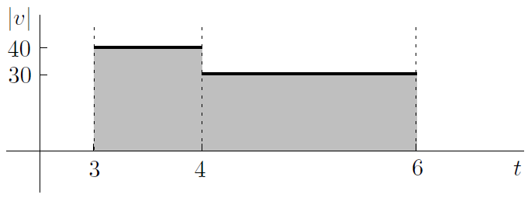

Now it's irrelevant whether the area is signed or not because there's nothing below the horizontal axis! So, we'll make the convention that **all areas are signed**. If we want the unsigned area, we'll take absolute values first

* Continuous velocity

We've seen that if a car (or other object) moves along a straight line so that the velocity is constant on a finite number of intervals in a partition of , then the displacement is the signed area between the graph of versus , the -axis, and the lines and . The distance is the same thing, except that you start with the graph of versus instead

What if the velocity **isn't** constant on a finite number of intervals? Unless you never turn off the cruise control, you'll be speeding up from time to time to pass another car, slowing down when you see a cop, and so on. Even getting from to mph requires some acceleration-you can't just change speeds instantaneously. So, let's consider the situation where velocity is a **continuous** function of time , for example:

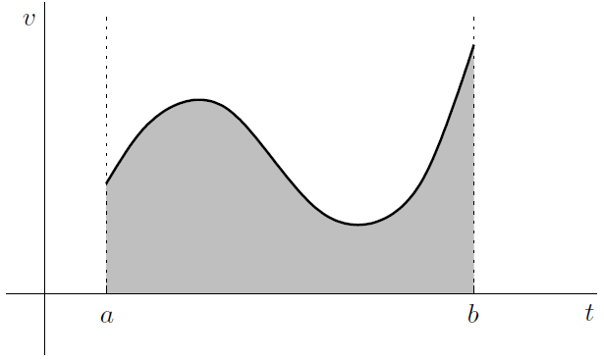

Here's the idea. Let's **sample** the velocity by picking some instant of time during

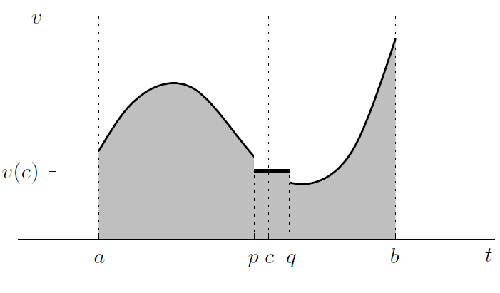

The number could be equal to the beginning number or the end number , or some number in between, as long as it lies in

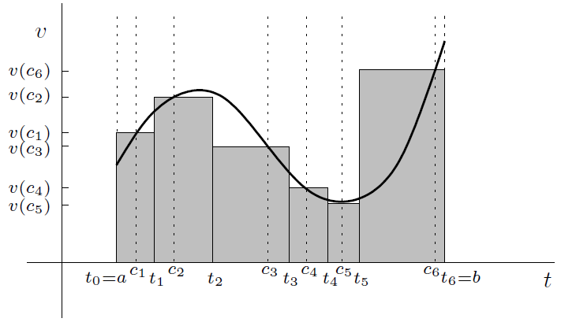

All we've done is approximate the nice smooth velocity curve using some staircase-like function, where each step intersects the curve. We can use the techniques from the previous sections to work out the shaded (signed) area, which will be an approximation to the actual area under the curve. We get

Unfortunately, the approximation is pretty lousy. So let's take a different partition with more intervals which are smaller, for example:

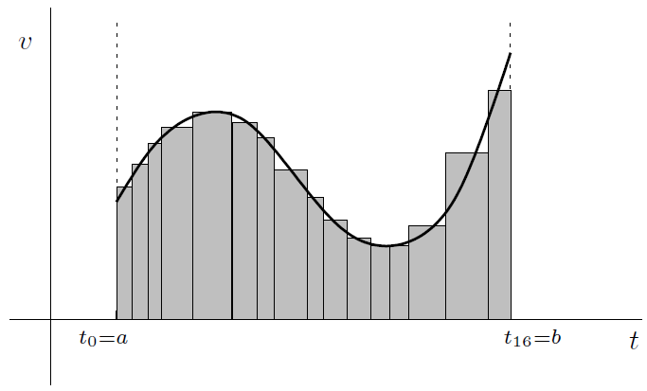

So somehow we need to make **all** the little time intervals small. The way to do this is to let the mesh of the partition be the longest of all the time intervals, then insist that the mesh get smaller and smaller, eventually down to 0 in the limit

Formally, the mesh is defined by

This is what we're trying to achieve in the following formula:

* Two special approximations

The above formula leaves a lot to be desired. How do you know that you get the same answer no matter what partitions you take and no matter how you choose the sampling times . It's actually a theorem that if is a continuous function of , then the above limit is independent of the partitions and sampling times. We can get an idea of the flavor of the proof by investigating two special approximations: the upper sum and the lower sum

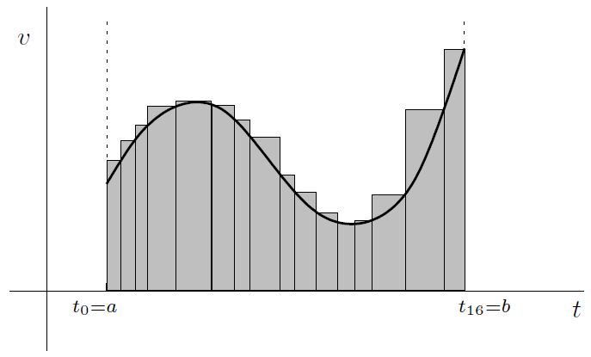

The area of the rectangles, which is called *an upper sum*, is clearly bigger than the area under the curve

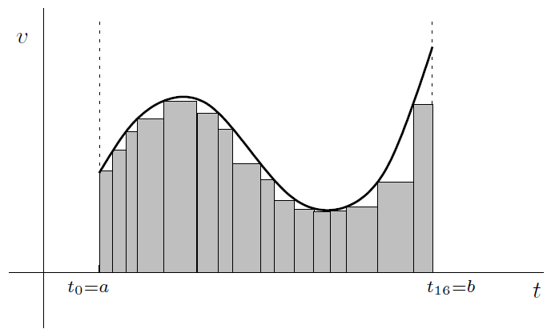

The area of all the rectangles, which is called *a lower sum*, is less than the area under the curve. Combining these observations, we have

If you use a sequence of partitions with smaller and smaller meshes, then the lower sum and the upper sum have the same limit (that's what I'm not going to prove). The sandwich principle then shows that the formula at the end of the previous section makes sense

**CHAPTER 16 Definite Integrals**



Now it's time to get some facts straight about definite integrals

1. The Basic Idea

We start off with some function and an interval . Take the graph of , and consider the region between the curve, the x-axis, and the two vertical lines and :

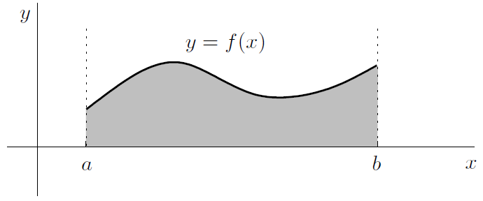

Let's say that the area of the shaded region above, in square units, is

This is a definite integral. You would read it out loud as “the integral from to of with respect to .” The expression is called the integrand. The and tell you where the two vertical lines go, and are called the limits of integration (not to be confused with regular old limits!) or the *endpoints of integration*. Finally, the tells you that is the variable on the horizontal axis. Actually, is a dummy variable

What if the function dips below the -axis? The situation could look like this:

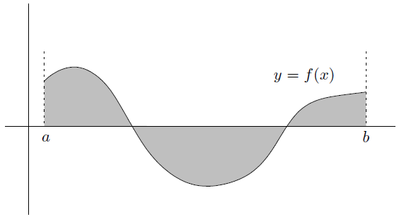

In general, the integral gives the total amount of signed area. More precisely,

is the signed area (in square units) of the region between the curve , the line and , and the -axis

Note that the integral is a number, but the area is in square units

Using our new notation, we can say that

and

]

* Some easy examples

Now, let's look at a few simple examples of definite integrals. First, consider

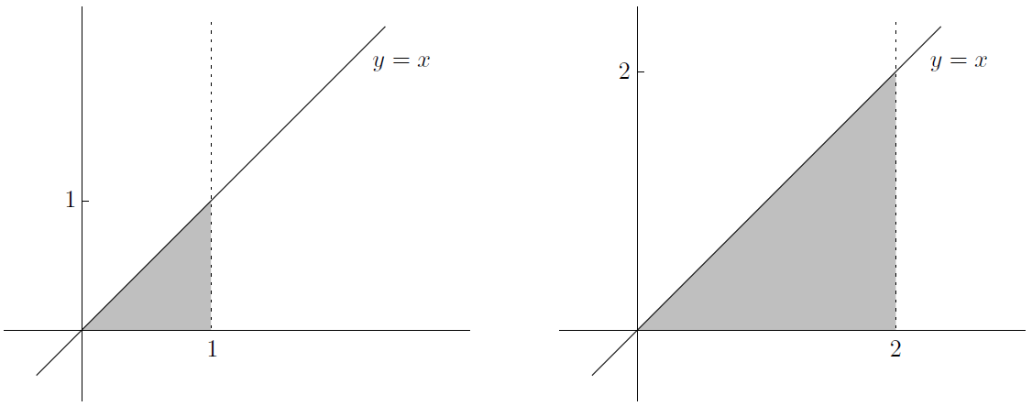

Now, let's take a look at another definite integral:

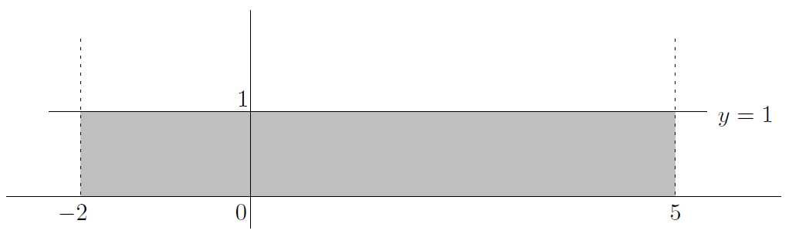

In fact, the more general integral

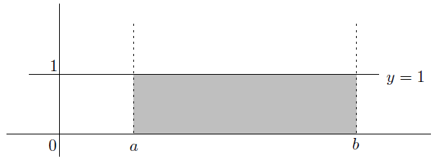

in general. This could also be written as simply

Finally, what is

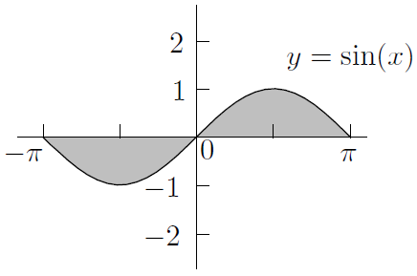

Before we move on, I'd like to point out a generalization of the previous example. That is

This is true by symmetry: every bit of area *above* the x-axis has a corresponding bit of area below the x-axis, just as in the above picture

1. Definition of the Definite Integral

Unfortunately, the definition of the definite integral is a lot nastier than the above definition of the derivative. The good news is that we've already done the grunt work in the previous chapter, and we can just state the definition:

Even though that definition is wordy, it still doesn't tell the full story! (Page 330)

The sum

which appears in the definition is called a *Riemann sum*

* An example of using the definition

1. Properties of Definite Integrals

if you reverse the limits of integration, you need to put in a minus sign out front. In general, for an integrable function and numbers and , we have

Now, what if the limits of integration are equal? In fact, it's generally true that

In general, for any integrable function and numbers , , and , we have

**You can split an integral into two pieces**, even if the break point is outside the original interval , as long as in both pieces the integrand is still integrable

There are two more simple properties of integrals which are even more useful. The first is that **constants move through integral signs**. That is, for any integrable and numbers , , and ,

The second property is that **integrals respect sums and differences**. That is, if and are both integrable functions, and and are two numbers, then

1. Finding Areas

If , then we can write

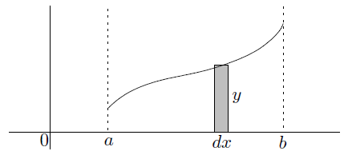

This idea is useful in helping to understand how to use the integral to find areas

* Finding the unsigned area
* Finding the area between two curves

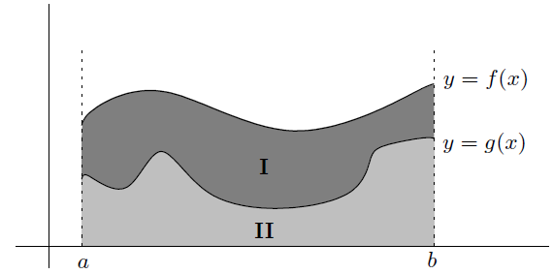

* Finding the area between a curve and the -axis

Let's try to find the area of the region enclosed by the curve , the -axis, and the line . Here's a picture of the region:

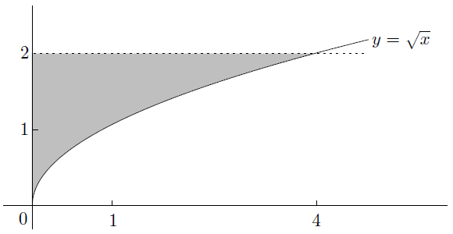

When we do this, we're effectively chopping up the region we want into horizontal strips, not the vertical ones we've used before. Here's an example of how this might look:

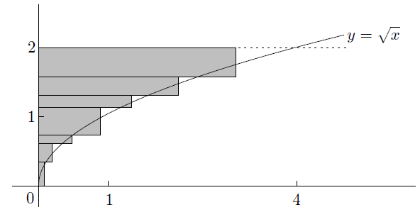

If , then , provided that the inverse function exists. So, we can summarize the situation as follows:

is the signed area (in square units) of the region between the curve , the lines and , and the -axis, if is invertible

If you prefer, you can write the above integral as

1. Estimating Integrals

Here's a very simple but important principle: **when one function is always larger than another, its integral is also larger**. Take a look at the following picture:

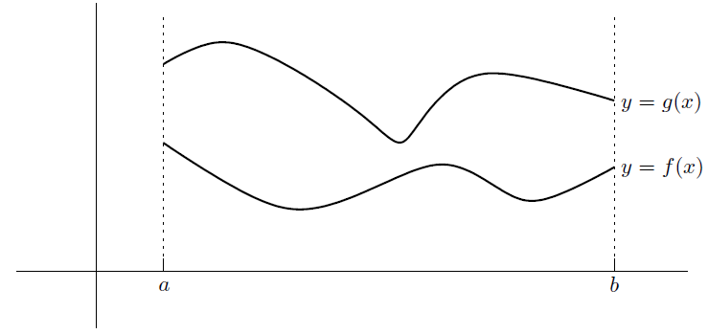

On the interval , the function always lies above . In any case, the area under (down to the x-axis) is clearly less than the area under (down to the x-axis). In symbols:

* A simple type of estimation

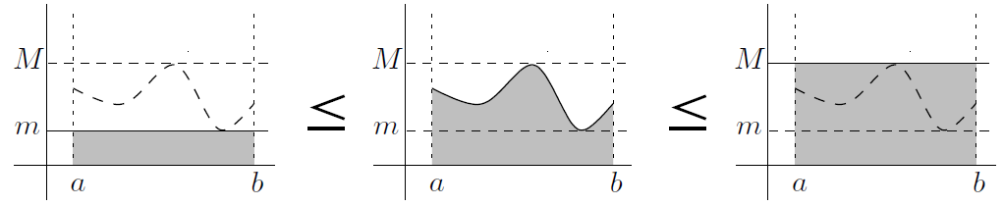

1. Averages and the Mean Value Theorem for Integrals

If the time interval goes from to , and the velocity at time is , then we've already seen that

Since the total time is , we have

More generally, we can define the average value of an integrable function on the interval as follows:

For example,

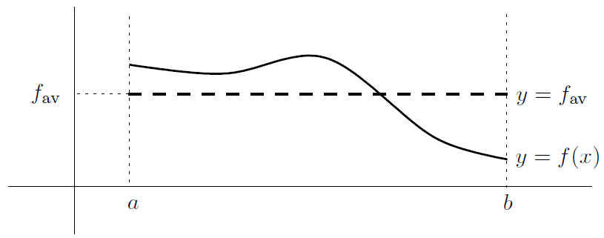

This actually says that the following two areas are equal:

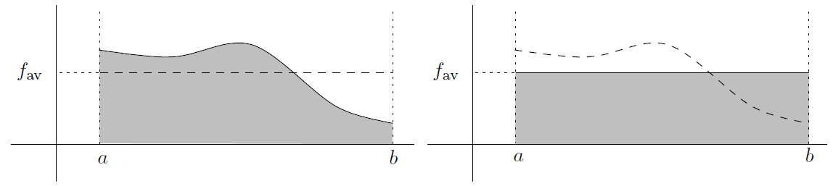

* The Mean Value Theorem for integrals

In the above graphs, observe that the horizontal line intersects the graph of . Let's label the corresponding point on the -axis as , like this:

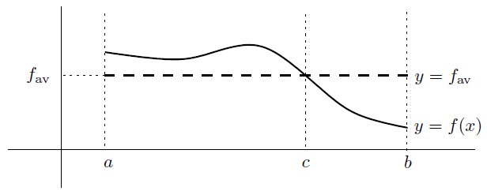

So we have . It turns out that if is continuous, then there is always such a number :

**Mean Value Theorem for integrals**: if f is continuous on , then there exists in such that

So, why is the above theorem also called the Mean Value Theorem? The difference between the two versions of the theorem is that in the regular version, the conclusion was interpreted in terms of slopes on the graph of displacement versus time; whereas now we have interpreted it in terms of areas on the graph of velocity versus time

1. A Nonintegrable Function

Now, let's look at an example of a function where there **are** too many discontinuities

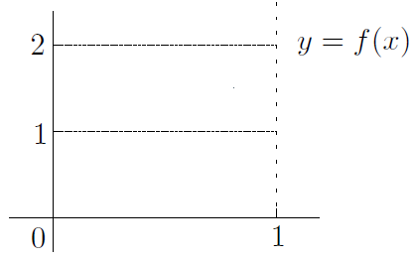

**CHAPTER 17 The Fundamental Theorems of Calculus**



1. Functions Based on Integrals of Other Functions

Let's try to find

There are two ways we can make this whole thing more general. First, the left-hand endpoint doesn't have to be

The moral of the story is that changing the left-hand endpoint from one constant to another

doesn't make too much difference

Our second generalization is that the integrand doesn't have to be . It can be any continuous function of . Let's suppose the integrand is . If is some constant number, then let's define

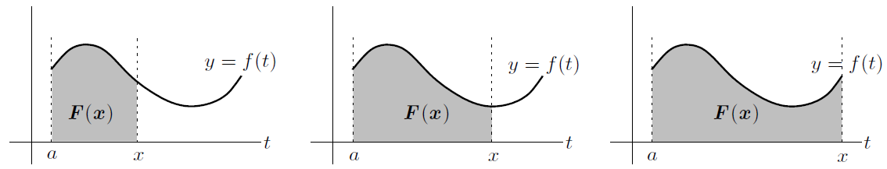

1. The First Fundamental Theorem

Here's the goal: find

without using Riemann sums. Let's do three things which are not really obvious at all (Page 358)

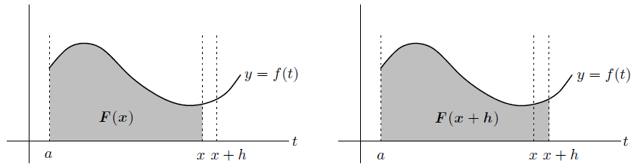

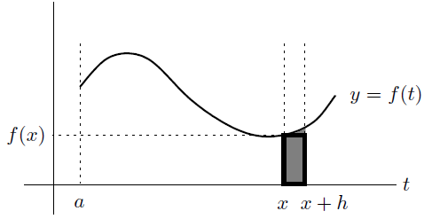

**First Fundamental Theorem of Calculus**: for continuous on , define a function by

Then is differentiable on and

* Introduction to antiderivatives

Suppose that and , so that

The First Fundamental Theorem tells us that . Since , we have , this means that . In other words, is a function whose derivative is . We say that is an *antiderivative* of (with respect to )

1. The Second Fundamental Theorem

The example with in the previous section points the way to finding in general. First, we know that the function defined by

is an antiderivative of (with respect to ). We really want to find (Page 362)

**Second Fundamental Theorem of Calculus**: if is

continuous on , and is any antiderivative of (with respect to ), then

Then is differentiable on and

In practice, the right-hand side is normally written as . That is, we set

1. Indefinite Integrals

We might as well have a shorthand way of expressing antiderivatives without having to write the long word “antiderivative.” Inspired by the First Fundamental Theorem, we'll write

to mean “the family of all antiderivatives of .” Bear in mind that any integrable function has infinitely many antiderivatives, but they all differ by a constant. This is what I mean when I say “family.” For example,

for some constant

If you know a derivative, you get an antiderivative for free. In particular:

The above example fits this pattern:

All the above integrals are examples of *indefinite integrals*. You can tell an indefinite integral from a definite integral by noticing whether or not there are limits of integration. Indefinite integrals don't have limits of integration, while definite integrals do:

* A definite integral, like , is a **number**. It represents the signed area of the region bounded by the curve , the -axis, and the lines and
* An indefinite integral, like , is a **family of functions**. This family consists of all functions which are antiderivatives of (with respect to ). The functions all differ by a constant

Here are two simple facts about indefinite integrals that follow directly from the similar properties for derivatives: if and are integrable, and is a constant, then

and

That is, the integral of the sum is the sum of the integrals, and constant multiples can be pulled through the integral sign

I want to make one more comment about the two Fundamental Theorems. The First Fundamental Theorem says that

In some sense, the derivative of the integral is the original function. You just have to be careful about what you mean by the “integral,” bearing in mind that the variable has to be the right-hand limit of integration, not the dummy variable. Now, the Second Fundamental Theorem says that

where is an antiderivative of . This means that . We can therefore rewrite the above equation as

which can be interpreted as saying that the integral of the derivative is the original function. Again, it's not really the original function: it's the difference between the evaluations of the original function at the endpoints and . Even with all this vagueness, it should still be clear that differentiation and integration are essentially opposite operations

1. How to Solve Problems: The First Fundamental Theorem

Think about how you'd find the following derivative:

Why go to all that work when the derivative and integral effectively cancel each other out? After all, if you wanted to find , you wouldn't waste time looking for when you just have to square it again. You'd just write down the answer and be done with it. Similarly, we can use the First Fundamental Theorem from above to say that

All you have to do is take the integrand and change to . The number doesn't even come into it. By the way, it would be a mistake to put a “” at the end: you are finding

a **derivative**, after all, not an antiderivative!

* Variation 1: variable left-hand limit of integration

Consider

The problem is that the variable is now the left-hand limit of integration, not the right-hand one we've been used to. No problem-just switch the and around, introducing a minus sign to compensate for this. You get

* Variation 2: one tricky limit of integration

Here's another example:

Because the right-hand limit of integration is , not , we can't just use the First Fundamental Theorem directly. We're going to need the chain rule as well

In summary,

Let's look at one more example of this sort of problem: what is

You might also encounter both of the above variations in the same problem. For example, to find

* Variation 3: two tricky limits of integration

Here's an even harder example:

Now there are functions of in both the left-hand and right-hand limits of integration. The way to handle this is to split the integral into two pieces at some number. It actually doesn't matter where you split it, as long as it is at a constant (where the function is defined). So, pick your favorite number-say -and split the integral there:

* Variation 4: limit is a derivative in disguise

Here's an example which looks a little different:

So actually, we have

for any you like. See, I told you that the limit was a derivative in disguise! To finish the problem, just apply the First Fundamental Theorem in its basic form to see that the above limit is just

1. How to Solve Problems: The Second Fundamental Theorem

To find a definite integral using the Second Fundamental Theorem

* Finding indefinite integrals

Start off by noting that

this means that

If , then ; so we can divide through by and write

(Once again, we replaced by simply ; this is OK since is just an arbitrary constant.) Now, what happens when ? The above method doesn't work on , which is just

we can prove the formula

In the meantime, we can now summarize most of the basic derivatives and corresponding antiderivatives that we've seen so far in one big table

**Derivatives and integrals to learn**:

As we've seen, if you replace by the constant multiple in any of the above differentiation formulas, you just have to multiply the corresponding formula by . For example,

What if you integrate instead? Now the rule of thumb is that if you replace by , then you have to **divide** by . For example,

* Finding definite integrals

The Second Fundamental Theorem tells us that to find

just find an antiderivative, plug in and , and take the difference (Page 374)

* Unsigned areas and absolute values

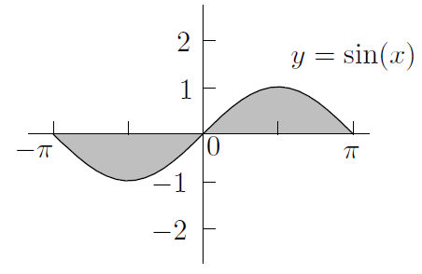

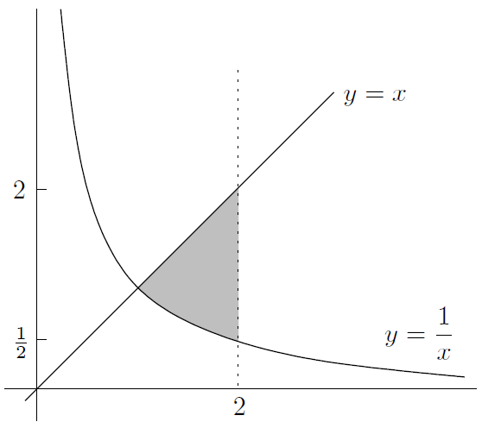

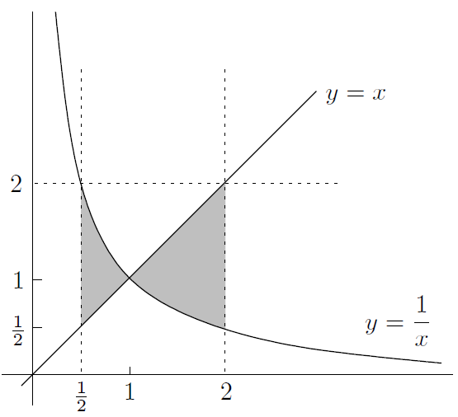

1. A Technical Point

We saw that

Although everyone writes the formula like this, technically it's not correct! To see why, let's start off with the graph of :

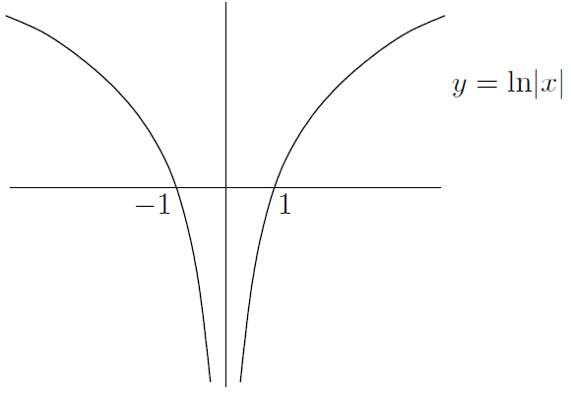

This has two pieces, either of which can be shifted up or down without affecting the derivative. For example, if we shift the left piece up by and the right piece down by , the graph looks something like this:

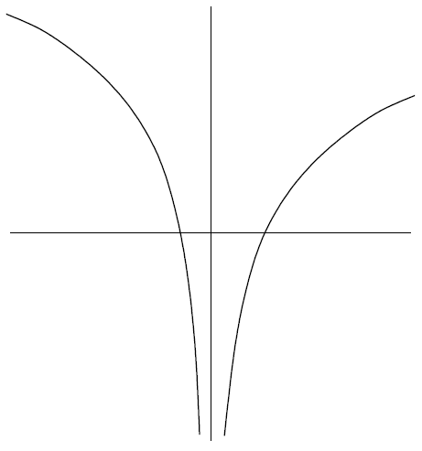

This function isn't of the form , but its derivative is still . So we really need to allow **two** constants, possibly different-one for each of the two pieces of the curve:

But there's a problem: the vertical asymptote at . So the only time that definite integrals of the form

make sense is when and are both positive or both negative. In either case, only one of the pieces of is involved, and there's no need to mess around with two different constants!

1. Proof of the First Fundamental Theorem

(Page 381)

**CHAPTER 18 Techniques of Integration, Part One**



1. Substitution

Actually, this is a special case of a nice fact: if is a differentiable function, then

So if the top is the derivative of the bottom, then the integral is just the log of the bottom (with absolute values and the

* Substitution and definite integrals

You can also use the substitution method on definite integrals. There are two legitimate ways to do this. For example, to find

you could find the indefinite integral first, then plug in the limits of integration

It's really important to go back to -land at the last step. Now we can use the Second Fundamental Theorem

which works out to be . So one way to use the substitution method on a definite integral is to focus on the indefinite integral first, then after you've found it, plug in the limits of integration. We'll finish this soon, but first note that it would be a major error to write

on the right-hand side instead. Since we're integrating with respect to , not , the limits of integration must refer to relevant values of

So, all in all, we've substituted **three** things:

1. the bit-that became something to do with , burning up some of the other stuff in order to make the change;
2. all the remaining terms in the integrand involving , so that they became terms in ;
3. the limits of integration

The best way to set it out is to make a working column at the left of your page, like this (Page 387)

* How to decide what to substitute

How do you choose the substitution? Good question. The basic idea is to look for some component of the integrand whose derivative is also present as a factor of the integrand. In the integral

the substitution works because its derivative is right there, waiting for us to use it

Sometimes the substitution is not obvious at all (Page 390)

Let's look at one more example:

There is a nice technique for dealing with integrals involving terms such as . You simply set , but take th powers before you differentiate to find . So:

to deal with , set and differentiate both sides of

By the way, did you notice anything different about this substitution from all the others we've done so far? It's a subtle point, but in all the other examples, we had an equation like , whereas here, we have . This worked out quite nicely, since we just replaced directly. In all the other examples, we had to find a constant multiple of the -stuff already present in order to have much of a chance

In general, there are no hard and fast rules about what to substitute. You just have to go along with your instinct, which will be accurate only if you have done plenty of practice problems. You can always try any substitution you like. If the new integral is worse than the original one, or you can't see how to migrate everything to -land, then don't panic: just go back to the original integral and try something else

There are two things I want to deal with. One is a justification of the substitution method; I'll do this in the next section. The other is to summarize the method of substitution:

* for **indefinite** integrals, change everything to do with and to stuff involving and , do the new integral, then change back to stuff;
* for **definite** integrals, change everything to do with and to stuff involving and , and change the limits of integration to the corresponding values as well, then do the new integral (no need to go back to -land here). Alternatively, treat the integral as an indefinite integral and when you get the final answer, then substitute in the limits of integration
* Theoretical justification of the substitution method

(Page 392)

A good way to think of is that a change in produces a change in which is times as large

the -land part of the calculation looks like this:

We know that . Since , we have . The above equation becomes

By the way, this nice equation allows us to prove the alternative method of substitution. In the alternative method, instead of setting , we set for some other function , and replaced by . In that case, our original integral now supposedly becomes

1. Integration by Parts

We saw how to reverse the chain rule by using the method of substitution. There is also a way to reverse the product rule-it's called integration by parts. Let's recall the product rule

Let's rearrange this equation and then integrate both sides with respect to . We get

It's perfectly usable in this form, but there's an abbreviated form which is even more convenient. If we replace by , and replace by , we get the formula

Let's see how it works in practice. Suppose we want to find

Substitution seems useless (try it and see), so let's try integration by parts. Set and . I recommend writing the following:

and then filling in the blanks by differentiating and integrating :

The easiest way to use the formula is to write a small version of it with generous spacing, then do the substitutions underneath, like this:

Now we still have one integral left, but it's just , which is . Plugging this in, we see that (Technically it should be , not , but minus a constant is just another constant and there's no need to distinguish.)

Now, how on earth did we know to choose and ? Why couldn't we have chosen and ? Well, we could have. But it's not very useful. The moral is that if is present, you should normally let so that is simply equal to

* Some variations

A few complications can arise. Sometimes you need to integrate by parts twice or more. For example, how would you find (Page 394)

Sometimes you can integrate by parts twice but things don't seem to get simpler. In this case, if you're lucky, then you might just get a multiple of the original integral back at the end. Then unless you are actually unlucky, you can throw it over to the other side and solve, which is a neat trick. (If you are unlucky, then the integrals cancel out, which doesn't help at all!) (Page 395)

There's one other type of integral that needs integration by parts but is in disguise. In particular, the integrand doesn't appear to be a product. Some integrals that fall into this category are

That is, the integrand is any inverse trig function (by itself) or a power of . In this case, you should let be the integrand itself, and let (Page 397)

When solving a definite integral by integrating by parts, find the indefinite integral first, then substitute the limits of integration at the end

1. Partial Fractions

Let's focus our attention on how to integrate a rational function. So we want to find an integral like

where and are polynomials. This covers a whole slew of integrals, for example,

These seem a little complicated. Here are some simpler ones:

The last four integrands are all rational functions, but they are a lot simpler. Try to work out all of these integrals using substitution. The first two of these integrals have denominators which are powers of linear functions, whereas the last two have quadratic denominators which cannot be factored

So, here's the idea: first we'll see how to take a general rational function and do some algebra to bust it up into a sum of simpler rational functions; then we'll see how to integrate the simpler types of rational functions. The simpler functions I'm talking about are all like the four above: they either look like a constant over a linear power, or they look like a linear function over a quadratic

* The algebra of partial fractions

Our goal is to break up a rational function into simpler pieces. The first step in this process is to make sure that the numerator of the function has degree less than the denominator. If not, we'll have to start off with a long division. So in the examples

The first is fine, but the second example isn't so great, because the degrees of the top and bottom are equal (to ). We'd have the same trouble if there were a cubic or higher-degree polynomial on the top. So, we have to do a long division. To do this, write

So we have

If we integrate both sides with respect to , we can break up the integral into two pieces, and actually do the integral in the first piece, to see that our original integral is equal to

The new integral has a degree of on the top and on the bottom, which is the way we like it. We're now ready to proceed

Next, we'll factor the denominator. If the denominator is a quadratic, check the discriminant: if this is negative, you can't factor the quadratic. Otherwise, you can factor it by hand or by using the quadratic formula. If your denominator is more complicated, you may have to guess a root and do a long division

After factoring the denominator, the next step is to write down something called the “form.” This is made by adding together one or more terms for each factor of the denominator, according to the following rules:

1. If you have a linear factor , then the form has a term like
2. If you have the square of a linear factor , then the form has terms like
3. If you have a quadratic factor , then the form has a term like

Those are the most common ones. Here are some rarer beasts:

1. If you have the cube of a linear factor , then the form has terms like
2. If you have the fourth power of a linear factor , then the form has terms like

Notice that **the form only depends on the denominator**. The numerator is irrelevant! Also, when I use constants like , and above, bear in mind that you can't reuse constants in different terms

So you need to keep advancing along the alphabet. Since the denominator factors as , we have two linear factors, and the form is

We can't use twice, so we used for the second term. Here's another example of finding the form. What would the form of

be? The answer is

Once you've found the form, you should write down that the integrand equals the form, then multiply through by the denominator

Actually, you're better off writing the denominator on the left-hand side in the factored manner, like this:

Now multiply through by the denominator to get

Anyway, now there are two different ways we can proceed. The first way is to substitute clever values of . If you put , then the term goes away, and you get . Now if instead you put in the original equation, the term goes away, so . Alternatively, another way of finding and is to take our original equation and rewrite it as

Now we can equate coefficients of to see that and

You might have noticed that in both of the ways we found and , we needed two facts. For the substitution method, we put and then , whereas for the method of equating coefficients, we equated the coefficients of and also the constant coefficients. We actually could have used one instance of each method (Page 401)

All that's left is to rewrite your integrand as equal to the form again, but this time with the constants filled in. So in our example,

Now integrate both sides, pulling out the constant factors as you split up the integral:

We have successfully busted up our original integral into two integrals which are much simpler

So far, we've seen that we do a long division unless the degree of the top is less than the degree of the bottom; then we factor the denominator; then we write down the form; then we use one of two methods to find the unknown constants. Finally, we write down the integrals of the various pieces

* Integrating the pieces

We need to see how to integrate the various pieces which remain after you break up the original integral. The simplest type of integral is of the form

To do this, just substitute

The same trick works for a power of a linear factor in the denominator; for example, to find

Substitute

The difficult case involves a quadratic in the bottom, like this:

Beware! If the quadratic can be factored, then you need to do this first. Then the left is that the quadratic on the bottom cannot be factored. That is, its discriminant is negative (Page 402)

* The method and a big example

Here's the complete method for finding the integral of a rational function:

**Step 1-check degrees, divide if necessary:** check to see if the degree of the numerator is less than the degree of the denominator. If it is, then you're golden-go on to step 2. If not, do a long division, then proceed to step 2

**Step 2-factor the denominator:** use the quadratic formula, or guess roots and divide, to factor the denominator of your integrand

**Step 3-the form:** write down the “form,” with undetermined constants, as described on the book (Page 399). Write down an equation like

**Step 4-evaluate constants:** multiply both sides of this equation by the denominator, then find the constants by (a) substituting clever values of x; (b) equating coefficients; or some combination of (a) and (b). Now you can express your integral as the sum of rational functions which either have constants on the top and powers of linear functions on the bottom, or look like a linear function divided by a quadratic function

**Step 5-integrate terms with linear powers on the bottom:** solve any integrals whose denominators are powers of linear functions; the answers will involve logs or negative powers of the linear term

**Step 6-integrate terms with quadratics on the bottom:** for each integral with a nonfactorable quadratic term in the denominator, complete the square, make a change of variables, then possibly split up into two integrals. The first one will involve logs and the second should involve . If there's only one integral, it could involve either logs or . This formula is very useful most of the time:

Remember, you don't always need to use all six steps. Sometimes you can go directly to the last step, such as in our example

**CHAPTER 19 Techniques of Integration, Part Two**



In this chapter, we'll finish gathering our techniques of integration by taking an extensive look at integrals involving trig functions. Sometimes one has to use trig identities to solve these types of problems; on other occasions there are no trig functions present, so you have to introduce some by making a trig substitution

1. Integrals Involving Trig Identities

There are three families of trig identities which are particularly useful in evaluating integrals. The first family arises from the double-angle formula for . For use in integration, it turns out that the best way to use the formulas is to solve the relevant equation for or . So, we have

and

It is well worth remembering these identities! In particular, if you ever have to take a square root of or , these identities save the day. For example,

looks pretty nasty, but in fact

Luckily, when is between and , the values of are always greater than or equal to zero, so we have reduced things to

Let's move on to the second family of trig identities. These are the Pythagorean identities:

These identities are valid for any , and sometimes they are obviously helpful. For example,

should just be written as

Now, sometimes you have to apply a devious trick in order to use the above identities. If you see or , where “trig” is some trig function (specifically sine, cosine, secant, or cosecant), in the denominator of an integral, consider multiplying by the conjugate expression. For example, to find

multiply top and bottom by the conjugate expression of the denominator, which in this case is . That is

Let's look at the third family of identities, the so-called products-to-sums identities:

It's quite a pain in the butt to remember these. Actually, they all follow from the expressions for and , so if you have those down, you can reverse engineer the above identities from them. These identities are quite indispensable for finding integrals like

1. Integrals Involving Powers of Trig Functions

Now we'll see how to find certain integrals which have powers of trig functions in their integrands. For example, how would you find or ? Unfortunately, these types of integrals require different techniques, depending on which trig function or functions you're dealing with

* Powers of sin and/or cos

Here's the golden rule: if one of the powers of or is odd, then grab it and don't let it get away-it is your friend! (If they are both odd, then take the one with the lowest power as your friend.) If you've grabbed your odd power, then you need to pull out one power to go with the ; then deal with what's left (which is now an even power) by using one of the identities

or

Anyway, the best way to see how the technique of pulling out one power from the odd power works is by looking at an example (Page 413)

Now if we put , then , so it's easy to get this integral over to -land-it's just

which works out to be

Now, what if neither power is odd? Well, if both powers are even-for example, if you had to work out -you should use the double-angle formulas. We just saw them in the previous section, but here they are again for reference:

and

Now you can just replace everything in sight, and you'll get a whole bunch of simpler integrals which are various powers of cosines. You then need to find them using the same techniques as we have just used, depending on whether the power in each integral is even or odd. In our example

* Powers of tan

Consider , where is some integer. Let's look at the first couple of cases. For , we need to know how to do . This is a pretty standard integral, which you can solve by setting , noting that :

The answer can also be written as

How about ? For this case, and indeed other cases, it's essential to use the Pythagorean identity

which we looked at in the previous section. So we have

To do higher powers , you have to extract and change it into . This gives you two integrals. The first can be done by substituting and using . The second is a lower power of and you can just repeat the method. For example, how would you find ? Let's see: (Page 415)

* Powers of sec

Yup, this one really sucks, except for , which is easy. Let's start with the first power, . There are many ways of finding this integral. The easiest involves a cool trick that is well worth remembering, as it's a real timesaver. Unfortunately it's the sort of trick that is completely counterintuitive, and it boggles the mind that anyone even thought of it in the first place. The idea is to multiply top and bottom by the bizarre quantity . Watch and be amazed:

since the derivative of the denominator is miraculously equal to the numerator

How about the second power of ? Not much to this one:

That was easy. Unfortunately, it gets pretty messy for larger powers. The standard idea is to pull out (which is similar to what we did with powers of ) and integrate by parts, using and as the rest of the powers of . This means that (remember, we don't need a constant here). When you do the integration by parts, you will of

course get a new integral; the integrand should be a lower power of multiplied by . Once again, we have to use and get two integrals. One of them is a multiple of the original integral! You have to put this back on the left-hand side. The other one is a lower power of , and you have to repeat the whole process until you get down to or , both of which we now know how to do

A formidable example: (Page 417)

* Powers of cot

These work just like powers of . You pull out and use the Pythagorean identity

Just beware that when you set , you have

* Powers of csc

These work just like powers of . You pull out and integrate by parts, using . Beware: you now have , and also involves a minus sign which you have to worry about

* Reduction formulas

The methods of the last four sections all involve knocking the power of the trig function you're dealing with down by , then repeating the process. Let's try to write out the method in general. First, we're dealing with , so we'll give it a name: (for integral number ). That is,

(Page 419)

The above equation is called a *reduction formula*, since it helps us reduce the number to a smaller number

The method also works for definite integrals. For example, how would you find the definite integral ? You could use the double-angle formulas, but that would be a pain in

the ass. (Try it if you don't believe me!) Instead, let's set (Page 420)

By the way, reduction formulas don't have to involve trig functions. For example, if (Page 421)

1. Integrals Involving Trig Substitutions

Now let's look at how to do integrals involving an odd power of the square root of a quadratic. Here are some examples of the type of integral we're considering:

The basic idea is that there are three types, corresponding to whether you have to worry about . Here is just some number. Each of these three types requires a different substitution. Most of the time, after substituting, you end up with an integral involving powers of trig functions, which is where the previous section comes in

* Type 1:

If you have an integral involving an odd power of , the correct substitution to use is . (You could use if you prefer, but there would be no advantage to it, so stick with sine.) The reason that this substitution is effective is that

and now you can easily take a square root. Remember that if you are changing variables from to , you have to go from -land to -land. That is, everything about the integral has to be in terms of , not . In particular, we'll need to replace by something in and . No problem-just differentiate the equation to get . Anyway, now we can hopefully do the integral in -land, but in the end we have to change the answer back to -land. To do this, it will be useful to draw the following right-angled triangle with one angle equal to :

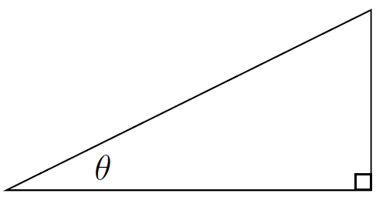

Now we know , so

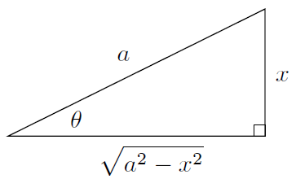

Let's see how it works in practice (Page 422)

Before we go on to Type 2, do you see that we've been a little careless here? (Page 423)

Luckily, the absolute value signs turn out to be unnecessary for Type 1 and also for Type 2 below (but not for Type 3), so we were right all along

* Type 2:

If an integral involves an odd power of , the correct substitution is . This works because

Also, we'll need to know that . Since , the triangle now looks like this:

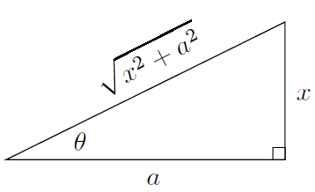

* Type 3:

Finally, how about integrals involving an odd power of ? Now the correct substitution is , since

and you can easily take square roots. To make the substitution, we'll also need the fact that . Since , the triangle looks like this:

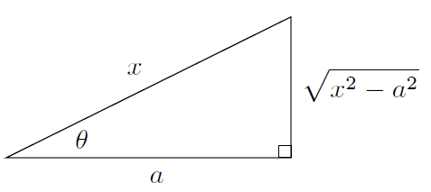

For example, to find

(Page 425) Actually, this time it's wrong to replace by ; this is only correct if in the original integral

* Completing the square and trig substitutions

Now, one other important point before we summarize the situation. From time to time, you might want to solve an integral involving an odd power of . That is, you now have a linear term to complicate matters. The technique is simple: complete the square first and substitute to get it into one of the three types that we've investigated. For example, to evaluate

first complete the square

Now let , so , and in -land the integral becomes

so replacing now by , we see that

The moral of the story, both here and when using partial fractions, is that a quadratic with a linear term can be made into a quadratic without one by completing the square and substituting

* Summary of trig substitutions

To summarize the three main types we've looked at, here's a table that shows the appropriate substitutions and triangles for each type:

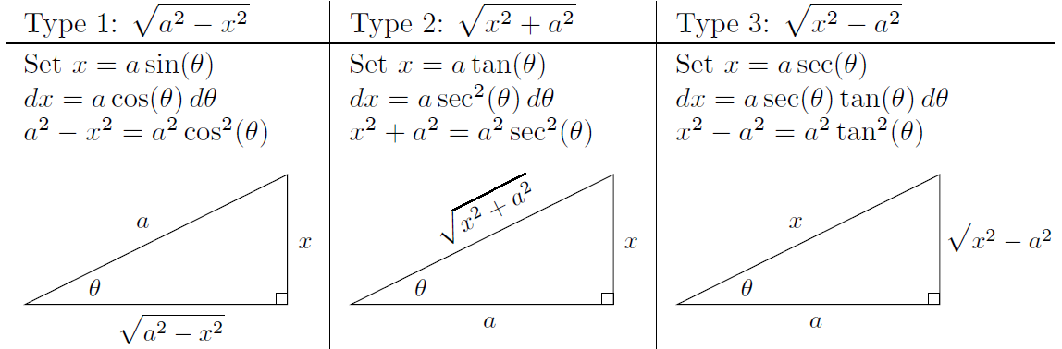

The next section discusses the technical point about when (and why) you can drop the absolute value signs when you take square roots of quantities

* Technicalities of square roots and trig substitutions

Now, think back to Type 1 above. We know that the range of is ; this means that is in the first or fourth quadrant, so . We don't need any absolute values!

The same goes for Type 2. In that case, we'd really like to simplify as . We have , so . The range of is , so is once again in the first or fourth quadrant. This means that is always positive, so again, we don't need absolute values

Everything goes wrong in Type 3, unfortunately. Here we need to deal with , but this isn't always equal to . You see, since , we have . You'll see that the range of is the interval , except for the point . So is in the fi rst or second quadrant, and could be positive or negative. At least it has the same sign as does, as you can see by looking at the graph of . So, if , you have to write instead. In that case, the triangle actually looks like this: (Page 427)

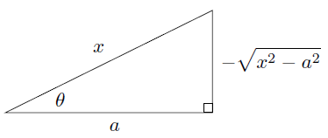

1. Overview of Techniques of Integration

We've now built up quite a toolkit of techniques of integration. Now the question is, given an integral, which technique do you use? (Page 429)

**CHAPTER 20 Improper Integrals: Basic Concepts**



1. Convergence and Divergence

What is an improper integral, anyway? In Chapter 16, we saw that the integral

certainly makes sense if is a bounded function on which is continuous except at a finite number of places. If has infinitely many discontinuities, the integral might still make sense, or it might be totally screwed up. What if isn't bounded? This means that the values of manage to get really large (positively or negatively or both) while is in the interval . This sort of thing typically happens when has a vertical asymptote somewhere in this interval: the function blows up there and can't be bounded. This causes the above integral

to be improper

The integral is *improper* if any of the following conditions apply:

1. isn't bounded in the **closed** interval ;
2. ; or

For now, let's concentrate on what happens if the first of these conditions fails. There is a simple case of when our function has a vertical asymptote at . The situation looks something like this:

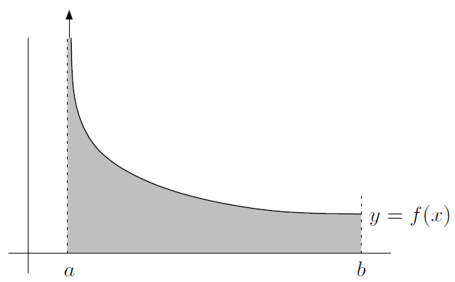

Since the region never stops going up, surely its area should be infinite, right? Not necessarily. A mathematical miracle can occur if the region is skinny enough, and the area can actually be finite. To see how a region can be unbounded yet have a finite area, we'll use limits once again. Here's the idea: let be a small positive number; then you can integrate over the region , since f is bounded there. You'll get some nice finite number. Now, replay the situation but with an even smaller . You get a new finite number. The situation now looks something like this:

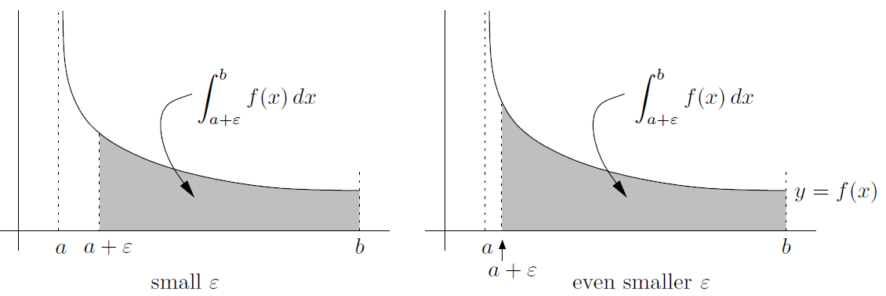

The smaller is, the closer our (bounded) approximating region is to the actual unbounded region. This suggests that we should continue the process with smaller and smaller , and see if the numbers we get have a limit as . If so, then we interpret square units to be the value of the area we're looking for. In that case, we say that the integral *converges* to . If there's no limit, then we can't find a meaningful answer for the area, so we give up and say that the above integral *diverges*. Note that **if the integral isn't improper, it automatically converges**!

Now, here's a summary of the situation when you have a blow-up point at :

if is unbounded for near only, then set

provided that the limit exists. If it does, then the integral converges; if not, the integral diverges. Just like any limit, the above one may fail to exist because it might be or , or things might oscillate around too much as tends to

This brings us to an important point. When we look at an improper integral, the most important thing we need to find out is whether it converges or diverges. It's much less important to know what the integral converges to (assuming it converges)

* Some examples of improper integrals

Consider the integrals

In the first case, we have

Since we got , the improper integral must diverge. How about the other integral? Using the formula again, we have

Now, here's a really important point. Suppose you have an improper integral , where has a vertical asymptote at only, and you want to know if the integral converges or diverges. Then the value of doesn't matter! You can change it to any finite number bigger than , so long as you don't pick up any new vertical asymptotes or blow-up points

* Other blow-up points

In the integral , if has only one blow-up point at the right-hand limit of integration (instead of ), then we can play the same game as we did above. The only difference is that this time we have to approach from the left instead of the right. So

if is unbounded for near only, then set

if the limit exists; if it doesn't exist, then as before, the integral diverges

But what if has a blow-up point at some number in the interior of the interval? In this case, if is bounded everywhere on except near some point in the interior , we have to split the integral into the two pieces

We can see that the above integrals are

respectively. Here's the essential point: the whole integral only converges if both pieces above converge. If either piece diverges, so does the whole thing

This example inspires our first main technique: to investigate an improper integral, split it up into pieces, if necessary. Each piece has to have at most one problem spot, which must be at one of the limits of integration. (For the moment, the term “problem spot” means the same thing as “blow-up point,” but in the next section we'll see a different sort of problem spot that isn't a blow-up point.)

For example, to analyze the integral (Page 436)

1. Integrals over Unbounded Regions

Now, we still have to look at what happens when one or both of the limits of integration are infinite; this means that the region of integration is unbounded. To handle

where is any finite number and has no blow-up points in , let's use another limiting technique. This time, we integrate over the region , where is a massively large number. This will give us a nice finite value. Then repeat but with an even larger to get a new value. Continue onward and see what happens to the values of the integrals. If they have a limit, then

the integral converges. Otherwise, it diverges. In symbols, we are defining

provided that the limit exists; in this case, the integral converges. Otherwise, it diverges. The value of is irrelevant. So long as you don't pick up any new blowup points of , the value of doesn't affect whether the improper integral converges or diverges. The only thing that really matters is how behaves when is very large indeed

In a similar manner to the above definition, if has no blow-up points in , then

What if has no blow-up points anywhere and we want to find

Although there are no blow-up points, there are still two problem spots: and . We have to split the above integral into two pieces so that each one has only one problem spot

Here are some examples involving an unbounded region of integration (Page 438), and there is a special case of the so-called comparison test

1. The Comparison Test (Theory)

Suppose we have two functions which are never negative, at least in some region of interest. If the first function is bigger than the second function, and the integral of the second function (over our region) diverges, then the integral of the first function (over the same region) also diverges. Mathematically, it looks like this. Let's say we want to know something about , but we only know something about . If for in the interval , and we know that diverges, then so does . In fact, since , we can write

So the first integral also diverges. The situation is even clearer when one looks at a picture:

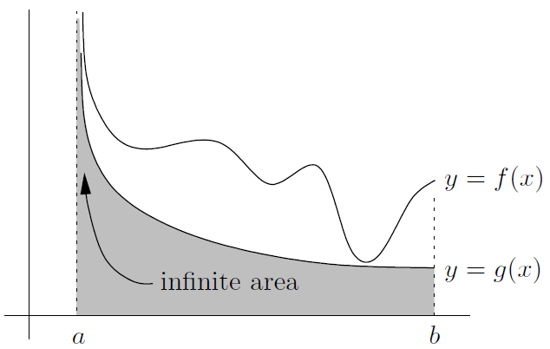

On the other hand, for convergence, it is the other way around. Here, if we want to know about

and we know that converges, we'd better hope that . You might say that we want to be “controlled” by . Well, then we'd get convergence (still assuming that both functions are positive). So, if on and converges, then so does , Mathematically,

so both integrals converge (noting that the left-hand integral is positive, so it can't diverge down to ). The picture looks like this:

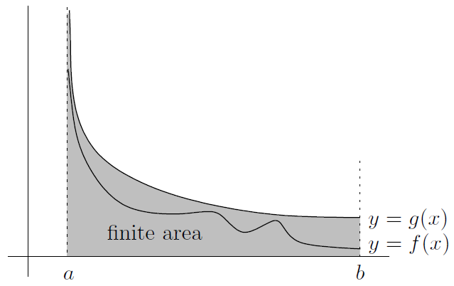

Beware: (Page 440)

1. The Limit Comparison Test (Theory)

The comparison test uses the improper integral of one function to get information about an improper integral of another function. The limit comparison test does the same thing, except that we don't actually need one function to be bigger than the other. Instead, we need the two functions to be just about the same. Here's the basic idea: suppose that two functions and are very close to each other at the blow-up point (and have no other blow-up points). Then and either both diverge or both converge. Their behavior is identical

* Functions asymptotic to each other

Suppose we have two functions and such that

This means that when is near , the ratio is close to . If the ratio were equal to , then would equal . Since the ratio is only close to , then is “very close” to

So, we'll say that as if the limit of the ratio is . That is,

as means the same thing as

All we've done is to rewrite each limit in a different form, but it is a very convenient form. Indeed, you can take powers of asymptotic relations and get new ones. For example, knowing that as , we can immediately write that as , or even that as . You can also replace by any other quantity that goes to as does, such as a power of . For example as . You can even multiply or divide two relations by each other, provided that the limit is at the same value of for both asymptotic relations. For example, we know that as since . So we can multiply and (both as ) together to get the asymptotic relation as

What you cannot do is add or subtract these relations. For example, if you start with and as , you can't just subtract the second relation from the first to get

* The statement of the test

If as , and neither function has any problem spots anywhere else on the interval , then the integrals and both diverge or both converge. (If they both converge, then the values they converge to may be different.) This is one case of the *limit comparison test*. Here's a sneak preview of its power; we'll see many more examples in the next chapter. Suppose we want to know whether

converges or diverges (Page 443)

Of course, there are cases of the test which apply when the blow-up point is at , or when the region of integration is unbounded

In particular (Page 444). A quick comment: most textbooks have a different statement of the limit comparison test. In particular, the limit of doesn't actually have to be -it could be any positive number and the above argument would still work (after a slight modification)

1. The -test (Theory)

Now that we have the comparison test and limit comparison test, we need to know how to use them. Our basic strategy, which will be greatly elaborated upon in the next chapter, will be to pick a function which we can compare our function with. Hopefully is simple enough that we can at least say whether its integral (over the region under consideration) converges or diverges

The question is, what are some functions we could choose as ? Well, the most useful are the functions for some . The -test:

* (**-test**, **version**) For any finite , the integral

converges if and diverges if

* (**-test**, **version**) For any finite , the integral

converges if and diverges if

Notice that the two versions of the test are basically opposites: except for when , one of the integrals

converges and the other one diverges. The case corresponds to , and as we already know, both of the integrals diverge in this case

One way to remember the correct version of the test is to remember what happens with and . I just remember the two little facts:

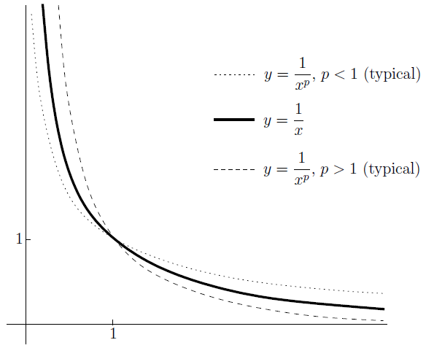

1. The Absolute Convergence Test

One of the assumptions in the comparison test is that the functions and are always nonnegative. What if you want to investigate the behavior of a function which is sometimes negative? Well, if the function is always negative, you could just pull out a minus sign and reduce it to the case of a positive function. We'll see an example of this in the next chapter. On the other hand, if the function keeps oscillating between positive and negative values throughout

the region of integration, you can appeal to the **absolute convergence test**. Here's what it says:

If converges, then so does

This also works on infinite regions of integration (such as instead of ). Watch out: if the absolute-value version of the original integral diverges, then the original integral could still converge!

Why is the above test useful? Well, for one thing, is always nonnegative, so you can use the comparison test on improper integrals involving it. For example, consider the improper integral (Page 447)

**CHAPTER 21 Improper Integrals: How to Solve Problems**



Let's get practical and look at a lot of examples of improper integrals

1. How to Get Started

Our first task is to split up the integral as appropriate, and our second task will be to deal with what happens if is sometimes negative

* Splitting up the integral

Here's the basic plan of attack:

1. **Identify all the problem spots** in the region
2. **Split up the integral** into enough pieces so that each new piece has at most one problem spot, which occurs at one of the endpoints of the integral
3. **Look at each piece individually. If any one piece diverges, so does the whole thing**. The only way the original improper integral can converge is if each piece converges

The key point is that all the pieces have to converge in order for the whole integral to converge

Here's an important case: what if there are no problem spots? That is, (Page 452). In summary, **if there are no problem spots, the integral automatically converges!**

* How to deal with negative function values

If takes on negative values for some in , which often happens when trig functions or logs are present, you need to take special care. Luckily you can often reduce matters to integrals with only positive integrands. Here are three ways to deal with negative function values:

1. If the integrand is both positive and negative as ranges over , you should consider trying the *absolute convergence test*. As we saw in Section 20.6 of the previous chapter, this says that

If converges, then so does

In general, don't forget this important point: the absolute convergence test only helps you show that an integral converges. That is, **you cannot use the absolute convergence test to show that an integral diverges!**

1. Suppose that the integrand is **always** negative (or zero) on . That is, on . If this is true, you can write

So what? Well, is now always nonnegative, so you can use the comparison test or the -test to see whether converges or diverges. Of course, if this integral converges, so does , and similarly if diverges, so does

1. If neither of the previous two cases seems to apply, you may be able to use the formal definition of the improper integral to see what's going on. An example of this is

which we looked at on page 448

This is not the end of the story. There are slightly freaky improper integrals which converge, but which are not absolutely convergent._ These sorts of improper integrals seem to come up quite often in actual physics and engineering applications, but they are beyond the scope of this book. So, it's time to go back and review the integral tests

1. Summary of Integral Tests

The most valuable tools you have at your disposal are the comparison test, the limit comparison test, and the -test. We looked at these tests from a theoretical point of view in the previous chapter; here are the statements once again, for reference. **In all the tests below, the integrand** **is assumed to be positive on the region of integration**

* **Comparison test, divergence version:** if you think that diverges, find a smaller function whose integral also diverges. That is, find a nonnegative function such that on , and such that diverges. Then

So diverges

* **Comparison test, convergence version:** if you think that converges, find a larger function whose integral also converges. That is, find a function such that for all in , and such that converges. Then

So also converges

As an alternative to the comparison test, there is the limit comparison test. This is useful when you can find a function which behaves just like the integrand near the problem spot

as means the same thing as

The definition also applies if you replace both instances of by (or ). In any case, if your integrand is really nasty and you can find a nicer function such that as approaches the problem spot, you're in business! That's because the limit comparison test says that whatever goes for also goes for . More precisely, here are two versions of the test depending on whether the problem spot is infinite or finite:

* **Limit comparison test, version:** find a simpler nonnegative function with no problem spots in , such that as . Then

- if converges, so does ; whereas

- if diverges, so does

Of course, you can change the region into and everything still works. There's also a version which applies when the problem spot is at some finite value , which is at the left endpoint of the region of integration:

* **Limit comparison test, finite version:** find a simpler nonnegative function with no problem spots in so that as . Then

- if converges, so does ; whereas

- if diverges, so does

Needless to say, this is also true if the only problem spot is at the right endpoint instead of , provided that as (not )

So it's up to us to pluck an appropriate function out of thin air to use as a comparison. It turns out that a lot of problems can be solved simply by taking to be equal to for some appropriately chosen . The convergence or divergence of the integral of such a function is precisely stated by the -test:

* (**-test**, **version**) for any finite , the integral

converges if and diverges if

* (**-test**, **version**) for any finite , the integral

converges if and diverges if

1. Behavior of Common Functions near and

OK, it's now time to answer the most important question of them all: how do you choose the comparison function ? This depends on whether the problem spot is at , or some other finite value, so we'll consider these cases separately

* Polynomials and poly-type functions near and

As far as polynomials are concerned, **the highest power dominates** as or . More precisely, suppose that is a polynomial; then it's true that

If the highest-degree term of is , then as or as

For example, we have (Page 456)

If is a poly-type function instead of a polynomial, a similar principle applies

Since we have many new asymptotic relations, we can use the limit comparison test to analyze a lot of improper integrals. For example, consider

We have

Now, we have to be careful! We'd like to say that the integral we want behaves exactly like the integral ; the difficulty here is that this integral now has an extra problem spot at . In fact, this integral diverges, but only because of the problem spot at . This would lead to the wrong answer altogether. In order to avoid these inanities, we should have started by splitting the original integral into the pieces

Beware of this situation-it arises often, so make sure that you split up the integral. Basically, if the “limit comparison function” has a problem spot that the original function doesn't, you have to split up the original integral to avoid introducing a new problem spot. Normally the new integrand will be of the form , so you just need to avoid when you have a problem spot at , just as in our example

Finally, consider

As we discussed above, the highest power in the denominator is difficult to pin down, since and cancel out. So, we have to multiply top and bottom by the conjugate expression of the denominator (Page 459)

* Trig functions near and

Perhaps the only really useful thing we can say here is that

and

for **any** real number . There are two main applications of the above inequalities. One is that you can use the comparison test in many cases. For example, does the integral

converge or diverge? Since the sine (or cosine) of **anything** is no more than in absolute value. So, we have

And we can get that

The other nice application of the facts that and is that you can treat the sine or cosine of anything as inconsequential compared to any positive power of , at least as or . For example

* Exponentials near and

Here's a really useful principle: **exponentials grow faster than polynomials**. We first saw this in Section 9.4.4 of Chapter 9. There we expressed the principle in the form

where is any positive number, even a very large one. Now consider the function defined by (Page 461). There must be some maximum height that the graph of gets to. Let's call it ; this means that for all . (Note that you get a different for each , but that doesn't really affect us at all.) We can get the useful inequality

The same is true if you replace by , where is any polynomial-type expression that goes to infinity when , and also if the base is replaced by any other number greater than . The important point is that you get to choose any you like, and you often have to be careful that you make it large enough. For example, consider

We notice that

This is just the above boxed inequality, with chosen to be . Why ? Because it works:

We have used the -test to show that converges. The comparison test now shows that the original integral converges as well. Now, how did I know to use ? What would happen if I used, say, instead? It doesn't work (Page 462). In practice, it's good to choose a number more than the power you are trying to kill

An important point: it is wrong, wrong, wrong to write as . It simply isn't true! If it were, then you could cancel out the positive quantity to conclude that as , and this is just crazy talk. So you should use the comparison test, not the limit comparison test, in the previous example

How about near ? Well, this is the same thing as understanding the behavior of near ! For example, to investigate

Make . Since

* Logarithms near

First, notice that we don't consider logarithms near , because you can't take the log of a negative number! So it's futile to ask what happens to as

On the other hand, logs grow slowly at . In fact, they grow more slowly than any positive power of . In symbols, we can say that if is some positive number of your choosing, then no matter how small it is, we have

We looked at this principle in some detail in Section 9.4.5 of Chapter 9. By a similar argument to the one we used at the beginning of Section 21.3.3 above, you can show that there must a constant such that

The same is true for logs of any base greater than , or if is replaced by the log of a polynomial with positive leading coefficient

For example, what do you make of (Page 465)

The methodology is very similar to how we handled exponentials in Section 21.3.3 above

Mind you, the principle that logs grow slowly isn't useful in every improper integral involving logs. Here are six improper integrals to consider: (Page 465)

1. Behavior of Common Functions near

We now know all about how polynomials, trig functions, exponentials, and logarithms behave at infinity. Now let's see what happens to them near zero

* Polynomials and poly-type functions near 0

For polynomials, **the lowest power dominates** as . This is the opposite of what happens as ! To be more precise, suppose that is a polynomial; then it's true that

if the lowest-degree term of is , then as

For example, as

For poly-type functions, it's not always easy to find the lowest-degree term, but the general principle still holds water. So, for example, as . The principle even works if constants are present-they are really multiples of , which is a very low-degree term! So, for example, as , as has a lower exponent than

* Trig functions near

Here are some very useful facts:

These are just restatements of limits we've already looked at in Chapter 7:

Beware: these asymptotic relations only work with products and quotients, not sums and differences. For instance, you cannot write as ; see the end of Section 20.4.1

Let's look at some examples (Page 470)

A word of warning: just because we're looking at the behavior as doesn't mean that the problem spot has to be at . It might even be at , as the following example shows:

* Exponentials near

In some sense, **exponentials have no effect at** . More precisely,

This is just another way of saying that

For example, the improper integral

diverges, because

Beware: this only applies to the exponential of a small quantity (like or ). An example of a tricky integral where you could trip up is

It would be wrong to write , since as

Here's another possible trap. In the integral

We need to be cleverer, from Section 9.4.2 of Chapter 9 to conclude that

It follows that

* Logarithms near

Here the principle is that logs go to slowly as . Let's make things go to instead by taking absolute values, remembering that is negative when . So the idea is that no matter how small is, there's some constant such that

This follows from the limit

which we looked at in Section 9.4.6 of Chapter 9

So, to understand (Page 473)

* The behavior of more general functions near

In Section 24.2.2 of Chapter 24, we'll learn about Maclaurin series. Anyway, the basic idea is that if a function has a Maclaurin series which converges to the function near , then the function is asymptotic to the lowest-order term in the series as . That is

if

Consider the following examples:

1. How to Deal with Problem Spots Not at or

If a problem spot occurs at some finite value other than , do a substitution. Specifically:

* If the only problem spot in occurs at , make the substitution . Note that . The new integral has a problem spot at only
* If the only problem spot in occurs at , make the substitution . Note that . Use the minus sign to switch the limits of integration. The new integral should have a problem spot at only

**CHAPTER 22 Sequences and Series: Basic Concepts**



Here's the good news: infinite series are pretty similar to improper integrals. So a lot, but not all, of the relevant techniques are shared and we don't need to reinvent the wheel. In order to define what an infinite series is, we'll also need to look at sequences

1. Convergence and Divergence of Sequences

A sequence is a collection of numbers in order. It might have a finite number of terms, or it might go on forever, in which case it is called an *infinite sequence*. For example,

is an infinite sequence which incidentally includes every integer, positive and negative. Sequences are normally written using subscript notation, where denotes the first element of the series, the second, the third, and so on. (Sometimes is the first element, the second, and so on. Also, we don't have to use ; for example, or any other letter is fair game.)

Given an infinite sequence, our main focus is going to be on the limiting behavior of the values of the sequence as the index tends to infinity. That is, what happens to the sequence as you look farther and farther along it? In math notation, does

exist, and if so, what is it? By the way, we haven't really defined the above limit, but the definition is not much different from the definition of for a function . The basic idea is that the statement

means that might wander around for a little while, but eventually gets very close-as close as you like-to and stays at least as close to for ever after. If there's such a number , then the sequence *converges*; otherwise it *diverges*

By the way, as we did with functions, we sometimes say that as . This means the same thing as saying

* The connection between sequences and functions

Consider the sequence given by

which we looked at earlier. This is closely related to the function defined by

In fact, is equal to for each positive integer . So if we can establish that exists, then we'll know that the sequence has the same limit. The sequence inherits the limiting properties of the function. There's also a connection to horizontal asymptotes

Inspired by these observations, we can easily extend some other properties of limits of functions to the case of sequences. For example, if you have two convergent sequences and , such that and as , then the sum gives a new sequence which converges to . The same goes for differences, products, quotients (provided that , since you can't divide by ), and constant multiples

Another useful fact is that the sandwich principle: In math-speak, if and both and as , then as as well (Page 479)

Another property which transfers over from functions is that **continuous functions respect limits**. Well, suppose that as . Then if is a function which is continuous at , we can say that as . The limit relation is preserved when you hit everything with (Page 479)

One more useful tool that we can borrow from the theory of functions is l'Hôpital's Rule. The problem with using the rule on a sequence is that you can't differentiate the quantity with respect to the variable , since has to be an integer. Indeed, when you differentiate a function with respect to a variable , the idea is that you wobble around a little and see what happens to . You can't wobble an integer around because it wouldn't be an integer any more. So, if you want to use l'Hôpital's Rule, you have to embed the sequence in a suitable function first. For example, if , you can find by letting (Page 480)

* Two important sequences

Pick some constant number and consider the sequence given by starting at . This is a *geometric progression*. Notice that each term is a constant multiple of the previous one. Let's look at a few examples of geometric progressions:

* if , the sequence is just which clearly converges to
* if , the sequence is just which clearly converges to
* if , the sequence is just which evidently converges to
* if , the sequence is just which diverges, but not to or , because it keeps on oscillating back and forth between and - in other words, the limit does not exist (DNE)
* if , the sequence is just which diverges in the same way (the limit does not exist)-in fact, this time the oscillations are even wilder
* if , the sequence is just which converges to 0; and finally
* if , the sequence is just which also converges to , despite the oscillations, since these oscillations eventually become as small as you like

These are all special cases of the general rule, which is as follows:

Geometric progessions don't have to start at . If we set , where is some constant, then the first term is equal to . Most important, if , then is regardless of the value of

Let's look at the limit of another sequence very quickly. In particular, if is any constant, then

1. Convergence and Divergence of Series

A series is just a sum. We'd like to add up all of the terms of a sequence

You begin with an infinite **sequence**

and use it to construct an infinite **series**:

To understand the limiting behavior of this series, make a **new sequence** of partial sums:

By definition, the limit of the series is the same as the limit of the new sequence of partial sums, if the limit exists; otherwise the series diverges

Here's how to define the value of an infinite series using sigma notation: (Page 483)

By the way, we don't need to begin our series at . You can begin at any number, even . Now, here's an important point: whether a series converges or diverges has nothing to do with the starting point of the series!

* Geometric series (theory)

Let's look at an important example of an infinite series. Suppose we start with the geometric progression , which we looked at in Section 22.1.2 above. We can use this sequence as the terms of an infinite series:

This is called a *geometric series*. The question is, does it converge, and if so, to what?

To find out, we'd better look at the partial sums (Page 484). Hopefully, in your previous math studies you've seen that the above expression can be simplified as follows:

First, suppose that . Then we saw in (Page 485). Here's how the whole argument

looks on one line, using sigma notation:

How about when isn't between and ? It turns out that the geometric series must diverge in this case; we'll see why at the end of the next section. So, in summary:

otherwise, if or , the series diverges

In the above geometric series, the first term is always , since . If you start at some other number instead, then the terms are , and so on. So you can get a more general form of the above principle:

otherwise, if or , the series diverges

1. The th Term Test (Theory)

For a series to converge, the sequence of partial sums has to have a limit. So, your step sizes, which are just given by the sequence , eventually have to become very small, at least if you want your series to converge. Mathematically, this means that you need to have as . This leads us to the *nth term test*:

th term test: if , or the limit doesn't exist, then the series diverges

If , then the series may converge or it may diverge, and you have to do more work to resolve the issue. Just beware: **the th term test cannot be used to show that a series converges**!

In a convergent series, although the terms must go to , that doesn't mean that the limit of the series is

1. Properties of Both Infinite Series and Improper Integrals

It turns out that there are some connections between infinite series and improper integrals, particularly improper integrals with a problem spot at

* The comparison test (theory)

This is basically the same as the comparison test for improper integrals (Page 487)

For example, consider

Using the comparison test

* The limit comparison test (theory)

In Section 20.4.1 of Chapter 20, we made the following definition:

as means the same thing as

There's a version of this for sequences that looks almost the same:

as means the same thing as

By the way, if as , we say that the sequences are *asymptotic* to each other

For example, consider

We see that

So the above relation can be written as

* The -test (theory)

There's also a -test for series. It's basically the same as the -test for improper integrals with problem spot at . In particular, it says that

Some simple examples of the -test are that

* The absolute convergence test

If the series keeps switching between positive and negative terms? Some examples of this are

The second and third of these series are actually *alternating series*. This means that the terms alternate between positive and negative numbers

The absolute convergence test says that if converges, so does . Again, the series can start at any value of , not necessarily

1. New Tests for Series

Let's look at four tests for convergence of series which have no corresponding improper integral version: the ratio test, the root test, the integral test, and the alternating series test

* The ratio test (theory)

Here's a really really useful test which only works for series, not improper integrals. It's called the *ratio test* because it involves the ratio of successive terms of a sequence

Let's set the scene: suppose we have a series . We'd like the terms to go to fast enough for this series to converge. Here's one way this can happen: suppose we consider a new sequence, which we'll call , of the absolute value of ratios of successive terms of the series. That is, we let

for each . This is a sequence, so maybe it converges to something. Now here's the result: if the sequence converges to a number less than , then we can immediately conclude that the series converges. In fact, it converges absolutely: that is, also converges. On the other hand, if the sequence converges to a number greater than , then the series diverges. If the sequence converges to , or if it doesn't converge, then we can't say anything about the original series

* The root test (theory)

The root test (also called the th root test) is a close cousin of the ratio test. Instead of considering ratios of successive terms, just consider the th root of the absolute value of the nth term. That is, starting with a series , let's make a new sequence given by

Now you see whether the sequence converges and try to find the limit. If the limit is less than , then the series converges (in fact, converges absolutely). If the limit is greater than , the series diverges. If the limit equals , then you can't tell what the heck is going on and have to try something else

* The integral test (theory)

We already saw in Section 22.4 above that there's a connection between improper integrals and infinite series. The integral test really nails down this connection

In summary, we have the **integral test**: if is a decreasing positive function such that for all positive integers , then

either both converge or both diverge. Again, the series can start at any number, not just ; just change the lower bound of the integral to match

* The alternating series test (theory)

When a series converges, but its absolute version diverges, we say that the series *converges* *conditionally*. So converges conditionally. Let's see why

The *alternating series test* says that if a series is alternating, and the absolute values of its terms are decreasing to , then the series converges. That is, we need to be alternately positive and negative, and to be decreasing, and . In that case, the series converges

**CHAPTER 23 How to Solve Series Problems**



The scenario: you are given a series , and you want to know whether or not it converges. If it does converge, then perhaps you'd like to know its value (that is, what it converges to). The series has to be pretty special in order to find a nice expression for its value. Of course, the series may not start at as in the above series-it could be or some other value of

This chapter is all about giving you a blueprint of how to proceed. Here's a possible flowchart for how to approach a series:

1. **Is the series geometric?** If your series only involves exponentials like or , it might be a geometric series, or it might be the sum of one or more geometric series
2. **Do the terms go to ?** If the series isn't geometric, try the **th term test**. Check that the terms converge to ; otherwise the series diverges by the nth term test
3. **Are there negative terms in the series?** If so, you may have to use the **absolute** **convergence test** or the **alternating series test**
4. **Are factorials involved?** If so, use the **ratio test**. The test is also useful when there are exponentials involved but the series isn't geometric
5. **Are there tricky exponentials with in the base and the exponent?** If so, try the **root test**. In general, if it is easy to take the th root of the term , the root test is probably a winner
6. **Do the terms have a factor of exactly as well as logarithms?** In that case, the **integral test** is probably what you want
7. **Do none of the above tests seem to work?** You may have to use the **comparison test** or the **limit comparison test** in conjunction with the ***p*-test**

The above blueprint will help guide your way through a lot of different series. It's not perfect! There are always tricks and traps that could arise

1. How to Evaluate Geometric Series

**If your series only involves exponentials like or , it might be the sum of one or more geometric series**. As we saw in the previous chapter, geometric series are simple enough that you can actually find their values (if they converge). The general form of a geometric series is , where is the common ratio. Rather than learn the formula in mathematical language, I recommend learning it in words:

sum of infinite geometric series , if

If the common ratio isn't between and , then the series diverges (Page 502 )

1. How to Use the th Term Test

**Always try the th term test first**! The test says:

if , or the limit doesn't exist, then the series diverges

If the terms of your series don't tend to , the series must diverge. If the terms do tend to , the series might converge or it might diverge: you have to do more work. **This test cannot be used to show that a series converges**

1. How to Use the Ratio Test

**Use the ratio test whenever factorials are involved**. Remember, factorials involve exclamation points, such as in or . The ratio test is also often useful when there are exponentials around, such as or . Here's the statement of the test

if , then converges absolutely if , and diverges if ; but if or the limit doesn't exist, then the ratio test tells you nothing

To use the ratio test, always start with the following framework:

1. If , then the original series converges; in fact, it converges absolutely
2. If , then the original series diverges
3. If , or the limit doesn't exist, then the ratio test is useless. Try something else
4. How to Use the Root Test

**Use the root test when there are a lot of tricky exponentials around involving functions of** . It's especially useful when the terms of your series look like , where both and are functions of . Here's the statement of the test

if , then converges absolutely if , and diverges if ; but if or the limit doesn't exist, then the ratio test tells you nothing

To use the root test, always start off with the following expression:

and then replace by the general term of the series. Find the limit (if it exists) and call it . Then you have three possibilities, which are identical to the possibilities which arise in the ratio test. The conclusions are luckily the same as well:

1. If , then the original series converges; in fact, it converges absolutely
2. If , then the original series diverges
3. If , or the limit doesn't exist, then the ratio test is useless. Try something else
4. How to Use the Integral Test

**Use the integral test when the series involves both and .** If is any positive integer, then we can say:

if , for some continuous decreasing function , then and either both converge or both diverge

In practice, here are the steps involved in using the integral test

* Replace by , change into , and put a at the end. Of course, if the series begins at , then you use instead, for example
* Check that the integrand is decreasing; you can do that by showing that the derivative is negative, or just by inspecting the integrand directly
* Now deal with the improper integral from the first step. The main advantage of integrals over series is that you can use a substitution (or change of variables, if you prefer) in an integral. The most common substitution in this context is
* If the improper integral converges, so does the series. If the integral diverges, the series diverges too

1. How to Use the Comparison Test, the Limit Comparison Test, and the -test

**Use these tests for series with positive terms when none of the other tests seem to apply**. You definitely want to try the th term test first, then use the ratio test if factorials are involved, the root test if the terms have exponentials where the base and exponent are both functions of , or the integral test if you have a factor of and logarithms are involved. What does that leave? Basically the same tools as you have for integrals: the comparison test, the limit comparison test, the -test, and an understanding of how common functions behave near and near . In any case, here are the tests once more. (For the comparison and limit comparison tests, we assume all the terms are nonnegative.)

1. **Comparison test, divergence version:** if you think diverges, find a smaller series which also diverges. That is, find a positive sequence such that for all , and such that diverges. Then

so diverges

1. **Comparison test, convergence version:** if you think converges, find a larger series which also converges. That is, find such that for all , and such that converges. Then

so converges

1. **Limit comparison test:** find a simpler series so that as . Then if converges, so does . On the other hand, if diverges, then so does . (Remember that “ as ” means the same thing as “”)
2. **-test:** if , the series

This is the same as the version of the -test for integrals

Now consider the series (Page 513)

A really nasty series: (Page 513)

1. How to Deal with Series with Negative Terms

Suppose some of the numbers which appear as terms in your series are negative. Here are some ways to handle this situation:

1. **If all the terms** **are negative, then modify the series by putting a minus sign in front of all the terms**
2. **If some terms are positive and some terms are negative, try the th term test** **first**
3. **If some terms** **are positive and some terms are negative, and the terms converge to**  **as , next try the absolute convergence test**:

if converges, then so does

In this case, we say that the sequence is *absolutely convergent* or that it converges absolutely

1. **If the** **series** **doesn't converge absolutely, try the alternating series test**. As we saw in Section 22.5.4 of the previous chapter

if the absolute values of the terms of an alternating series decrease to monotonically as , the series converges

So there are actually three things to check if you want to use the test on a series :

* the terms alternate between positive and negative (that is, the signs of the terms are, in order, , or perhaps )
* the quantities tend to as gets large; that is,
* the absolute values of the terms are decreasing in (so the underlying sequence is getting smaller and smaller, in terms of absolute value)

If all three of these properties are true, then the series converges. **Note: you should always try the absolute convergence test first. If the series converges absolutely, do not use the alternating series test!**

**CHAPTER 24 Introduction to Taylor Polynomials, Taylor Series, and Power Series**



We now come to the important topics of power series and Taylor polynomials and series

1. Approximations and Taylor Polynomials

Here's a nice fact: for any real number , we have

Also, the closer is to , the better the approximation

* Linearization revisited

What is the equation of the line which best approximates the curve near the point ? The answer to this question is that the line we're looking for is the tangent line to the curve at the point , and its equation is

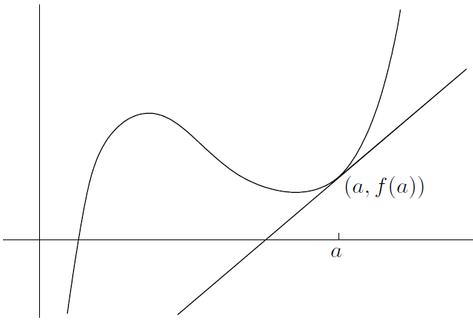

* Quadratic approximations

Why stick to lines, though? Let's ask the same question we did at the beginning of the previous section, but with parabolas instead. Here is our question: what is the equation of the quadratic which best approximates the curve near ? Using the same function as in the picture above, here's a guess as to what the quadratic should look like:

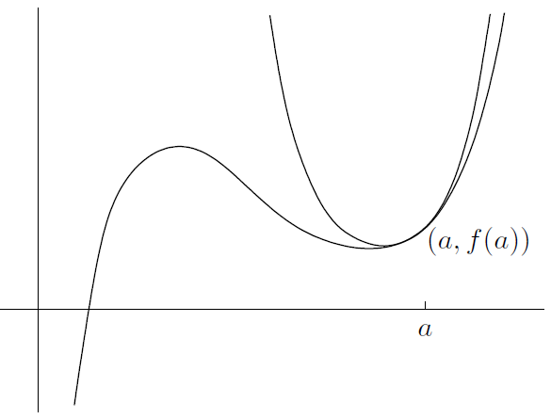

It turns out that the formula for the quadratic which best approximates the curve for near (that is, near the point on the curve) is given by

You can think of the last term as a so-called *second-order correction term*. This means that we should actually be able to do a better job of approximation than just by using the tangent line. The second-order correction term helps us get even closer to the curve, at least for near

* Higher-degree approximations

**A Taylor approximation theorem:** if is smooth at , then of all the polynomials of degree or less, the one which best approximates for near is given by

In sigma notation, the formula looks like this:

In this formula, remember that , that means the same thing as (zero derivatives), and that means the same thing as (one derivative)

We call the polynomial the *Nth-order Taylor polynomial of* at (Page 522)

Once again, the important property of is that

for all

The Taylor approximation theorem actually depends on Taylor's Theorem, which we'll look at in the next section

* Taylor's Theorem

Here's what the error is in our case:

What we'd really like is another formula for the error. That's where Taylor's theorem comes in. We want to use the value of to approximate the true value , so we consider the error term, which is the difference between the true value and the approximate value:

Actually, is called the *Nth-order error term*; it's also referred to as the *Nth-order remainder term*, since it's all that remains when you take away from . As promised above, Taylor's Theorem gives an alternative formula for :

**Taylor's Theorem:** the th-order remainder term by about is

where is some number which lies between and

Note that the number depends on what and are, and cannot be determined in general! Since , we can write the whole kit and caboodle as

This seems pretty nasty. And what on earth is with this number , anyway? (Page 524)

1. Power Series and Taylor Series

Here's another fact:

for all real numbers . You might notice that it looks similar to the approximation at the beginning of Section 24.1 above, but there are two big differences. First, we're no longer dealing with an approximation, and second, there's an infinite series on the right-hand side!

So, let's see if we can understand what the above equation actually means. Suppose we start with the right-hand side,

This looks like a polynomial, but it isn't, since there's no highest-degree term. It just keeps on going forever. In fact, it's an example of a power series

If , you get the series

This series might converge, or it might diverge. So which is it? The answer is that it converges, and what's more, we even know that it converges to

* Power series in general

A *power series about* is an expression of the form

where the numbers are fixed constants. Even though a power series isn't a polynomial, we'll still refer to as the *coefficient* of in the power series. The above series can also be written using sigma notation as

Something nice happens to the power series

when you set : all the terms vanish except for the at the beginning, so the series automatically converges (to , of course!)

Let's transfer this special property over to some other number . All we have to do is replace by . So here is the general expression for a *power series* about :

In sigma notation, this looks like

This series converges for sure when , since all the terms except vanish. The number is called the *center of the power series*

* Taylor series and Maclaurin series

In the previous section, we saw that a general power series about is given (using sigma notation and also in expanded form) by

This converges for , and might converge for other values of . We could then plug in all these values of one at a time, find what the series converges to in each case, and call that . So, starting with a power series, we have defined a function

Suppose that we instead start off with some smooth function . We're going to define a special power series about by using all the derivatives of :

When you expand the sigma notation, this becomes

The coefficients of this power series are given by . The series is called the *Taylor series of* *about* . So, starting with a function, we have defined a power series

In other words, the Taylor polynomial is the th partial sum of the Taylor series

We have just one more definition: the *Maclaurin series* *of* is just another name for the Taylor series of f about . So it's given by

* Convergence of Taylor series

OK, let's review the situation. We started out with a function and a number , and we constructed the Taylor series of about

since then we'd know that the Taylor series converges for any and also that it converges to the original function value . The problem is, the above equation isn't always valid (Page 530)

So, how do you know if and when a Taylor series actually converges to its underlying function? Start by writing (Page 531)

In other words, **if you want to prove that a function equals its Taylor series at some number , try to show that as**

1. A Useful Limit

This section isn't about power series at all-it just contains a proof of a limit we needed twice in the previous section: (Page 534)

**CHAPTER 25 How to Solve Estimation Problems**



1. Summary of Taylor Polynomials and Series

Here are the most important facts about Taylor polynomials and series, all of which were developed in the previous chapter:

1. Of all the polynomials of degree or less, the one which best approximates the smooth function for near a is called the th-order Taylor polynomial about , and is given by

Using sigma notation, this can be written as

1. The polynomial has the same derivatives as at , up to and including order . That is,

and so on up to . The above equations aren't true in general if a is replaced by any other number, or for derivatives of order higher than . (In fact, the derivatives of of order higher than are identically , since is a polynomial of degree .)

1. The th-order remainder term , otherwise known as the th-order error term, is simply the difference . It follows that

for any . The remainder term is given by

where is some number between and a which cannot be computed in general

1. So, the complete expression for is given by
2. The infinite series

is called the Taylor series of about . For any particular , this series may or may not converge. If for any particular the remainder term converges to as , then we can write

for that . That is, is equal to its Taylor series representation (about ) at the point

1. In the special case where , the Taylor series is

This is called the *Maclaurin series* of . So, whenever you see the words “Maclaurin series,” you can mentally replace them by “Taylor series about .”

1. Finding Taylor Polynomials and Series

Suppose you want to find a certain Taylor polynomial or series. If you're lucky, you can take a Taylor polynomial or series you already know, manipulate it, and get the polynomial or series you want. Unfortunately, this doesn't always work: sometimes, you need to bust out the formula for the Taylor series of about . This can be a real pain in the butt, however! Differentiating once or twice is bad enough, but differentiating hundreds and thousands of times is ridiculous. Things aren't so bad if you only want to find a Taylor polynomial of low degree, since then you only have to calculate a few derivatives (Page 537)

On the other hand, some functions are really easy to differentiate. One such example is the function defined by (Page 537)

It's really helpful to set up a table of derivatives. In general, the template should look like this:

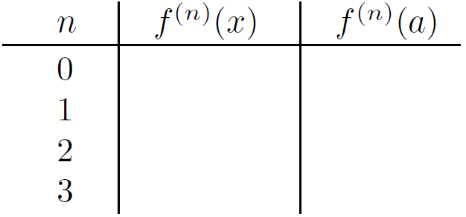

For about

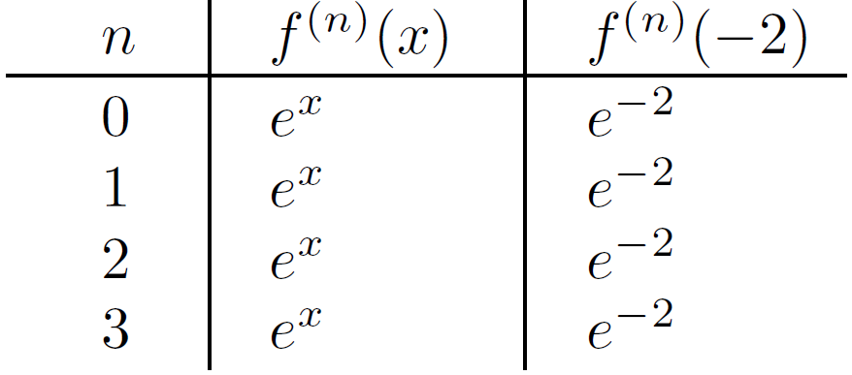

For about

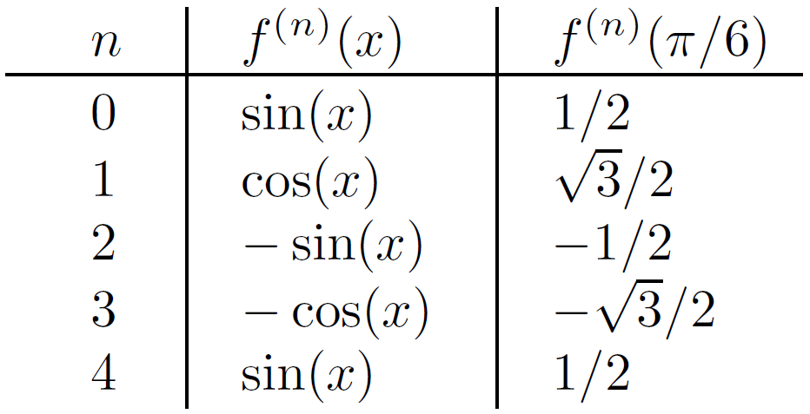

For about

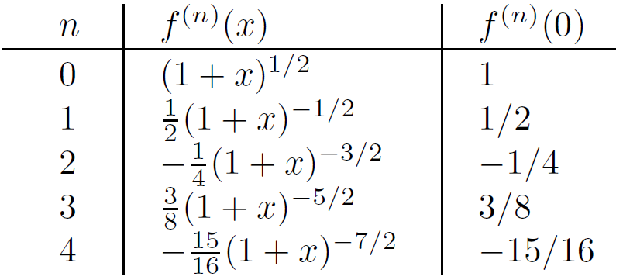

Now, let's write down the general formula for the Maclaurin series,

In fact, it turns out that the remainder term goes to when is between and (this is tricky to prove!), so we actually have

when . This is a special case of the *binomial theorem*, which says that

for . The series on the right-hand side diverges when or unless happens to be a nonnegative integer

1. Estimation Problems Using the Error Term

Consider the following two similar examples:

1. Estimate using a Taylor polynomial of order , and also estimate the error
2. Estimate with an error no more than

With these two types of problems in mind, check out the general method for solving estimation (or approximation) problems:

1. Look at what you want to estimate, and pick a relevant function . In our examples above, we want to estimate , so set . Later on, we will set , since , the quantity we want to estimate
2. Pick a number which is pretty close to this value of , and so that is really nice. This means that you should be able to write down exactly, as well as , , and so on. In our example, we'll put , since that's pretty close to and also is easy to compute
3. Make a table of derivatives of , just like we did in the previous section. It should have three columns which show the values of , , and . If you know the order of the Taylor polynomial to use, that's the value of you'll need; make sure to go up to the th derivative in the table. Otherwise, just write down as many rows as you can be bothered to; you can always fill in more later if you need to
4. If you don't care about the error in your estimate, skip to step 8. Otherwise, write down the formula for :

making sure to write “ is between a and .” As you're writing, replace by its true value on the fly, including in your comment about

1. If you know the order of the Taylor polynomial to use, replace by this number in the above formula. If not, make an educated guess based on how small you need the error to be. The smaller, the higher should be. For many problems, will do nicely. If you're wrong, you'll know soon enough; you'll just have to repeat this step and the next two steps with a higher value of
2. Now, replace by the value you want in the formula for . No unknown variables should be left except for , and you should write down the possible range of as an inequality. In our case, with and , we know that lies in between, so we'd write
3. Find the maximum value of , where lies in the appropriate interval. This is how big the error can possibly be. If you know the value of , you're all done with the error estimate. If not, compare the actual error with the one you want. If your actual error is smaller, that's great-you have found a good value of . Otherwise, you're a little bit screwed-you have to go back to step 5 and try again. (We'll look at some techniques for maximizing in Section 25.3.6 below.)
4. Finally, it's time to find the actual estimate! Write down the formula for :

Now replace and by the values from above to get a formula in terms of alone. Finally, write down the approximation

and plug in the actual value of that you need. The left-hand side will be the quantity you want, and the right-hand side will be the approximation

1. One other piece of information is available if you want it: if is positive, your estimate is an underestimate; if is negative, the estimate is an overestimate. These facts follow from the equation

* First example
* Second example
* Third example
* Fourth example
* Fifth example
* General techniques for estimating the error term

In all the above examples, we had to estimate the quantity for in some given range. Here are some general tips for doing this:

1. Regardless of the value of , you can always use the standard inequalities and
2. If the function is increasing, then its value is biggest at the righthand endpoint
3. If the function is decreasing, then the greatest value of occurs at the left-hand endpoint of the interval
4. In general, you might have to find the critical points of the function in order to maximize it
5. Another Technique for Estimating the Error

Cast your mind back to the alternating series test. The idea is that at each point in the series, adding the next term overshoots the actual value, so the entire error is less than the next term in absolute value (Page 549)

**CHAPTER 26 Taylor and Power Series: How to Solve Problems**



In this chapter, we'll look at how to solve four different classes of problems involving Taylor series, Taylor polynomials and power series

1. Convergence of Power Series

Let's say we have a power series about :

As we saw in the case of geometric series, a power series might converge for some and diverge for other . The question that we want to ask is this: given our power series, for which does it converge, and for which does it diverge? Furthermore, if the series converges for a specific , it would be nice to know whether the convergence is absolute or merely conditional

* Radius of convergence

There are only three possibilities that can occur:

1. There is some number , called the *radius of convergence* of the power series, such that the picture looks like this:

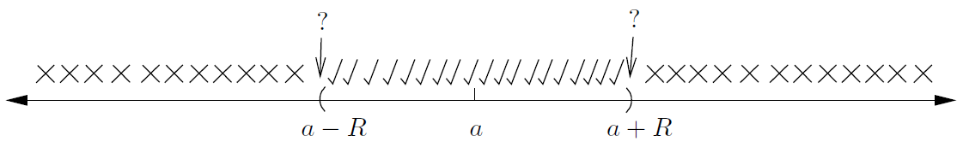

The explanation of this diagram is (Page 553)

An example of this is the geometric series . This is a power series with which converges absolutely when and diverges otherwise. The radius of convergence is therefore equal to , and the series diverges at the endpoints and

1. The power series might converge absolutely for all , in which case the diagram looks like this:



In this case, we say that the radius of convergence is . As we saw above, an example of this is the power series for ,

Other examples include the Maclaurin series for and

1. The power series might converge absolutely only for and diverge for all other . In this case, the radius of convergence is . We'll soon see that this is the case for the series

for example. The picture for this case looks like this:



* How to find the radius and region of convergence

Given a power series, how do we find the radius of convergence? The answer is to use the **ratio test**. Sometimes the root test will be more effective, but for most problems the ratio test is better. Here's the general approach:

1. Write down the limiting absolute ratio; this should always look like

If instead you use the root test, you should get

1. Work out the limit. It's important to note that the limit is as , not . There's a big difference! Regardless of whether you use the ratio test or the root test, the answer should be of the form , where might be a finite number, , or even . The important point is that there is a factor of present
2. In either the ratio test or the root test, the important thing is whether the limit is less than , greater than , or equal to . So, if is positive, then divide by to understand everything: if , the power series converges absolutely; if , then the power series diverges; whereas if , then we can't tell and need to check the two endpoints. We are in the first situation from the previous section, and the radius of convergence is
3. If , then the limiting ratio is always regardless of the value of . Since , this means that the power series converges absolutely for all , so we are in the second case from the previous section and the radius of convergence is
4. If , then it looks like the power series never converges. In fact, the series must converge when , but it will diverge for every other and so we are in the third case from the previous section: the radius of convergence is

First, consider the power series

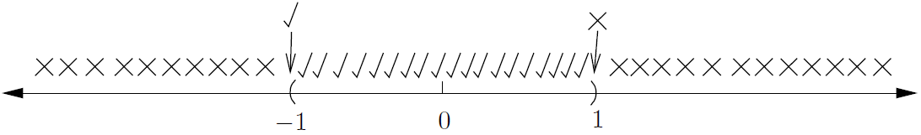

Now consider

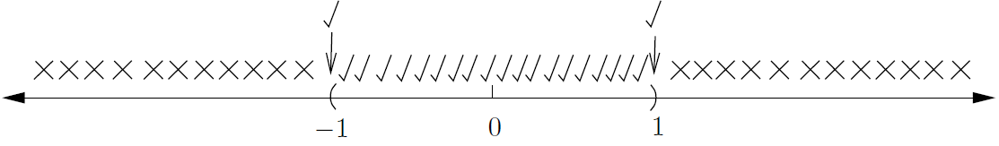

How about



Now consider

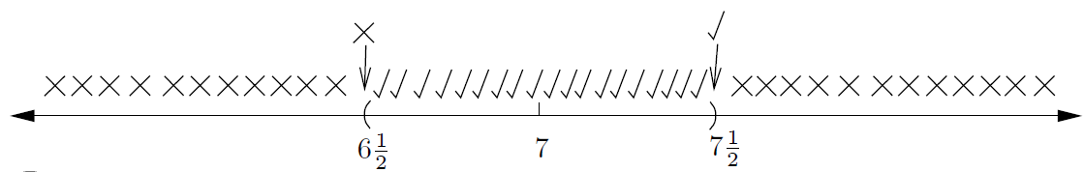

Consider the series



1. Getting New Taylor Series from Old Ones

Let's look at some techniques for finding Taylor series. One way to find the Taylor series about of a given function is to use the formula directly. For most functions, this is a pain. Often a better idea is to use some common Taylor series to synthesize new ones. Of course, you have to know some Taylor series first! It is really useful to have the following five Maclaurin series

1. For : (in Section 24.2.3)

which is true for all real

1. For : (in Sections 26.2.2)

which is true for all real

1. For : (in Section 24.2.3)

which is true for all real

1. For : (in Section 22.2)

which is true only for

1. For or : (in Sections 26.2.3)

which are true for . (Actually, the first formula is also true for as well, and the second formula is true for , but this gets a little complicated!)

Anyway, suppose that you've learned all five series. Here's how to manipulate them to get new power series

* Substitution and Taylor series

The most useful technique is substitution. In a Maclaurin series, you can replace by a multiple of , where is an integer, to get a new Maclaurin series. For example, we know that

for any ; so if you want to find the Maclaurin series for , simply replace by in the above series to get

Let's look at another common example: what is the Maclaurin series for ?

which is valid for , then replace by to get

which is valid for , since the inequalities can reduce to

Suppose instead we wanted to work out the Maclaurin series for . Then we would have replaced by instead. This gives

but this is valid only for , which can reduce to

Now, suppose you start with the following equation, which is true for all real :

If you replace by , you get a Taylor series about instead:

The right-hand side is not the Taylor series about of , because the left-hand side is no longer -it’s . It’s the Taylor series about of

The moral of this last example is that if you replace by , then you get a Taylor series about instead of a Maclaurin series, but the function is different. This can still be useful. For example, to find the Taylor series of about , start with one of the formulas from the previous section:

Now, let's replace by

By the way, the substitution technique can also be used to find Taylor polynomials, but you have to be careful to get the order right. For example, if you take and , the Taylor polynomial of order is

Now if , it's a mistake to replace by in the above polynomial and claim the third-order Taylor polynomial of is

This is actually the **sixth-order** Taylor polynomial of about , so the left-hand side should say instead of

* Differentiating Taylor series

If a power series converges to a differentiable function on an open interval , then it turns out that you can differentiate the series term-by-term to get a new series which converges to on the same interval. The situation at the endpoints and is a little trickier: the differentiated series might diverge even if the original series converges. So check the endpoints separately

Our first example is to find the Maclaurin series for , assuming that we know the Maclaurin series for is given by

the formula is valid for all . If you differentiate both sides, term-by-term on the right, you can get

Here's another example of differentiating a power series. Suppose you want to find the Maclaurin series for . The best way would be to start with the series for , which is obtained from the standard geometric series (#4 above) by replacing by

this is valid for . Then differentiate both sides, term-by-term on the right-hand side, you can get

This is valid for

Once again, you can apply these ideas to Taylor polynomials; you just have to be careful with orders, once again. Since differentiating a polynomial knocks the degree down by one, the differentiated Taylor polynomial is order one less than the original polynomial

* Integrating Taylor series

You can also integrate a power series term-by-term. The new series converges in the same interval as the old one (except perhaps at the endpoints of the interval of convergence). If you use an indefinite integral, don't forget the constant! Let's see a few examples. First, let's try to prove the following formula for

For . To do it, we'll use the geometric series formula, which is #4 in Section 26.2:

valid for

It's a good idea to put the constant first instead of as at the end, since it's really the zeroth-dgree term in the power series. Now we have to find out what actually is. The best way is to substitute

which reduces to . So you get

valid for

Another example: how would you find the Maclaurin series for ? We can be really sneaky and integrate a series we already know. Let's see, is an antiderivative of

Now we substitute to find out . Since the original series for converges when , so does the series for

Let's look at an example of a definite integral. Suppose that a function is defined by

Start by finding the series for

this is valid for all real

You can also apply the above integration techniques to Taylor polynomials; this time the order of the Taylor polynomial increases by

* Adding and subtracting Taylor series

If you know the Taylor series about for two functions and , then the Taylor series for the sum is of course the sum of the two respective Taylor series, at least in the overlap of the regions where the Taylor series converge. The same goes for the difference . The only thing you need to do in practice is to group terms of the same degree together, and worry about where the resulting series converges (Problem: Ignore higher order in Page 565)

* Multiplying Taylor series

You can also multiply two Taylor series to get a new one which converges to the product of the two relevant functions, at least in the intersection of the regions where the Taylor series converge. Writing this in sigma notation can get pretty messy and usually involves double sums. Normally one is interested in the first few terms of a series (Problem: Ignore higher order in Page 566)

Dividing Taylor series

You can do exactly the same thing with quotients by using long division. The trick is to ignore all but the terms of order up to the one you are interested in. For example, to find the Maclaurin series for up to fourth order, first write as , then set up a long division just as you do with polynomials

in the long division for :

So the Maclaurin series for is , up to terms of fourth order

So the moral of the story is that you may not have to differentiate over and over again and use the formula for Taylor series. If you're lucky, you can instead use some of the five basic series, plus one or more of the techniques of substitution, differentiation, integration, addition, subtraction, multiplication, and division

1. Using Power and Taylor Series to Find Derivatives

Recall the formula for the th coefficient of the Taylor series of about :

Let's multiply through by to arrive at the following formula:

In words, this means that

So if you know the Taylor series of a function about some point a, you can easily find the derivatives of that function at a. This is all you get! There's no information about the value of the derivatives at any other value of ; it's only

1. Using Maclaurin Series to Find Limits

You can also use some Taylor series to find certain limits. In particular, if you have a limit like

where both the numerator and the denominator are when , then you could use l'Hôpital's Rule (Page 570): The correct method is to replace everything in sight by enough terms of the appropriate Maclaurin series. Basically, if everything cancels out, you haven't used enough terms, whereas if something is still left, you've gone far enough and can proceed. So, it's better to use more terms rather than fewer

Here's the real reason all the above limits work: if has a Maclaurin series with lowest-degree term , then

**CHAPTER 27 Parametric Equations and Polar Coordinates**



So far, we've sketched the graphs of many equations of the form with respect to Cartesian coordinates. Now we're going to look at things in a different way

1. Parametric Equations

When you write an equation like , you are expressing as a function of . So if you have a particular value of in mind, then you can easily find the corresponding value of by plugging that value of into the above equation. On the other hand, consider the relation , it’s a little harder and you can write

Now let's try a different approach: suppose that both and are functions of another variable . For example, we could set

If you like, you could even write to emphasize the as a function of . Then you can get corresponding values for **both** and by plugging your value of into the above equations. The variable is called a *parameter*, and the above equations are called *parametric equations*

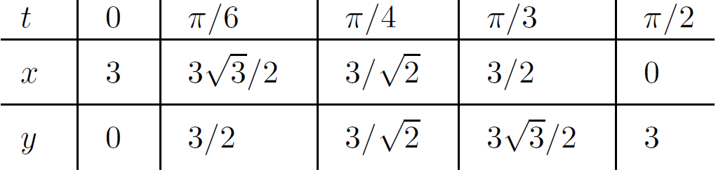

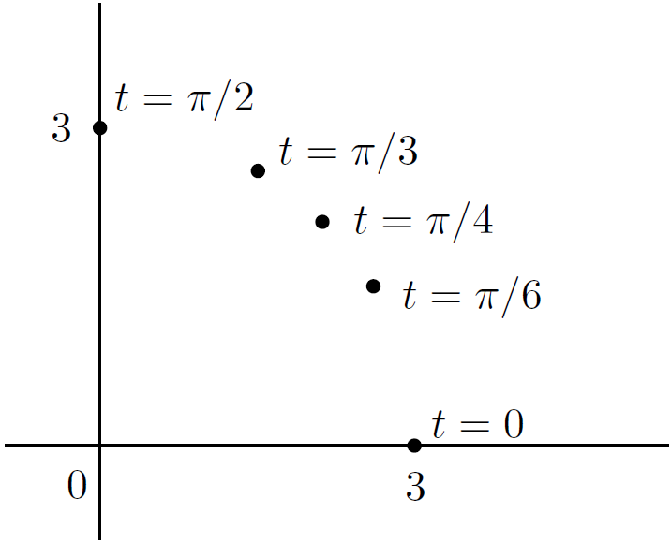

Notice that if you pick a point on the circle, there isn't just one value of which corresponds to that point! There are infinitely many, all separated by multiples of

So, the above pair of parametric equations describes the circle , at least if you let range over a large enough interval-for example, . You can say that

is a *parametrization* of . Is the graph of the same as the graph of the above parametrization? No, the parametric version tells you a little more; it allows you to find the extra information of direction and speed

There are many other ways to draw the same circle . For example, and , is twice as fast as previous one. Alternatively, and , starts at and go clockwise around the circle instead of counterclockwise

How would you find a parametrization for ? (Page 577)

How about ?

* Derivatives of parametric equations

This is a calculus book, so we'd better do some calculus with this parametric stuff. To find the equation of a tangent line to the curve, we'll need a derivative, of course. Since and are both functions of , we have to use the chain rule. This says that

now divide through by and rearrange to get

If you are thinking of as and similarly for , then you can rewrite this equation as

Let's look at three examples of how to use this

First, suppose that we want the slope and equation of the tangent line at the point corresponding to on the parametric curve defined by

Differentiating, we find that

Since we only care about the point

So at , we have

Well, then we have to put in the original equations for and above to see that and . So the equation of tangent line is

Now for a trickier example. Let's try using our parametrization and from the curve at point ; here . We have

So by the chain rule,

We can see that

So the tangent line is

Now for our trickiest example (conceptually speaking, at least). Suppose that we are given the following parametric equations:

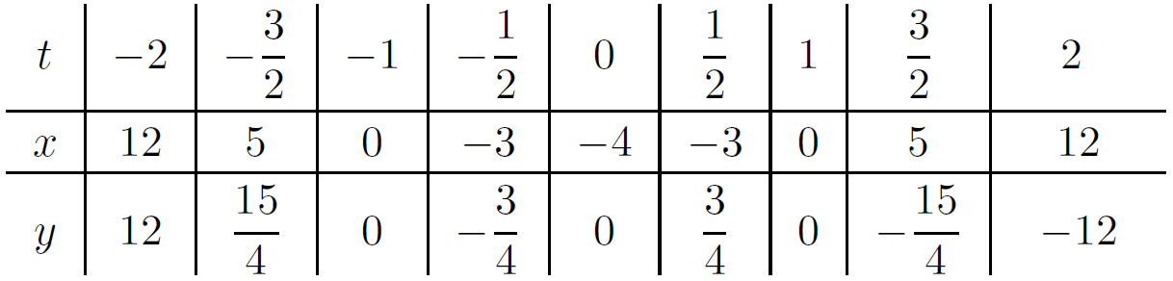

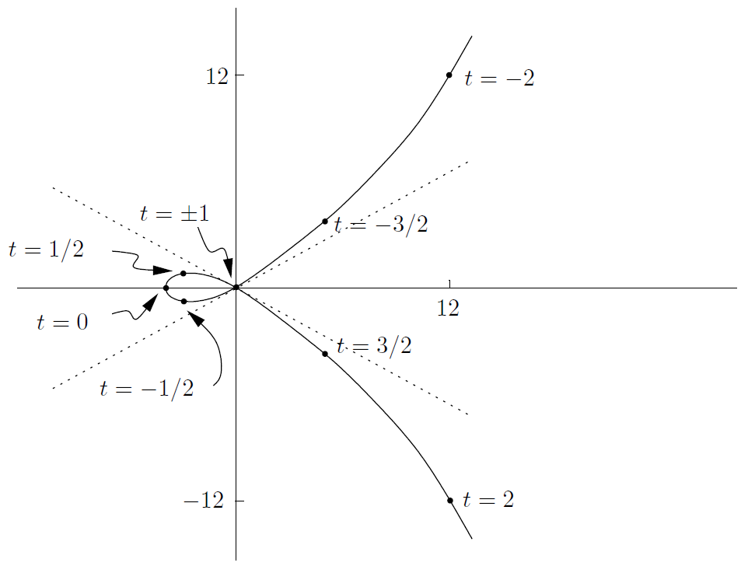

Suppose that now we want to find the **second** derivative of the above parametric equations at . The secret to finding is to consider it as . That is, think of the second derivative as the derivative of , which itself is the derivative of y with respect to

We already saw above that

We now use the chain rule to write

Now we can finally substitute

1. Polar Coordinates

* Converting to and from polar coordinates

Consider the point in polar coordinates, which could look something like this:

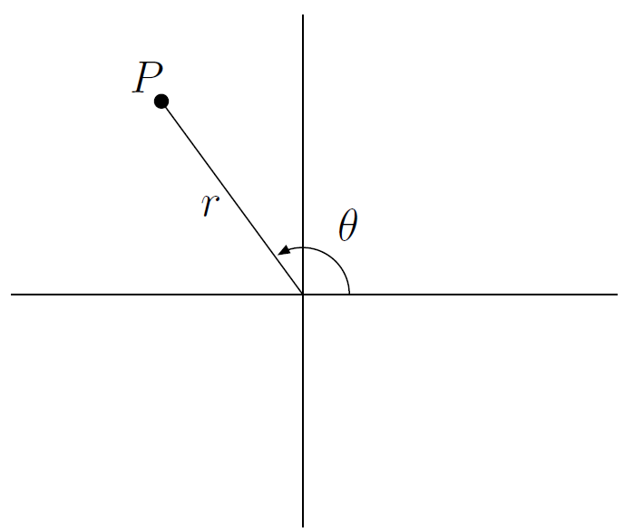

Remember, your friend started at the origin facing toward the positive direction on the -axis, then turned counterclockwise an angle , then marched forward units to get to the point . What are the Cartesian coordinates of ? Well, we know that and , so that gives us

(Compare this with the example , from Section 27.1 above.) Anyway, these equations show us how to convert from polar to Cartesian coordinates. For example, given in polar coordinates by , it's not a bad idea to draw a picture:

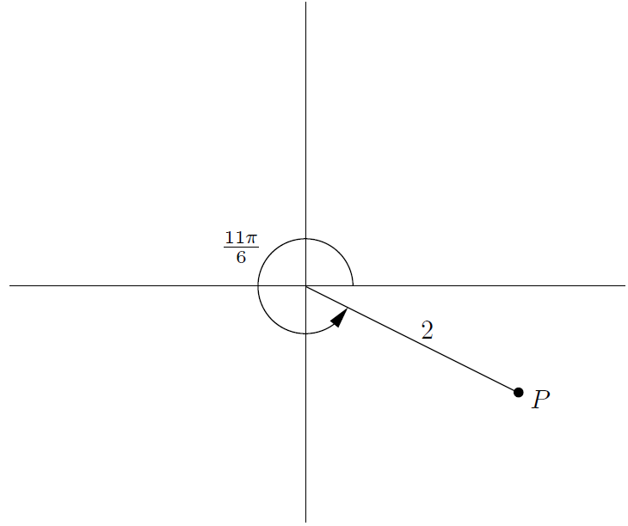

The Cartesian coordinates are

It's always easier translating from a foreign language into your native language than the other way around; the same thing happens with polar coordinates. It's a little harder getting from Cartesian coordinates to polar coordinates. Here's a summary of the situation:

Let's look at an example: suppose we want to write in polar coordinates

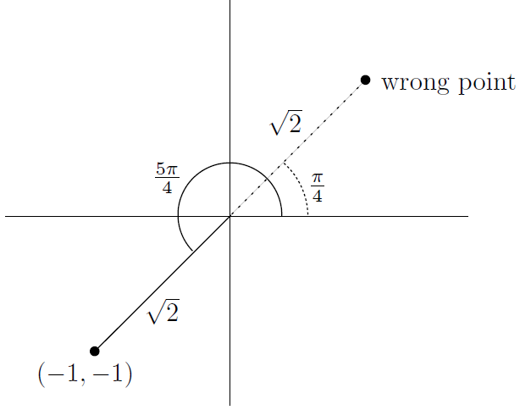

We now have two ways of writing in polar coordinates: and . The complete list of points in polar coordinates we could use is as follows:

The convention is usually to choose the one where and lies between and

A few more examples: what are polar coordinates for the points with Cartesian coordinates ? Let's plot these points on the same set of axes:

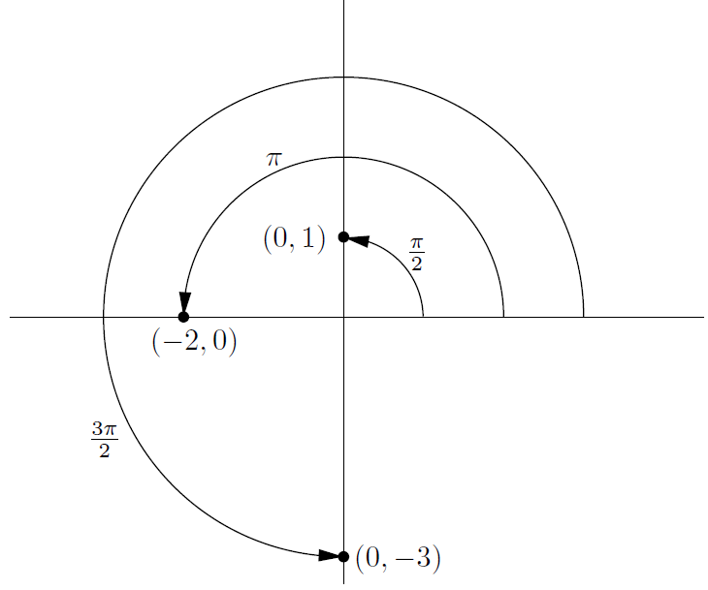

You can get in some trouble using the formula from above. Just look at the picture: has polar coordinates , has polar coordinates , and has polar coordinates

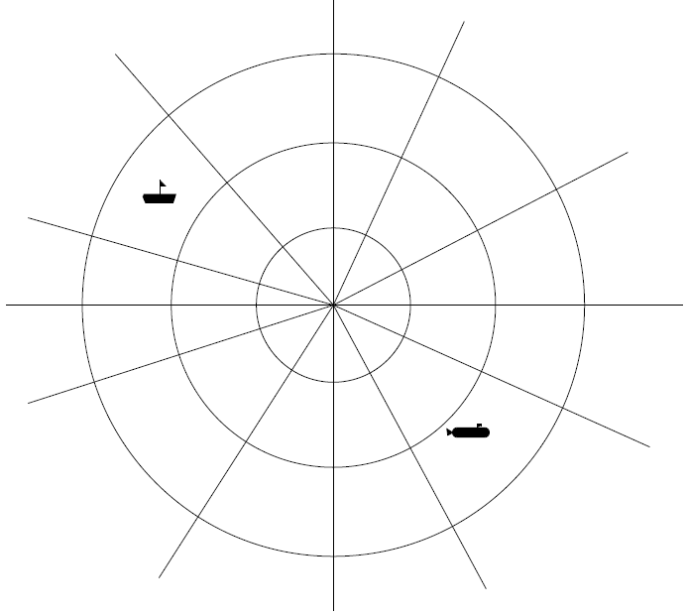

This is just a “grid” in polar coordinates

* Sketching curves in polar coordinates

Suppose you know that for some function , and you want to sketch the graph of all points in polar coordinates where for in some given range. This isn't so easy to do. Probably the best way to proceed is to draw up a table of values and plot points. It can also be helpful to sketch in Cartesian coordinates first. For example, to sketch in polar coordinates, where :

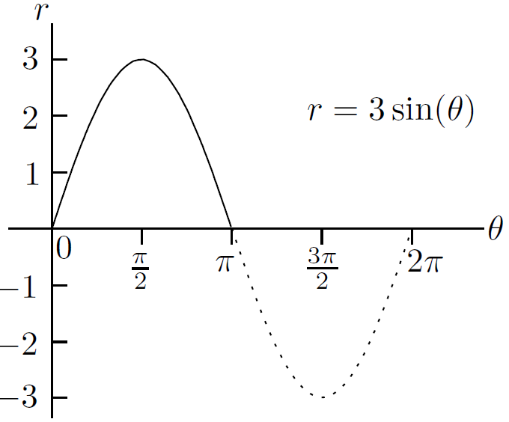

So the curve we want looks something like this:

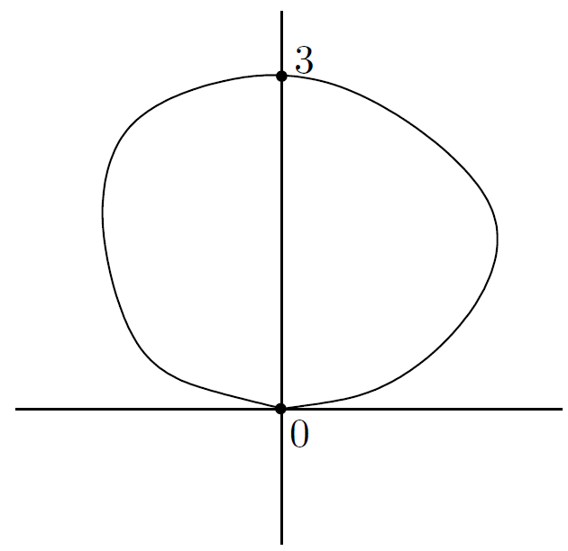

This looks a little pathetic. To tighten it up, we can write down the following table of values:



Plotting these points leads to the following picture:

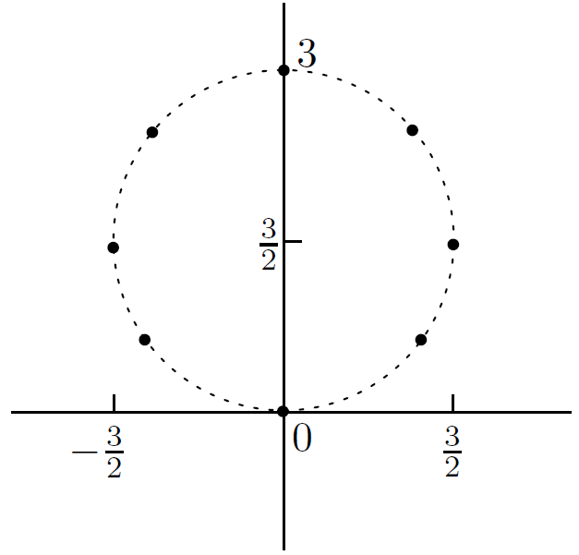

Let's look at another example. Suppose that we want to sketch the curve , where

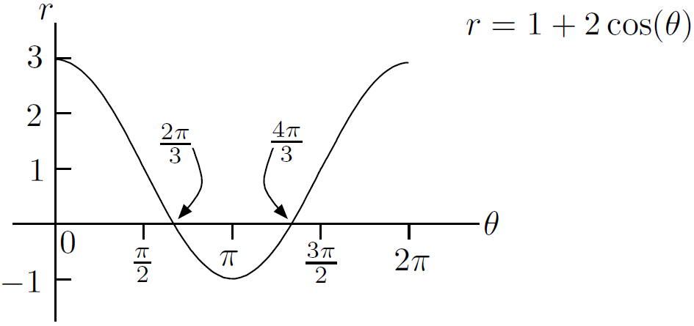

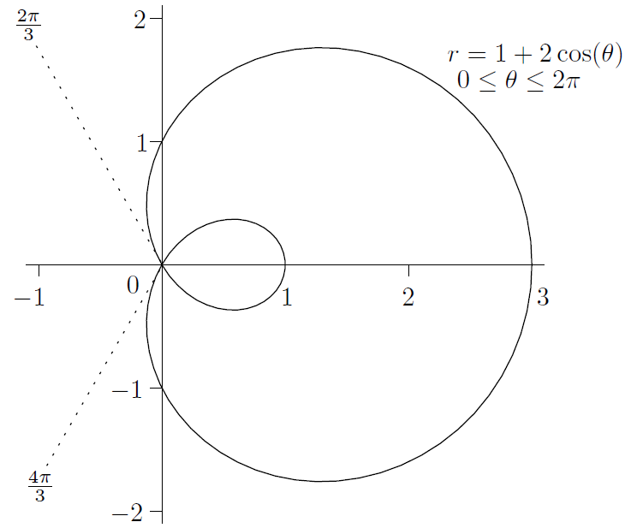

You should try sketching a lot of polar curves until you feel you're going round in circles

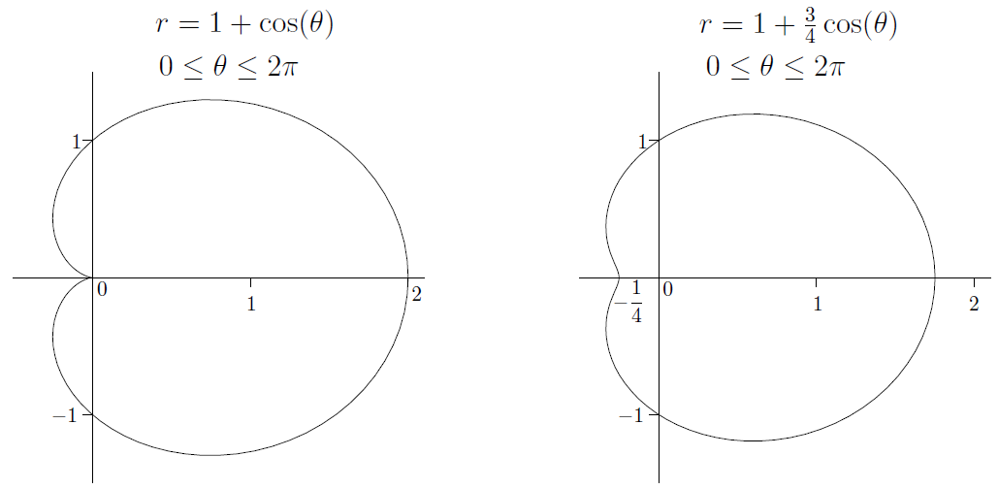

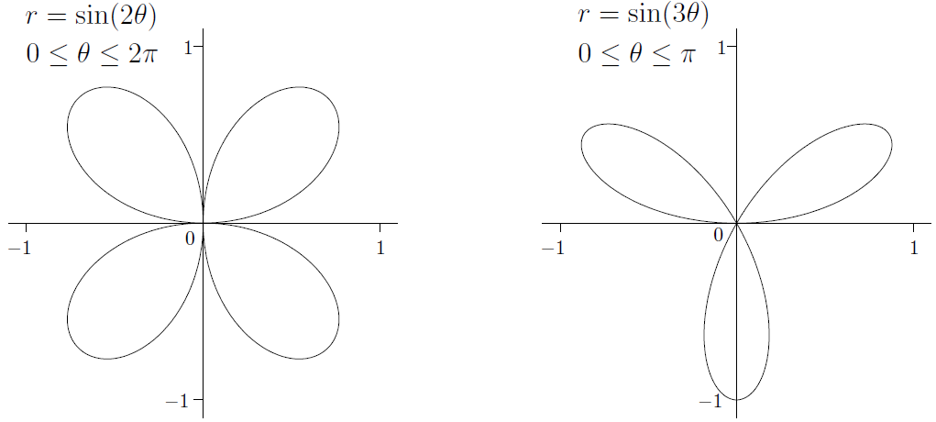

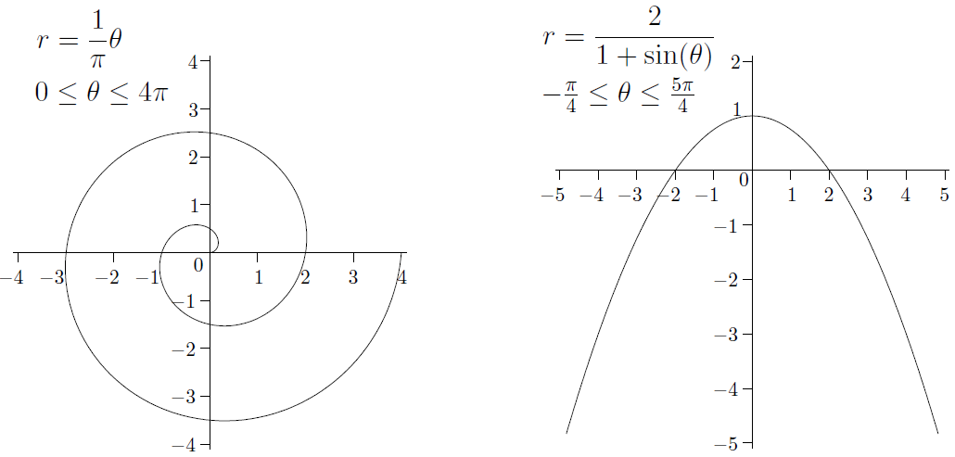

Some facts about the above curves:

1. The curve given by is called a *cardioid*. The curve is an example of a limacon, of which the cardioid is a special case
2. In the above graph of , the angle only goes from to . As goes from to , the graph is retraced, just as in the case of the circle
3. The curve given by is an example of a *spiral of Archimedes*. This is not periodic: as increases, the spiral gets bigger and bigger
4. The curve given by looks like a parabola. In fact, you should try to show that the above equation becomes in Cartesian coordinates

* Finding tangents to polar curves

Luckily, finding tangents to polar curves is just a special case of finding tangents to curves given by parametric equations. Let's see how it works in the case of polar coordinates

We have , and we'd like to find the tangent to the curve at some point on the curve. Using and , we can write

this means that x and y are parametrized by . By the formula from Section 27.1.1 above, we have

This gives the slope of the tangent in general. Finally, we just have to plug in the value of we care about (Page 590)

* Finding areas enclosed by polar curves

If we want to find the area enclosed by the polar curve , where is assumed to be continuous, then we're going to have to integrate something. But what? We just have to set up the correct Riemann sum. Suppose we take a small chunk of angle between and . Then as we move counterclockwise along this chunk of angle, meanders from to . If is very small, then doesn't have a chance to move far away from , so we can approximate the wedge we're looking for by a thin slice of pie of radius units and angle , centered at the origin, as shown in the following diagram:

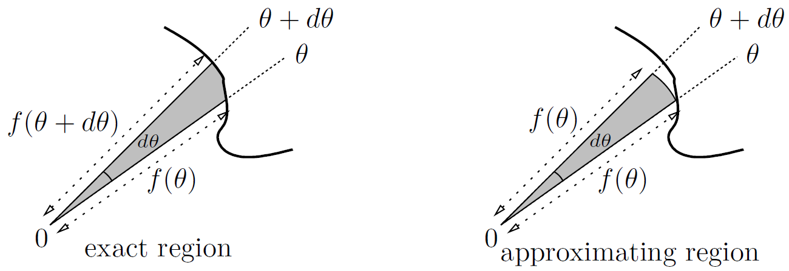

The area of a sector is one half of the radius squared, multiplied by the angle of the sector (in radians, of course!). So, we can approximate the area of the wedge (in square units) by , which is just . The total area

As usual, the area is given in square units

Example (Page 592)

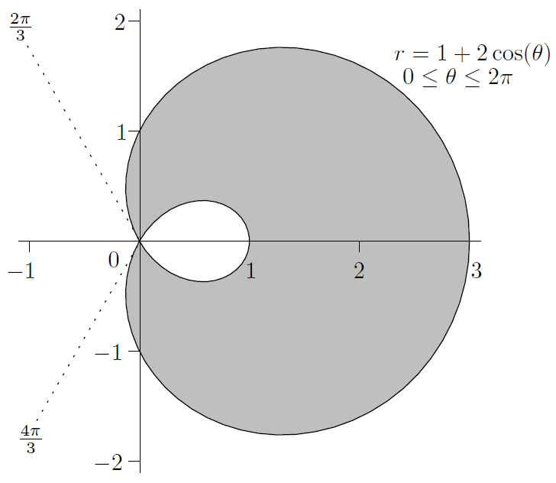

**CHAPTER 28 Complex Numbers**



1. The Basics

It kind of sucks that you can't take the square root of . So, we'll just do it anyway. Let's just create a square root of and call it . OK, so then we must have . Is the only square root of ? No, should also be a square root, since if there were any justice in the world, then

Since and , we now have two roots for the quadratic after all-but they are not real: they are imaginary. How about ? That's also imaginary. In fact, , so is a negative number. So, when we say that a number is *imaginary*, we mean that its square is a negative number. The only imaginary numbers are of the form where is a real number not equal to . You can also write instead of

Now, you can add or subtract real and imaginary numbers, for example , but you can't simplify the result. In this way, we get all the complex numbers, which are all the numbers of the form , where and are real. The set of all complex numbers is normally denoted by the symbol . Notice that all imaginary numbers are complex numbers (). All real numbers are also complex numbers (). Every complex number has a real and an imaginary part. If , then the real part is and the imaginary part is . These are written as and , respectively. For example, and . Note that is not , it’s just

Adding and subtracting complex numbers is pretty easy. Just add (or subtract) the real parts, and then do the imaginary parts (Page 596)

Multiplication isn't much harder-you just expand, but remember to change into whenever you see it (Page 596)

By the way, what is ? How about ? ? , , . In fact, because , we can see that the powers of keep on cycling through

How about division? That's a little trickier, but not much. The technique is very similar to rationalizing the denominator. It's inspired by the following observation: If you have a complex number and multiply it by the complex number , you get a real number

If , the related number is so important that it has a name: it is called the *complex conjugate* of and denoted . Note that the complex conjugate of a real number is the same number. Now as the above formula shows, a number multiplied by its complex conjugate is real. Inspired by Pythagoras' Theorem and the above formula, given a complex number , let's define the *modulus* of to be . We write the modulus of as . So

It’s exactly the same as the absolute value. Our notation for modulus is completely consistent with the previous notation for absolute value. In fact, think of the modulus as a beefed-up version of absolute value. Anyway, the difference of two squares formula above shows that a complex number multiplied by its complex conjugate is the square of its modulus. That is,

Now let's see how to solve quadratic equations. For example, let's say that you want to solve . Just use the quadratic formula and the fact that to write

Notice that we have simplified as . Now, how about if you have a quadratic whose coefficients are complex numbers? The quadratic formula still works, but you may well have to take the square root of a complex number, not just a negative number

* Complex exponentials

We've discussed how to add and multiply complex numbers. How about exponentiating them? (Page 598)

We'll define , for any complex number , by the following equation:

And we can show that

1. The Complex Plane

Real numbers are usually represented as points on a number line, which is one-dimensional. Complex numbers literally have an extra dimension. Indeed, if , we can't squish all the information into just one real number. Instead of a real number line, we'll use a complex number plane. The complex number will be represented as the point in Cartesian coordinates. It's pretty easy to plot complex number like , , and :

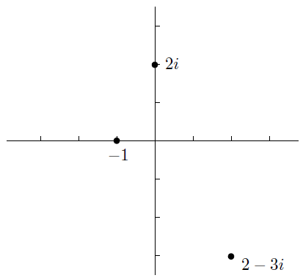

You should think of each point as representing one complex number, rather than as a pair of real numbers

In the previous chapter, we saw that you can also express every point in the plane in polar coordinates instead. So suppose you have a point in the complex plane which has polar coordinates . What is the complex number represented by that point? Well, we can convert to Cartesian coordinates using and . So the point in polar coordinates represents the complex number . In particular, if , then is just

Now, there's a pretty bizarre and funky identity, due to Euler, which is really important:

This is true for all real . This means that the complex number , has polar coordinates when you plot it on the complex number plane. So lives on the unit circle and has angle from the positive -axis. The following picture shows a few positions of for different values of :

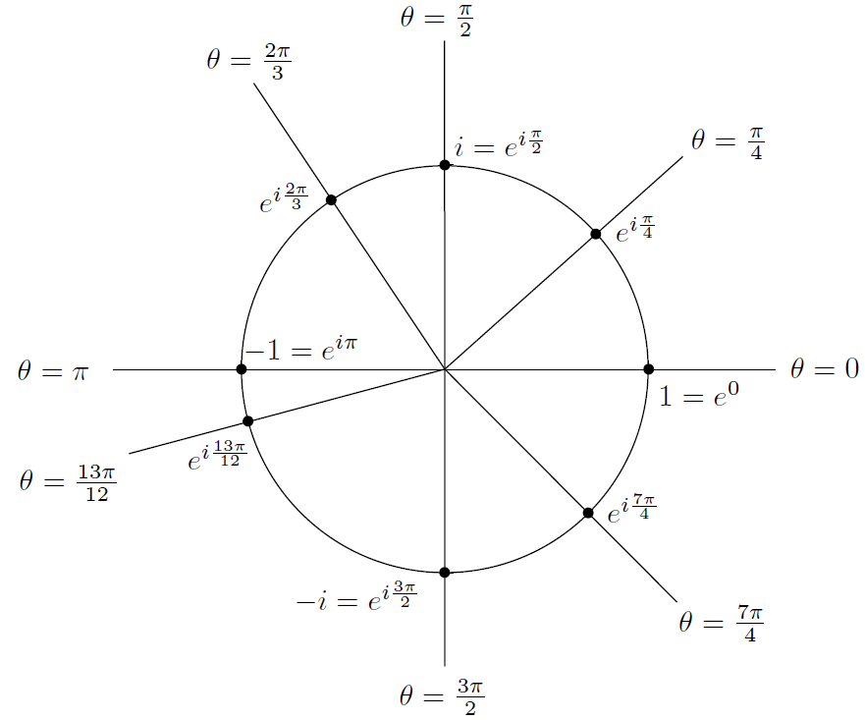

For points not on the unit circle, you just have to multiply by . Specifically, we saw that if is represented by the point in polar coordinates, then . By Euler's identity, this means that . So we have shown that

Let's say that a complex number like is in *polar form*, (as opposed to , which is in *Cartesian form*). This formula looks a bit strange, but it's true enough (Page 600)

Let's agree that when we're dealing with complex numbers, we'll never let be negative (Page 600)

is **periodic** in with period .

* Converting to and from polar form

To convert a complex number from polar to Cartesian form, just use Euler's identity directly (that's in case you have already for gotten!). For example

On the other hand, converting from Cartesian to polar form is more difficult, as we observed in Section 27.2.1. There we saw that

where we have now dropped the possible solution since we want for complex numbers. By the way, we defined the modulus of to be . So is the same as . The modulus is therefore the distance from the point to the origin (in the complex number plane). The angle is called the *argument* of and is written . (Normally one requires that so that there's no ambiguity.)

Let's revisit a couple of examples that might seem confusing (Page 602)

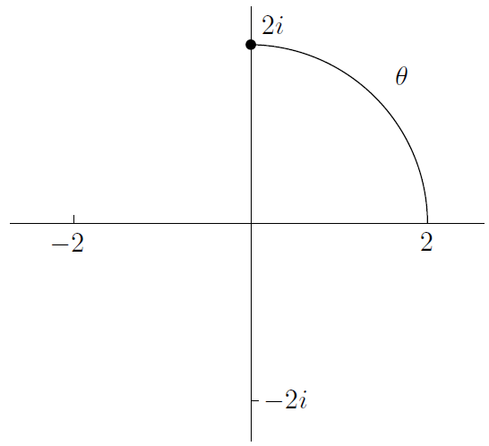

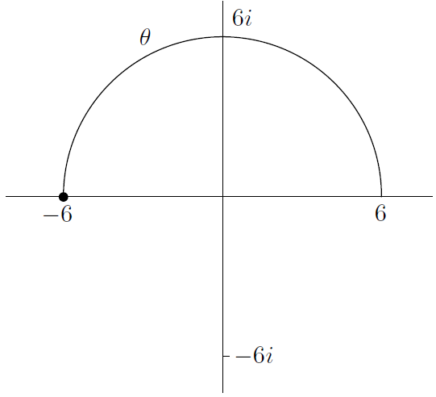

1. Taking Large Powers of Complex Numbers

Why on earth would you want to use the polar form? One reason is that it's really easy to multiply and take powers in polar form. Imagine you wanted to multiply by . This is pretty simple-you just use the normal exponential rules (see Section 9.1.1 in Chapter 9) to write

A lot of the time, you might want the final answer in Cartesian form. For example, suppose we'd like to compute and give the answer in Cartesian form. Expanding the expression by multiplying out would be crazy, so we won't go there. The correct way to proceed is to translate

into polar form, take the th power, then translate back into Cartesian form (Page 603)

In summary, to take a large power of a complex number, first convert it to polar form, then take the power. Find the largest even multiple of less than the angle , and take that away from and replace by that new number. Finally, convert back to Cartesian form

1. Solving

Let's move onto a trickier subject: how to solve equations of the form , where is a given integer and is a given complex number. This amounts to taking th roots of , but we don't just want to say since that doesn't tell us very much. Instead, we'll try to find a solution directly. Since powers work so well in polar form, that's what we'll use

For example, to solve , we should use polar coordinates for both and . Since we don't know what is, let's put . Now to find , we just have to find what and are. As for , let's write and then find and . Now, let's draw a picture of the situation:

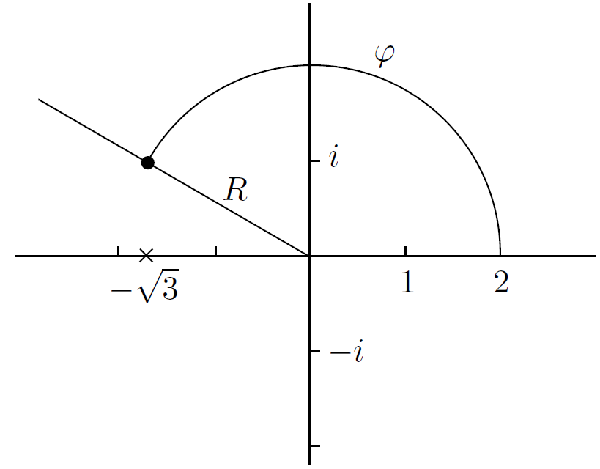

So our equation becomes

We can dissect the above equation into

The first is easy to solve: just take the th root to get , which is legit since is a nonnegative real number. As for the second equation, you may be tempted to say , but it's not that simple. Remember, is - periodic in the variable ! You can express this fact via the following important principle

So it looks as if there are infinitely many values of , and therefore infinitely many values of that solve our equation. Appearances can be deceptive, however! You see, since , you only need to use the first five values for , namely, (Page 605)

It's interesting to plot the solutions in the complex plane (Page 606)

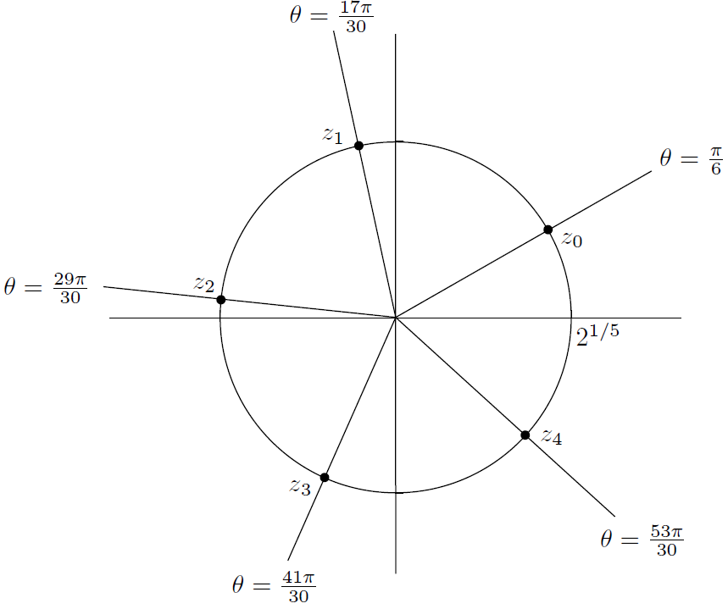

In general, there are solutions to the equation , which when plotted form the vertices of a regular -sided polygon. (The exception is if , in which case is the only solution, but it is of multiplicity .)

So, let's outline the main steps in solving : (Page 607)

* Some variations

Suppose you want to solve the equation . No problem-just let , so that the equation is . Solve this exactly as we just did at the end of the previous section

Here's a tougher one (Page 609)

We need to find the square roots of the complex number . How do we do this? By solving the equation

One more example. How would you factor over the complex numbers? Let's set , so that the equation becomes (Page 609)

This is the complex factorization. To get the real factorization, we need to use a nice fact: if is any complex number, then has real coefficients when you multiply it out. Indeed, you get , but it's easy enough to see that (which is real), and we've already seen that , which is also real

1. Solving

Now it's time to see how to solve equations of the form for given . It'd be nice if we could just write , but this isn't very helpful. For example, what exactly is ? Let's try to answer this question

Fortunately, solving isn't much harder than solving ; in fact, if anything, it's simpler. Before we see how to do this, we need to understand a little better. Let's see what happens if we write . We get

So what? Well, the main point is that this is already in polar form. The modulus is and the argument is . If you prefer, (remember, is real and positive) and . This means that if is in Cartesian form , then is **automatically** in polar form: . So, the main difference between solving and is that you don't need to put in polar form in the first case, whereas you do in the second case. A sort of by-product of this is that there are infinitely many solutions to the equation (unless , in which case there are no solutions)

Let's solve

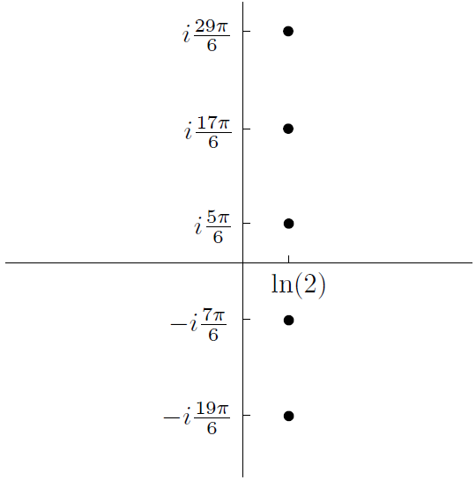

The solutions are equally spaced on the vertical line. Incidentally, this means that they form an arithmetic progression of complex numbers.

Let's look at one more example. Suppose you want to solve

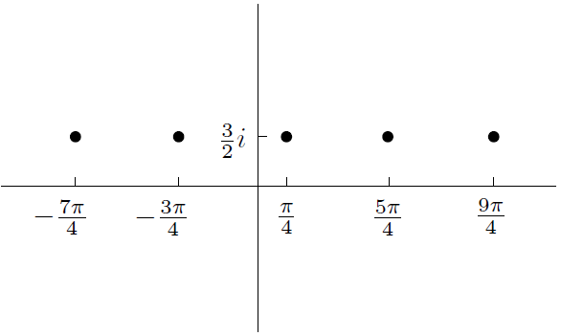

Once again, the solutions are in arithmetic progression, but this time they lie on the horizontal line

1. Some Trigonometric Series

A trigonometric series is a series of the form

for some coefficients and

For example, consider the trigonometric series

where is real. Note that this is not a power series in , since is not a power of . On the other hand, we can make the whole thing into a power series by using the complementary series

in a clever way. In fact, we can find both series at once. The key is Euler's identity. Let's find both series at once by combining them like this:

Now, the last sum looks familiar. In fact, we saw in Section 28.1.1 above that

for all complex numbers . Now we can get

So

Well, we need to convert the right-hand side into Cartesian form

This is the polar form of . To get the Cartesian form, we need to convert into . Putting it all together, we get

Now, if two complex numbers are equal, then their real parts must be equal, and also their imaginary parts must be equal

Not easy, but this is basically what you have to do. I'll do one more example (Page 614), to find (we will have a geometric series)

1. Euler's Identity and Power Series

Let's finish the chapter with a justification of Euler's identity

using power series (Page 615),

**CHAPTER 29 Volumes, Arc Lengths, and Surface Areas**



We have used definite integrals to find areas. Now we're going to use them to find volumes, lengths of curves, and surface areas

1. Volumes of Solids of Revolution

We'll start with finding volumes of solids of revolution. The idea is that there is some region in the plane, and some axis also in the plane, and a solid is formed by revolving the region about the axis. For our purposes, the axis will always be parallel to the -axis or the -axis. (It is possible to deal with diagonal axes, but it's a real pain unless you use techniques from linear algebra.)

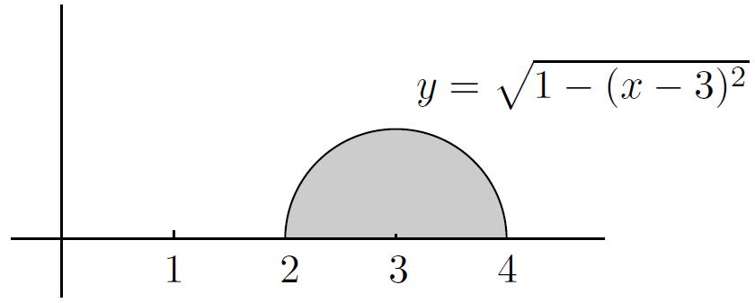

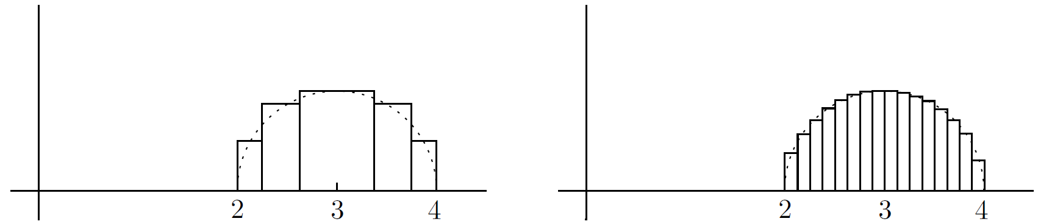

Here's the pattern: we make a little strip of width units and height units at position on the -axis, work out its area, then put a definite integral sign in front to get the total area we're looking for. This technique doesn't just work for areas-it also works for volumes. In particular, let's see how it works using two different methods for finding volumes of revolution: the disc method and the shell method

* The disc method

Suppose that we revolve the semicircle from the previous section about the -axis. This will give us a sphere. Let's try to work out its volume. We'll start with one strip, just like in the picture at the end of the previous section, and revolve that strip about the x-axis. Here's what we get:

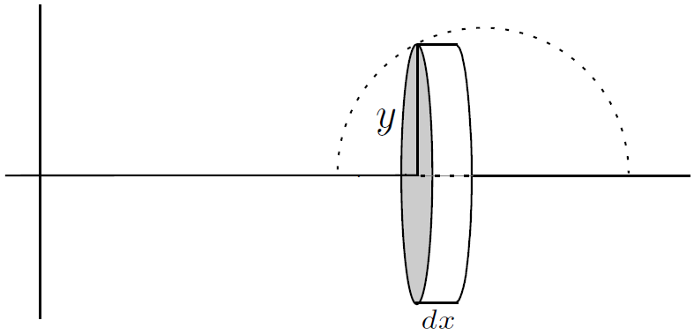

This is a thin disc of width units and radius units. Since the volume of a cylinder of radius units and height units is cubic units, the volume of our thin disc is cubic units. For example, if you use five strips, you might get something like this:

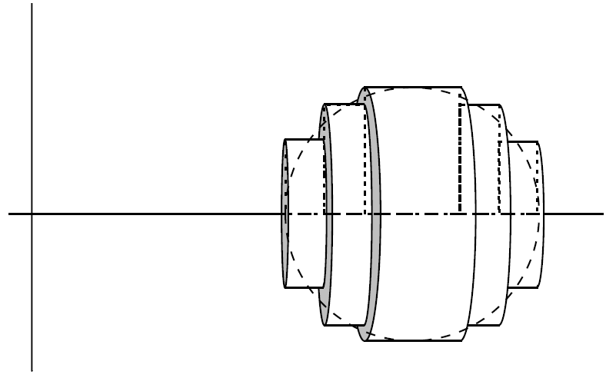

In the limit, as the maximum disc thickness goes down to zero, the approximation becomes perfect: the total volume of the discs tends toward the volume of the sphere. In our case, and goes from to , so we have

The volume works out to be cubic units (try it!) which is what we'd expect, since we're dealing with a sphere of radius unit here. The method we just used is called the *disc method*; it is also known as the method of *slicing*

* The shell method

Now, let's suppose that we take our favorite semicircular region from before but this time we revolve it about the -axis. Try to imagine what you'd get. Let's approximate the semicircle by thin strips again, but this time we'll revolve each strip about the -axis, instead of the -axis. As we saw before, a typical strip looks like this:

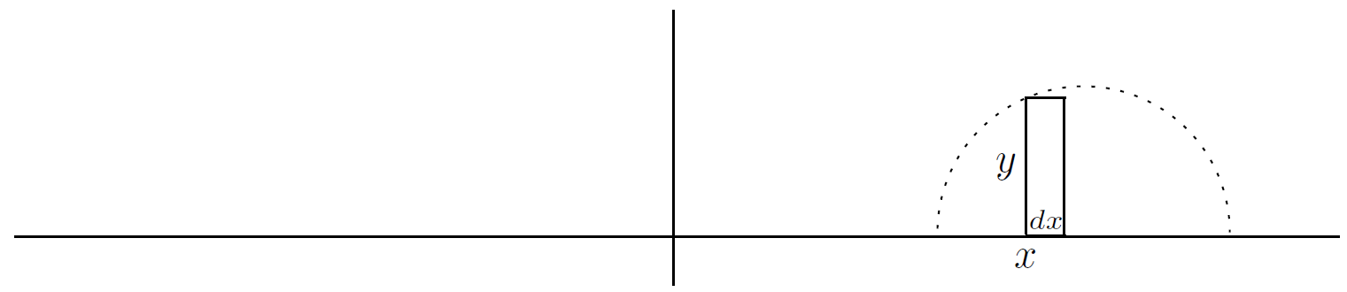

When you revolve it about the y-axis, you don't get a disc-you get a cylindrical shell:

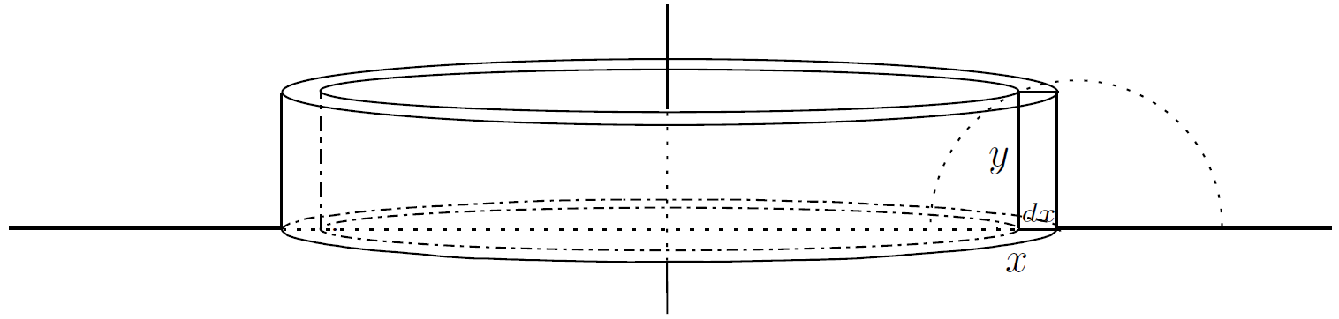

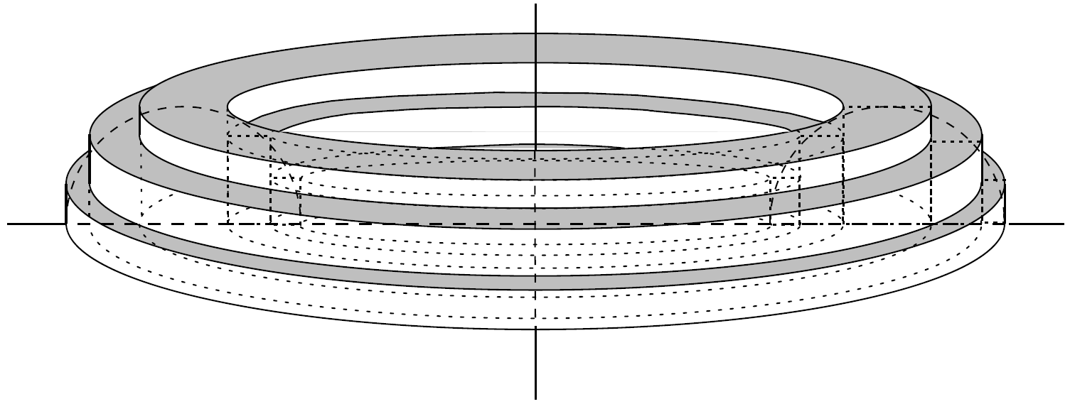

This weird solid is a pretty lumpy bagel half, but its volume is fairly close to what we're looking for

First we need to find the volume of one generic shell. The point is, it's **almost** a rectangular prism. So, the idealized version of the unfolded can looks like this:

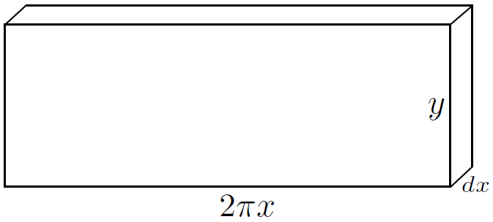

The thickness is units, and the side we cut along is still the height of the cylindrical shell, that is, units. The long side is equal to the circumference of the shell (think about it!) which is units, since the radius of the shell is basically units. The volume of the shell is very close to cubic units. Now all we have to do is integrate from to to see that the volume of the bagel half (in cubic units) is (Page 621)

The method we just used is, unsurprisingly, called the *shell method*

* Summary . . . and variations

So far we have seen how to use the disc and shell methods in the special case of our semicircle. The same method works for general regions which are contained between a curve, the -axis, and two vertical lines:

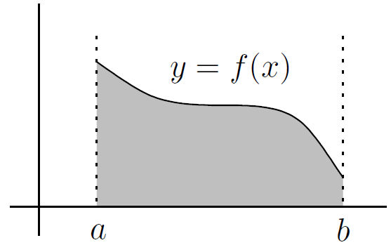

By the same reasoning that we used above in the special case of the semicircle, we can arrive at the following principles:

* If you revolve the area under the curve between and (as shown above) about the -axis, then the disc method applies and the volume is equal to
* If you revolve the area under the curve between and (as shown above) about the -axis, then the shell method applies and the volume is equal to

It's an even better idea to be able to derive these formulas by knowing how to find the volume of a typical disc or shell. This will be especially useful if you encounter one (or more) of the following variations:

1. The region to be revolved might lie between a curve and the -axis (instead of the -axis)
2. The region to be revolved might lie between two curves, instead of just being a region under a curve down to an axis
3. The axis of revolution may be parallel to the -axis or -axis, not the axis itself

It's important to know how to decide whether to use the disc method or the shell method:

* if the really thin bit of each strip is **parallel** to the axis of revolution, the **disc method** applies
* whereas if the really thin bit of each strip is **perpendicular** to the axis of revolution, the **shell method** applies
* Variation 1: regions between a curve and the -axis

If the region is between the curve and the -axis, you probably want to take strips lying on their sides, with the thin part of the strip along the -axis:

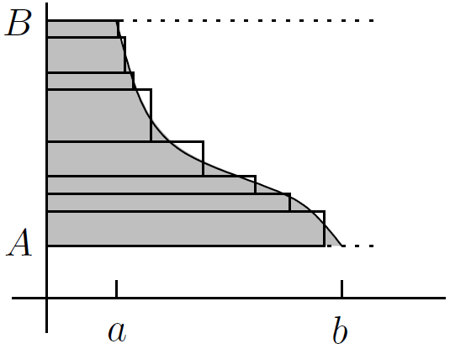

Be very careful that the limits of integration are relevant points on the -axis, not the -axis, since the integral is taken with respect to (because of the )

In summary, then, the rule of thumb is this:

If the region lies between a curve and the -axis, switch and

Here's an example of Variation 1 (Page 624)

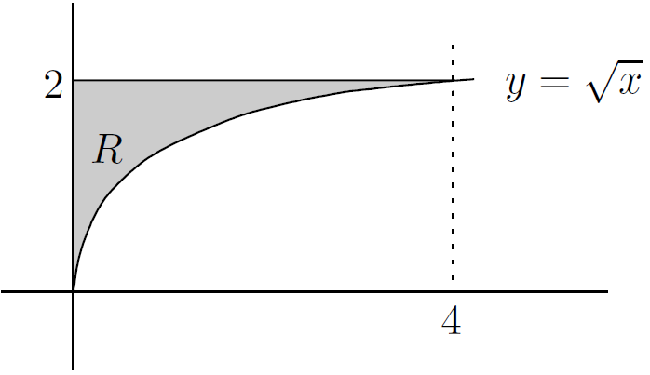

* Variation 2: regions between two curves

Suppose the region to be revolved lies between two curves. We'll handle this situation in the same way as finding the area of a region between two curves in Section 16.4.2 of Chapter 16. The general idea is to take the top curve and revolve the region under it all the way to the axis, to get a bigger solid than you want. Now take the bottom curve and revolve the region under it all the way to the axis, to get a solid which you actually need to cut out of the big solid and throw away to get the desired solid. Finally, subtract the small volume from the big one. Indeed, consider the following three regions:

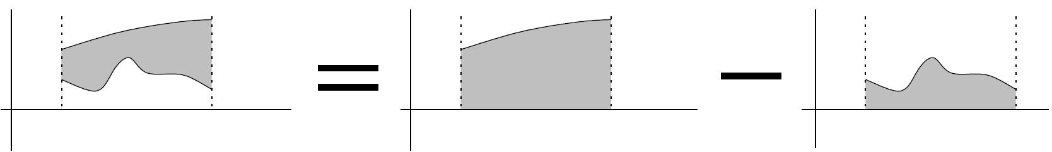

Now, regardless of whether you revolve about the -axis or the -axis, the volume of revolution of the region we want is equal to the difference between the volume of revolution of the big region and the volume of revolution of the small region

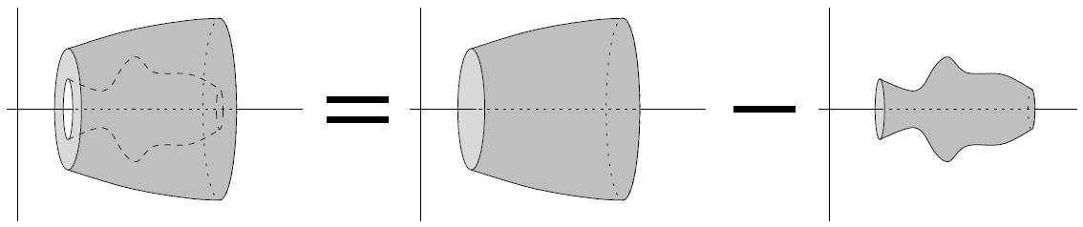

So, here's what we conclude:

If the region lies between two curves, find the difference between the two corresponding volumes of revolution

Let's look at a concrete example. What is the volume of the solid formed by revolving the region about the -axis?

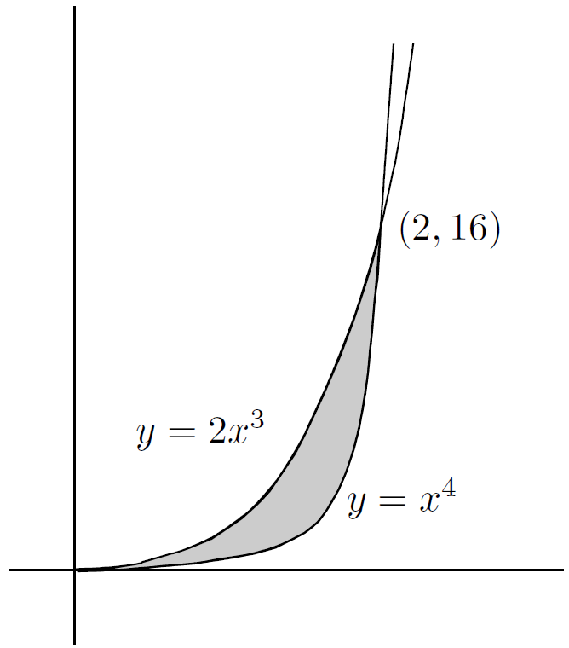

Use the disc method on each of the two curves to see that the volume we want is

You should work this out and check that the answer is cubic units

How about revolving the same region about the -axis? First, the disc method:

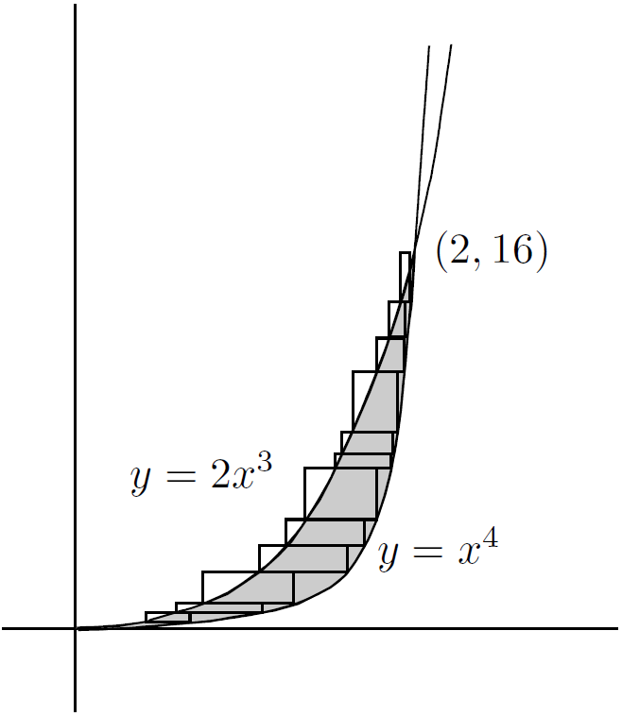

This works out to be

Let's try to find the same volume by using shells. This time, we slice the region vertically:

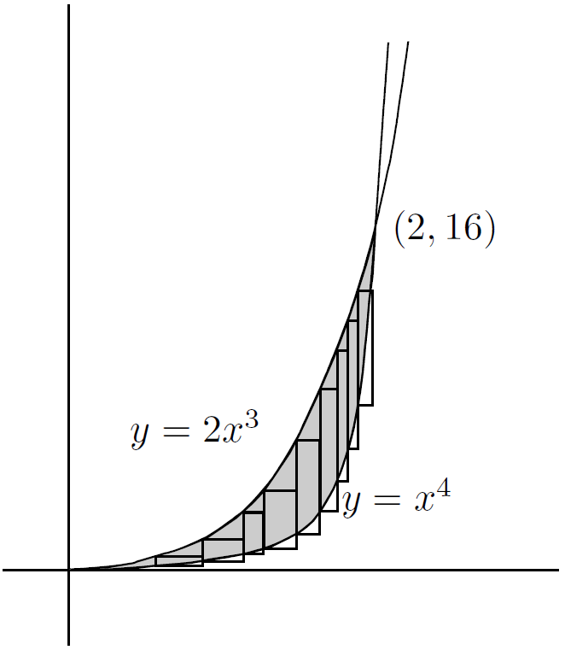

which is cubic units

This variation also applies when the area doesn't go all the way down to the axis. For example, suppose we want to find the volume of revolution when the region between the curve and the line is revolved about the -axis

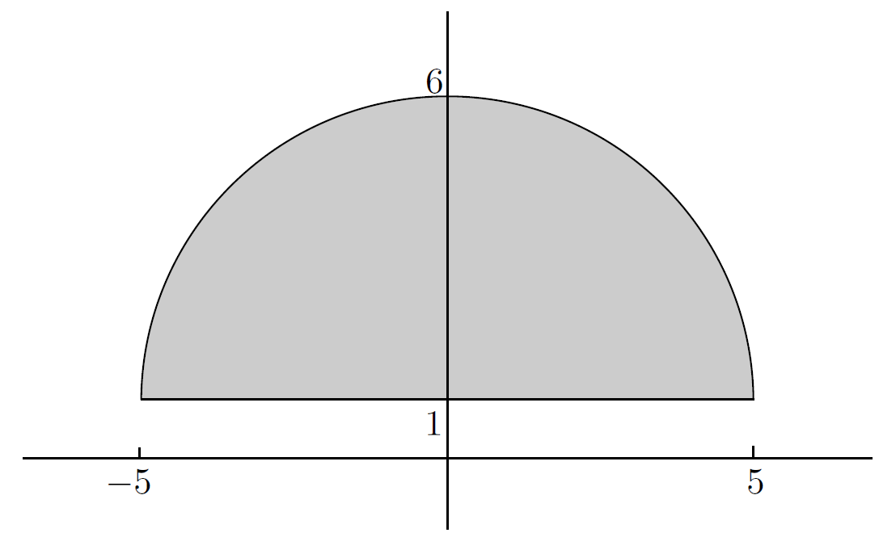

* Variation 3: revolving about axes parallel to the coordinate axes

Finally, let's see how to handle revolution about the axis or , where is some number not necessarily equal to . We'll start with , which is parallel to the -axis but is at height . Suppose we want to revolve the region between the curve and the lines , , and about the line

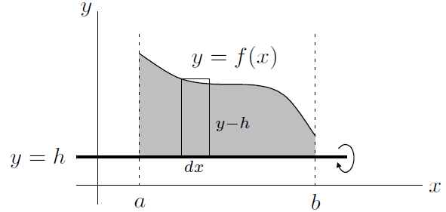

The width is , but the height isn't : it's . If happens to be negative, then the height of the strip is more than . . . The volume of the whole solid of revolution is

In fact, the only difference between this formula and the regular disc method is that has been replaced by the quantity . The only problem with this is that it's possible that the line is actually above the curve, like this:

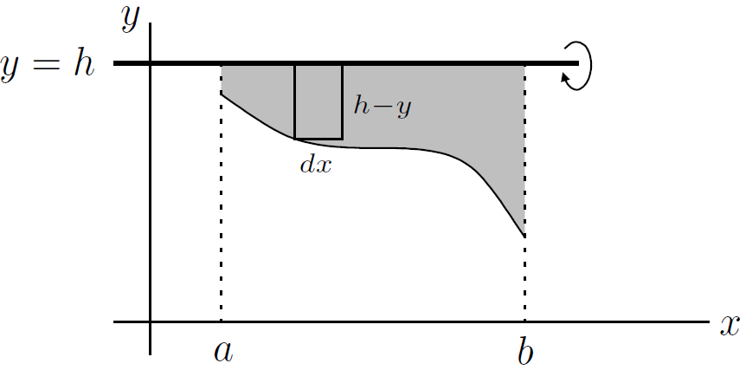

In this case, the height of the strip is , not . It's good to be careful about these things. Besides, the shell method is a different story. Suppose we now want to find the volume of the solid formed by revolving the region below about the axis :

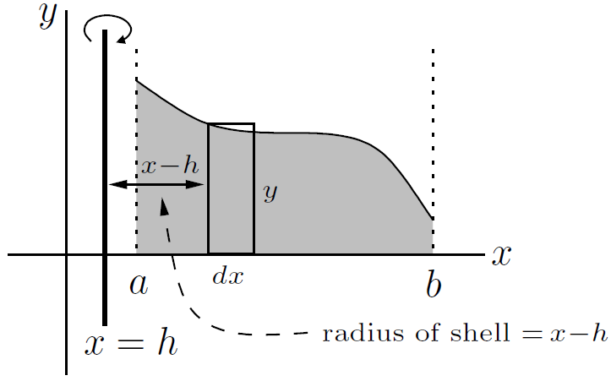

The total volume is cubic units

How about if the axis is to the right of the region? Consider the following picture:

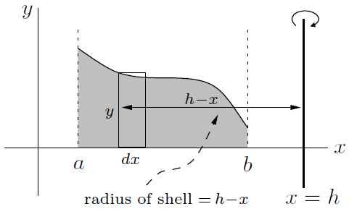

The volume of revolution is cubic units

So, here's the general idea for Variation 3:

If the axis of revolution is , replace by

If the axis of revolution is , replace by

Let's look at some examples of Variation 3. In all the examples, we'll be dealing with the region between the curve , the line and the line :

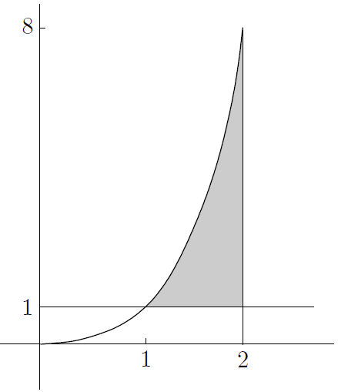

Let's start with finding the volume when the region is revolved about the line . The volume is given by

which easily works out to be cubic units

How about revolving the same region about the line ? This is actually a combination of Variation 1 and Variation 3. The volume is

which simplifies to cubic units. It's a good idea to make sure that you can also work this out by finding the volume of a typical disc

Now, what about if we revolve the same region about ? We'll use a combination of Variation 2 and Variation 3. The volume is given by

which works out to be cubic units

Let's repeat the same example, this time taking horizontal strips. Now we have to use the disc method. The volume is

which again works out to be cubic units

1. Volumes of General Solids

Most solids can't be formed by revolving some planar area about an axis in that plane. One technique for finding the volume of such a solid is the method of *slicing*, which actually generalizes the disc method from Section 29.1.1 above

Basically, here is your choice: (Page 632)

1. Choose an axis
2. Find a typical cross-sectional area at a point x on the axis; call this area square units
3. Then if is the volume of the solid (in cubic units), we have

where is the range of which completely covers the solid

Let's use the above technique to find the volume of a “generalized” cone (Page 632)

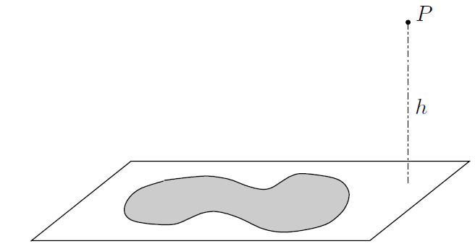

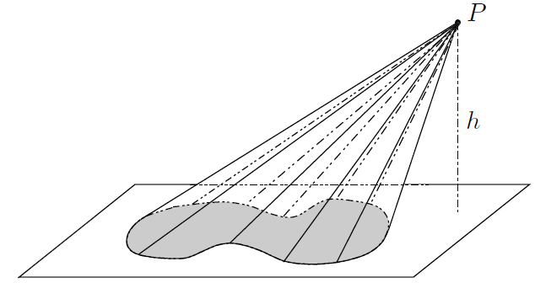

So, how do we find the volume?

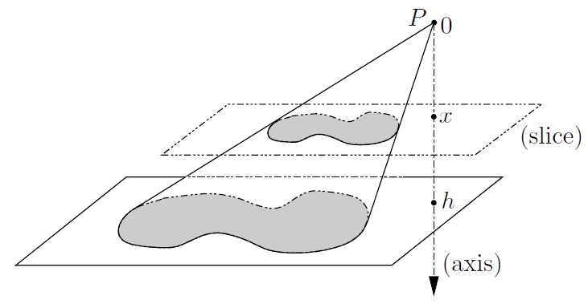

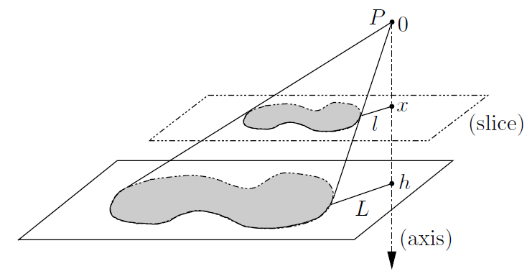

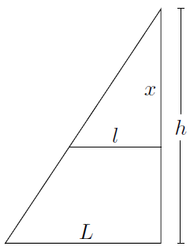

Using similar triangles, we can get

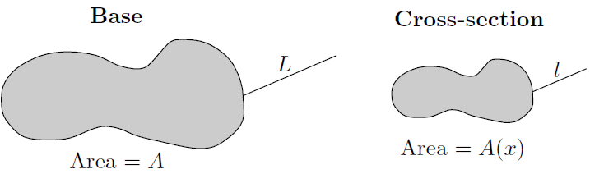

Now here's an important principle of similarity: the ratio of areas of the figures is the **square** of the ratio of the two corresponding lengths

Finally, we're ready to integrate!

Hey, so we just got the formula for the volume of any sort of pyramid or cone-like object. For example, for the regular old cone, the volume is cubic units, which is exactly what we found above since . Same thing for a square pyramid-the volume is cubic units (where the side length of the base is units), which works as well because the base area is given by

Let's look at one more example (Page 636)

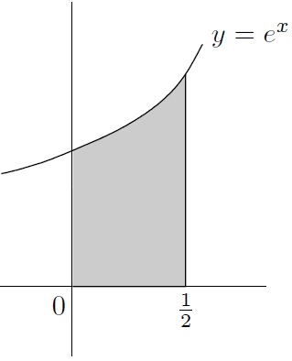

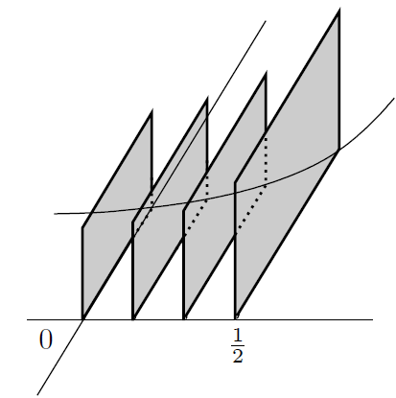

1. Arc Lengths

Say we have a graph of for some function , where ranges from to . This length is called the *arc length* of the curve, and we're going to find a formula for it. The strategy will be to get a sort of prototype expression, then to adapt this to get several useful versions of the formula

So, let's look at a little piece of curve between and :

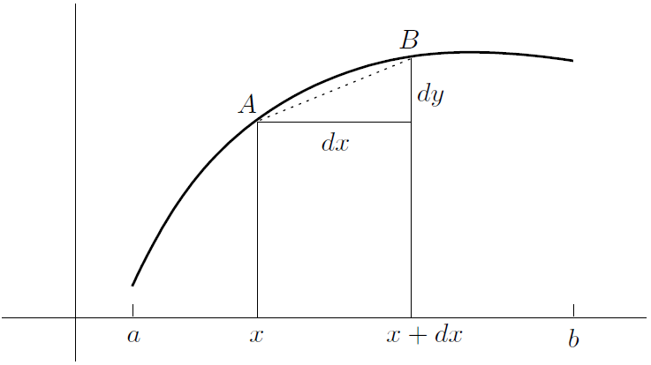

Let's approximate the length of the curve between and by the length of the dotted line segment . The closer and are to each other, the better the approximation. By Pythagoras' Theorem, the length of is units. Now we just need to repeat this process with lots of little line segments. As usual, the integration takes care of the adding up and limiting parts, but you have to be careful. If you just put an integral sign in front of the little length , you'll get

The problem is, this integral doesn't really mean anything!

We need to integrate with respect to one variable. Anyway, in each of the cases below, we'll see how to adapt the above prototypical formula to get a legitimate formula for arc length:

1. If and ranges from to , then take out a factor of in the above integrand (as we just did above) and pull it out of the square root to get

(standard form)

In terms of , you can rewrite this as

1. Suppose that is given in terms of . If and ranges from to , then you take out a factor of instead (or if you prefer, swap each occurrence of and in the boxed formula above) to get

(in terms of )

which can also be written as

1. How about the parametric form? This means that and are functions of a parameter which ranges from to . We can think of the quantity as and similarly for . We can then pull the out and take its square root to get the useful formula:

(parametric version)

1. A special case of this last formula occurs in the case of polar coordinates. The curve is , where ranges from to ; We know that and , so replacing by . Finally

(polar, )

By the way, you should express all these arc lengths in units

Let's look at some examples (Page 639)

* Parametrization and speed

Before we move on to finding surface areas, there's one little fact related to the arc length formula in parametric coordinates that I'd like to look at. Suppose an ant (not a snail, this time!) is crawling around on a at piece of ground, and we define the ant's position at time seconds to be . The ant's velocity in the direction is and its velocity in the direction is . Its real speed has to involve both of these velocities, by Pythagoras' Theorem, we should have:

Hey, this is the quantity that we've been integrating to find arc length in the parametric case! So we now have a meaning for the integrand in the formula for arc length, at least in the parametric case: it is the instantaneous speed of a particle moving along the curve

Consider some examples (Page 640)

1. Surface Areas of Solids of Revolution

The last thing we'll consider in this chapter is how to find the surface area of a surface formed by revolving a curve about an axis. The method is a sort of combination of how we found arc lengths and volumes. Let's suppose we are revolving about the -axis (Page 641)

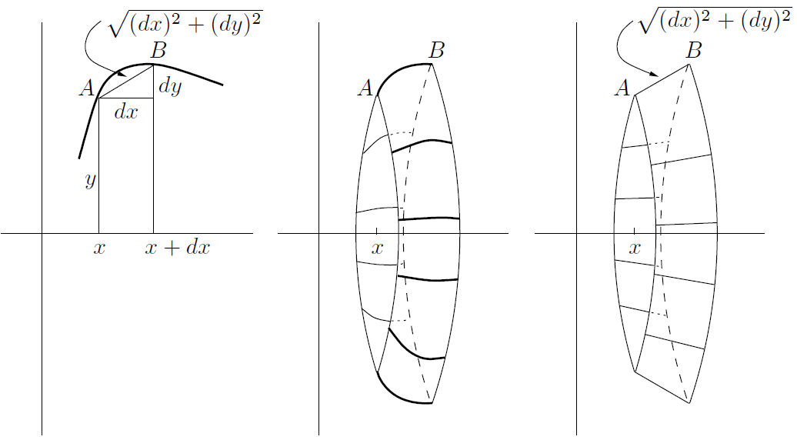

Actually, we are even lazier than that: now the loop is cylindrical

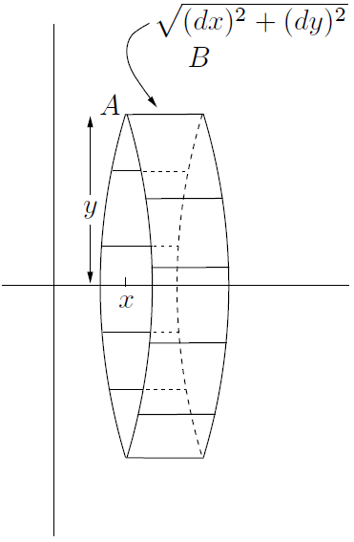

So we are led to the prototypical formula for revolution about the -axis:

The prototypical formula for revolution about the -axis is

Let's see how we can modify the formulas so we can actually use them:

1. Suppose we want to revolve the curve about the -axis, where ranges from to . We take out a factor of in the integrand of the first prototypical formula and pull it out of the square root, just as we did in the case of arc length, to get

(about the -axis)

In terms of , it looks like this:

1. If instead we want to revolve the same curve about the -axis, the same manipulations applied to the other prototypical formula give

(about the -axis)

or in terms of ,

1. Of course, there's also a parametric form. If and are functions of a parameter which ranges from to , then dividing and multiplying by leads to the following formulas:

(parametric version, about the -axis)

and

(parametric version, about the -axis)

Again, all of these surface areas are in square units

Here're some examples (Page 643)

**CHAPTER 30 Differential Equations**



A differential equation is an equation involving derivatives. These things are really useful for describing how quantities change in the real world

1. Introduction to Differential Equations

We considered the equation

where is some fixed constant, and claimed that the only solutions to it are of the form for some constant . The equation is an example of a *first-order differential equation*. This is because there's only a first derivative floating around. In general, the order of a differential equation is the order of the highest derivative involved. For example, a fourth-order differential equation (Page 646)

Now consider a specific example of the first-order differential equation at the beginning of this section, but with an extra condition:

We know is the general solution, so set . Now put and to see that , get . So the actual solution is

What we have just been looking at is an example of an *initial value problem*, or *IVP*. The idea is that you know a starting condition (in this case, ) as well as a differential equation that tells you how the situation evolves from there (in this case, ), and you can use these two facts to find out the exact solution with no undetermined constants. For a second-order differential equation, you effectively need to integrate twice, so you'll get two undetermined constants; it follows that you need **two** pieces of information

Now, the study of differential equations is pretty bloody huge. These things are hard to solve. Luckily, there are some simple types which can be solved without too much trouble

1. Separable First-order Differential Equations

A first-order differential equation is called *separable* if you can put all the -stuff on one side (including the ), and all the -stuff on the other side (including the )

For example, the equation can be rearranged to read

so it is separable. As another example, the equation

can be rearranged (check out the algebra yourself!) into

(Page 646)

1. First-order Linear Equations

Here's a different type of first-order differential equation:

where and are given functions of . Such an equation is called a *first-order linear* differential equation. It may not be separable, and it may not even look particularly linear! For example,

doesn't look very linear, yet this equation is indeed first-order linear. The reason is that the powers of and are both one

Let's see the linear equation from above,

There's a neat trick: Imagine that we multiply both sides by the quantity

Watch carefully, now: there's nothing up my sleeve as I rewrite this as

Now all we have to do is integrate both sides with respect to

Dividing by , we get the solution

where is an arbitrary constant

The key to the previous solution was multiplying by . The quantity is called *an integrating factor*. It turns out that for the general first-order linear differential equation

a good integrating factor is given by the equation

where you don't need a in the integral. After you multiply the original differential equation by this integrating factor, the left-hand side can be “factored” as

Here are two more examples. First, how would you solve

(Page 650)

One more example of a first-order linear differential equation: (Page 651)

In summary, here's the method for dealing with first-order linear differential equations:

* Put the stuff involving on the left-hand side and the stuff involving on the right-hand side, then divide through by the coefficient of to get the equation into the standard form
* Multiply through by the integrating factor, which we'll call , given by

where no is needed in the integral in the exponent

* The left-hand side becomes , where is the integrating factor. Rewrite the equation with this new left-hand side
* Integrate both sides; this time you must put a on the right-hand side
* Divide by the integrating factor to solve for
* Why the integrating factor works

Why is the weird expression a good integrating factor? (Page 652)

1. Constant-coefficient Differential Equations

Now it's time to look at linear differential equations with constant coefficients. These equations look something like this:

Here is some function of only, and are just plain old constant real numbers. Notice that the left-hand side of the above equation looks a bit like a polynomial in , except that instead of taking powers of , we are taking derivatives

First, we need to look at some general ideas for solving both first- and second-order constant-coefficient linear equations

Let's start by considering a simple case: assume there's no stuff in on the right-hand side. Two such examples are

Such equations are called *homogeneous*

* Solving first-order homogeneous equations

This is pretty easy. The solution to

is just

* Solving second-order homogeneous equations

This case is a little more involved. We need to solve

Although it might seem a little strange, the easiest way to do this is to pluck a quadratic equation seemingly out of thin air. The quadratic equation, called the *characteristic quadratic equation*, is . The next thing is to find the roots of the characteristic quadratic. There are three possibilities, depending on whether there are two real roots, one (double) real root or two complex roots. Let's summarize the whole method, then solve the above three examples

**How to solve the homogeneous equation** :

1. Write down the characteristic quadratic equation and solve it for
2. If there are two different real roots and , the solution is
3. If there is only one (double) real root , the solution is
4. If there are two complex roots, they will be conjugate to each other. That is, they must be of the form . The solution is

In all three cases (2, 3 and 4), and are undetermined constants

So, for example , we saw that the characteristic quadratic equation is . Factor the quadratic as , we see that the solution to our equation is given by

for some constants and

The characteristic quadratic equation in example reduces to , so the solution to the homogeneous equation is

Finally, if we use the quadratic formula to solve the characteristic quadratic equation of example , we get . So, with and , that the solution to the equation is

* Why the characteristic quadratic method works

Step 2 (Page 655)

Step 4 (Page 656)

Step 3 (Page 656)

* Nonhomogeneous equations and particular solutions

Now let's see what happens if we do have some stuff in alone, which we put on the right-hand side. For example, consider the differential equation

We know that the derivatives of are all , so let's try . We will get , which is not equal to the right-hand side, but it’s pretty close. So, let's try again: set , so we have

So we have shown that is a solution to our original equation. It's not the only solution, though. For the related homogeneous equation , we'll write as instead of just , where the stands for homogeneous

Here I wrote the solution from above as ; this is called a *particular solution*, which explains the subscript

So the solution are and . Furthermore, **all** the solutions to the nonhomogeneous equation are in this form

The same methodology works for both the first-order and the second order cases. The only issue is how to guess the particular solution. We will see it in next section

Here's a summary of our methods so far:

1. Rearrange the equation into the correct form. That is, put all the -junk on the right-hand side. You should be able to reduce the equation to

for the first-order case, or

for the second-order case

1. Using the techniques from Sections 30.4.1 and 30.4.2 above, solve the associated homogeneous equation

The solution, which we'll write as , will have one or two undetermined constants in it (depending on whether the equation is first- or second order). We call the homogeneous solution of the equation

1. If the original function is actually , then we're already done; the complete solution is
2. On the other hand, if the function is anything other than , then write down the form for the particular solution . The form will have some constants which must be determined. Substitute into the original equation and equate coefficients to find the constants
3. Finally, the solution is

* Finding a particular solution

So far, we have blissfully ignored the stuff involving which could appear on the right-hand side (it was called earlier). Now it's time to deal with it. The tactic is to write down the form of the particular solution, then to find the actual solution by plugging the form into the equation. The table below shows how to come up with the correct form (Page 658)

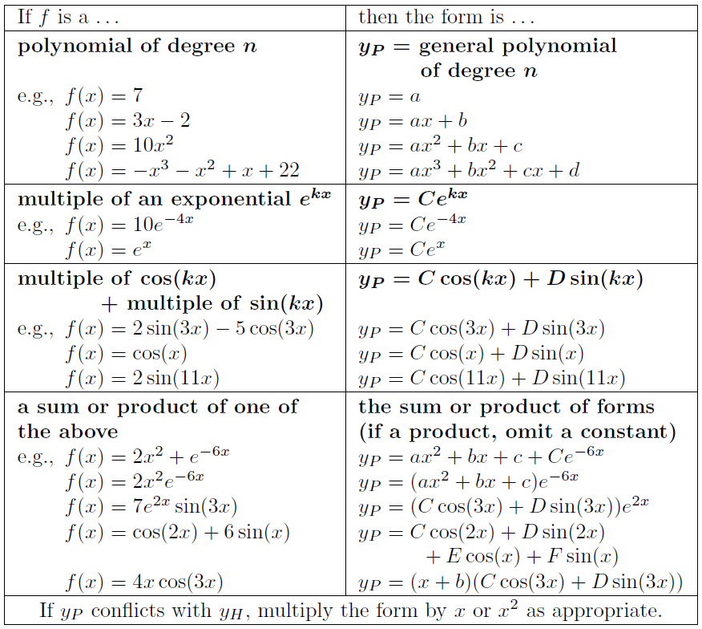

This table should be fairly self-explanatory, except for the last line

* Examples of finding particular solutions

Once you've written down the form for , you still have to substitute into the original differential equation in order to find the constants. To make the calculation easier, you should first calculate and (for the first order case, you actually only need ) (Page 660)

* Resolving conflicts between and

The last line of the table in Section 30.4.5 above indicates that there might be conflicts between and . How can this happen? Well (Page 662)

* Initial value problems (constant-coefficient linear)

Let's see how to deal with initial-value problems (IVPs) involving constant coefficient linear differential equations. As usual, to solve an IVP, first solve the differential equation, then use the initial conditions to find the remaining unknown constants

1. Modeling Using Differential Equations

Many quantities in the real world can be modeled (that is, theoretically approximated) by differential equations. Examples include heat ow, wave height, inflation, current in electrical circuits, and population growth, to name a few. Here's a simple example of a somewhat realistic situation involving population growth (Page 665)